2016 Motivational Minutes on Gratitude
(Also see Attitude and Thoughts.)

- The Black Dot

Quote of the day:

“He is a wise man who does not grieve for the things which he has not, but rejoices for those which he has.” — Epictetus

Reflection:

One day, a professor entered the classroom and asked his students to prepare for a surprise test. They all waited anxiously at their desks for the exam to begin. The professor handed out the exams with the text facing down, as usual. Once he handed them all out. He asked the students to turn the papers over. To everyone’s surprise, there were no questions just a black dot in the center of the sheet of paper.

The professor then told them he wanted them to write about what they had seen there. At the end of the class the professor took all the exams and started reading each one out loud in front to the students. All of them without exception wrote about the black dot, trying to explain its position in the center or defining the dot, etc.

After all had been read the professor explained. “I’m not going to grade you on this. I just wanted to give you something to think about. No one wrote about the white part of the paper. Everyone focused on the black dot and the same happens in our lives.

We have a white piece of paper to observe and enjoy, but we always focus on the dark spots. We have many blessings and have many reasons to celebrate every day. However, we mainly focus on the dark spots, the lacks, such as health issues that bother us, lack of money, complicated relationships, disappointments and the list goes on. The dark spots are very small when compared to everything we have in our lives, but they are the ones that pollute our mind.

Take your eyes away from the black dot in your life and enjoy the blessings of each moment that life gives you. Be happy and live life filled with thankfulness.

**
- Hedonic Treadmill

Quote of the day:

“Happiness cannot be traveled to, owned, earned, worn or consumed. Happiness is the spiritual experience of living every minute with love, grace, and gratitude.” – Denis Waitley

Reflection:

There’s something called the hedonic treadmill, which is what happens when we, as humans, feel we’d be happier if certain things in our lives were different; maybe it’s a promotion, weight loss, more money, etc. Then we think, if we can just obtain that goal—if we can just get obtain that “bigger” something, or simply “more” of what we think we want—we think that will make us happier, and on and on it goes. Interestingly, some of that desire is healthy; it’s what causes us to want to develop our talents and improve. Imagine if we were all satisfied living in mud huts and hunting for survival, or if we all would be happy sending telegrams or using carrier pigeons for communication.

While striving to improve our lives and those of our loved ones is a normal part of life, the key thing to remember is to stop and be thankful for everything that we have right now, to realize that many people get by on so much less than we “think” we need. It is a healthy practice, to “count our blessings,” as the old song says. Then, rather than focusing on things or changes we “wish” we had, we can actually enjoy the wonderful lives we have right now.

**

- Take Time to Be Grateful

Quote of the day:

“When you arise in the morning, give thanks for the morning light, for your life and strength. Give thanks for your food, and the joy of living. If you see no reason for giving thanks, the fault lies with yourself." —Tecumseh

Reflection:
One thing that seems to be universally appreciated is gratitude. Many holidays around the world celebrate harvests, independence, victory in historical battles, and so on. Having a special day of remembrance gives us an opportunity to count our blessings for all the wonderful things we have in our lives that we often take for granted. Whether or not you celebrate Thanksgiving as a traditional holiday, it’s a wonderful idea to pick a time or day when you can focus on being grateful for the good in your life.

Gratitude adds so many benefits to our daily lives. One study found that “Gratitude makes us nicer, more trusting, more social and more appreciative. As a result, it helps us make more friends, deepen our existing relationships, and improve our marriage.”

That’s pretty impressive! It’s also been shown to make one:

- More optimistic
- Less materialistic
- More spiritual
- Less self-centered
- Sleep better
- Healthier
- Have higher self-esteem

And the list goes on…It’s hard to grumble about all the things we’re not happy with when we spend time celebrating the wonderful friendships, life experiences, children, or other important parts of our lives that we love and cherish. Take time to be grateful.

**

- A Reason To Be Grateful
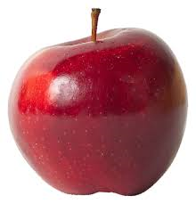

Quote of the Day:

"Gratitude is not only the greatest of virtues, but the parent of all the others.” — Cicero

Reflection:

Here’s a sweet Christmas story from Anna Perlini. Ana is a co-founder of Per un Mondo Migliore
(http://www.perunmondomigliore.org/), a humanitarian organization active in the former Yugoslavia since 1995.

Christmas 1984 was our family’s third Christmas away from Europe. The remote village in eastern India where we had moved to help as volunteers, had become a second home. After some initial difficulty in adjusting to such a different climate and culture, we soon came to appreciate the wonderful people we lived around and to embrace the new sights, sounds, tastes, and fragrances. I began to especially look forward to shopping at our local market, which seemed to have a year-round selection of fabulous juicy fruits—mangos, bananas, lichees, papayas, jackfruits, limes, and others. It was on one of those trips to the market that we happened to see a stand that was selling, at an exorbitant price, some beautiful apples. We were told that these had arrived from the far north of the country, which explained the price tag.

Memories from my childhood surged, and of course, Christmas is a time when memories seem to carry special potency. My eldest daughter was accompanying me that day and put my feelings into words: “It would be so nice to have an apple for Christmas.” That’s how the idea for our family’s Christmas surprise came about. My husband and I spent an evening wrapping small cardboard boxes filled with cookies, nuts…and one big, red apple!

On Christmas morning, the kids opened their boxes and jumped up and down at the sight of those apples! I think we parents had just as much fun watching them and, since we also got a Christmas box, savoring our own precious apple.

We returned to Europe a number of years ago and have since had plenty of apples, but our entire family still cherishes the fond memory of that one “poor” Christmas when we experienced that “rich” feeling of thankfulness for a simple apple.

May we always find a simple, humble reason to be grateful—not just at Christmas, but in every
celebration and event all year-round.
- Little Things

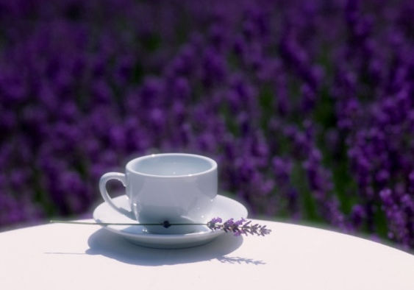

Quote of the day:

“The best things in life are nearest: breath in your nostrils, light in your eyes, flowers at your feet, duties at your hand, the path of right just before you. Then do not grasp at the stars, but do life’s plain, common work as it comes, certain that daily duties and daily bread are the sweetest things in life.” – Robert Louis Stevenson

Reflection:

The following article is from Amanda White taken from Activated Magazine.

The other day I was listening to a Christian radio program on the way to the gym. Each day they ask a question for their listeners to respond to, either via phone or their Facebook page. The topic that day was: “What do you look forward to?” The answers that listeners were sending in were simple, yet refreshing. For example, one woman said she looked forward to having a cup of tea at night once her children were in bed.

It got me thinking about the simple things in life. Essentially, that’s what we all generally look forward to—the little things—a hug after a long day, a cup of something hot in the morning, the sun shining again after a rainy patch enabling us to finally hang our laundry, a comfortable bed to slide into at night, a refreshing shower, a freshly mowed lawn, a meal out. I like to see these small things as being as much a part of God’s love for me as the bigger gifts He sometimes sends my way.

Sure, sometimes we look forward to big and exciting things, like an upcoming vacation. But more often than not, it’s the simple day-to-day things that bring us joy and put a smile on our face. I’m reminding myself that I need to think more about those things, appreciate them more, as they get so easily lost amidst the craziness of life. It’s not a new realization by any means. It’s just one of those principles of life and happiness that easily fade out of focus when so many bigger and more stressful things are obstructing my view or weighing me down.

I decided to start small. I took that woman’s advice on the radio. I set aside a few minutes to relax with a cup of tea that night after the kids were in bed, and I enjoyed every sip!

Are you thankful for the simple things in life? Why not start a praise journal and see how many simple things make you happy.

