Motivational Minutes on Kidness from 2015
(Also see
- Don’t Wait To Give A Complement

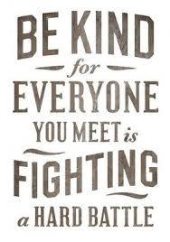
Quote of the day:
"You cannot do a kindness too soon because you never know how soon it will be too late.” — Ralph Waldo Emerson
Reflection:
I came across this story that illustrates these wise words from Ralph Waldo Emerson.
A charming old gentleman used to occasionally stop by at an antique shop in New Hampshire to sell furniture. One day after he left, the antique dealer's wife said that she wished she had told him how much she enjoyed his visits. The husband said, "Next time let's tell him so." The following summer a young woman came in and introduced herself as the daughter of the old gentleman. Her father, she said, had died. Then the wife told her about the conversation she and her husband had had after the old gentleman's last visit. The young woman's eyes filled with tears. "Oh, how much good that would have done my father!" she cried. "He was a man who needed to be reassured that he was liked." "Since that day," the shopkeeper said later, "whenever I think something particularly nice about people, I tell them. I might never get another chance."
Are you putting off showing some kindness or giving a complement? Don’t delay—do it today.
**

- Show Gentleness
57 Quote of the day:
“We can never go amiss in showing gentleness. There is no day when it will be untimely; there is no place where it will not find welcome. It will harm no one, and it may save someone from despair.” —J. R. Miller
Reflection:
All human hearts hunger for tenderness. We are made for love—not only to love, but to be loved. Harshness pains us—it touches our sensitive spirits as frost touches the flowers, and stunts the growth of all lovely things. Gentleness is like a genial summer to our life. Beneath its warm, nourishing influence beautiful things in us grow. It’s like Aesop’s Fable about the wind and the sun.
The wind and the sun saw a traveler. The wind said to the sun, “I can make that traveler take off his coat quicker than you.” The sun agreed and slipped behind a cloud. Then the wind began to blow and blow each blow a little harsher, but the traveler clutched his coat tighter. Soon the sun said it was her turn. She slide out from behind the cloud and shone warm and gentle and within no time the traveler had taken off his coat.
The dictionary has some good definitions [for gentleness]. It says that gentleness is having a mild and kind nature or manner. It’s also having a gracious and honorable manner. It is kindness, consideration, and a spirit of fairness and compassion.
That’s really something to strive for, isn’t it? Wouldn’t you like to have that said about you?
**

- Unremembered Acts of Kindness
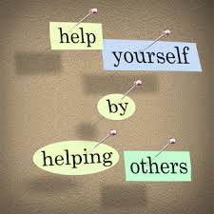
Quote of the day:
"That best portion of a man's life, his little, nameless, unremembered acts of kindness and love.” -- William Wordsworth
Consider:
Here’s an interesting story about doing a kindness and it coming back to you.
One day, a poor Scottish farmer while trying to make a living for his family, heard a cry for help coming from a nearby bog. He dropped his tools and ran to the bog. There, mired to his waist in black muck, was a terrified boy, screaming and struggling to free himself. The farmer saved the lad from what could have been a slow and terrifying death. The next day, a fancy carriage pulled up to the farmer’s sparse surroundings. An elegantly dressed nobleman stepped out and introduced himself as the father of the boy the farmer had saved. 'I want to repay you,' said the nobleman. 'You saved my son's life.' 'No, I can't accept payment for what I did,' the Scottish farmer replied waving off the offer. At that moment, the farmer's own son came to the door of the family hovel. 'Is that your son?' the nobleman asked. 'Yes,' the farmer replied proudly. 'I'll make you a deal. Let me provide him with the level of education my own son will enjoy. If the lad is anything like his father, he'll no doubt grow to be a man we both will be proud of.' And that he did. The farmer’s son attended the very best schools and in time, graduated from St. Mary's Hospital Medical School in London, and went on to become known throughout the world as the noted Sir Alexander Fleming, the discoverer of Penicillin, but the story doesn’t stop there. Years afterward, the same nobleman's son who was saved from the bog was stricken with pneumonia. What saved his life this time? Penicillin. The name of the nobleman? Lord Randolph Churchill ... His son's name? Sir Winston Churchill.
What if the farmer had not taken the time to save the boy? Think of all that would have been lost. You never know what a selfless act of kindness will lead to, or what your part is to play in our great journey of life. The next time you are faced with a choice to help someone remember this story.
**

- Make What is Excellent in Others Belong to You as Well

64 Quote of the day:
“Appreciation is a wonderful thing. It makes what is excellent in others belong to us as well.” ― Voltarie
Reflection:
When someone is elderly or sick and pretty much housebound, no longer actively involved in the world around them, they can feel isolated. It can be a very lonely life. It’s important for these people to know that their life, still matters and that their love and encouragement makes a difference in the lives of their loved ones and those they influence.
One idea to honor that special person (whether they be a parent, teacher, child, friend, spouse or whoever), especially if you cannot be by their side, is to write short notes of love and gratitude to them that can be given or read to them weekly or even daily. A friend of mine did his for her elderly mother. She sent her a one or two line note every week for a year before she died. Through these notes she acknowledged her love and gratitude to her mother on a regular basis. It was something in print and preserved so that her mother could read them over and over.
What my friend was doing through these notes was essentially a “living eulogy.” After her mother’s death, she was so grateful for letting her mother know how much her life had meant to her and so many others, before she left this life. By honoring the beauty of her mother’s life and the good that she had done, my friend was validating her life and acknowledging that her many years on this earth had been worthwhile. What better way to honor a person than to do it while they’re still living!
I thought you might find this idea useful as an example of a way to encourage others that their life matters and how much you appreciate them. Below are three example notes:
- Dear (fill in the blank), Someone said, “Silent gratitude isn’t much use to anyone,” so I want to be sure I voice my gratitude to you for all that you have given and the beautiful life you have lived. I hope I can help you understand how precious that is to me and to others, and that, secure in this knowledge, you will know that your life truly has been worthwhile.

- Dear (fill in the blank), You have made a great difference in my life and the direction I have taken. You helped guide me during those very difficult years, and for that I will be eternally thankful.

- Dear (fill in the blank), I love your patience, your calm, your trust and generosity. I want to be more like you.
**
- Swimming With the Dolphins
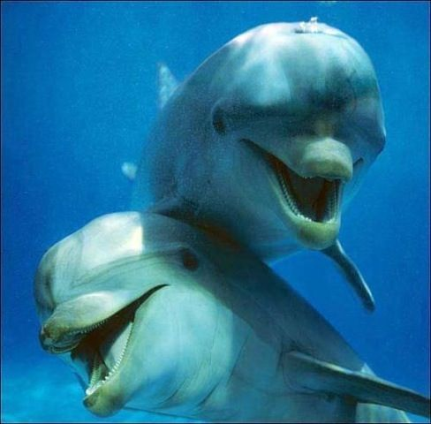

109 Quote of the day:
“To the dolphin alone, nature has given that which the best philosophers seek friendship for no advantage.” — Plutarch
Reflection:
I love dolphins and find their stories so fascinating. There are many stories about the wisdom of dolphins, from how they have saved drowning people to their response toward the disabled who enter the aquarium water. I think the following account is particularly touching.
There was a young woman with cancer who went to Florida to die. She had friends there who worked with dolphins and disabled children, and they had her join the dolphins in the water. The dolphins treated her so gently it seemed obvious they sensed her affliction. These same dolphins would swim over to a hemiplegic child and exercise the child’s paralyzed limbs. That young woman who swam with the dolphins called her therapist one night to say she was having trouble dying. He answered that it would be easy when she was ready. He told her he had never had a call from a dolphin with that problem. She died peacefully that evening.
Dolphins, like dogs, have an uncanny ability to love unconditionally even unto death, their talent lies in their care, concern, love and friendship for no advantage. It would be to our benefit to learn a lesson from the dolphins.
**

