Motivational Minutes on Risk Taking from 2015
(Also see Adversity and Attitude files.)
- Set To Work And Inspiration Will Come

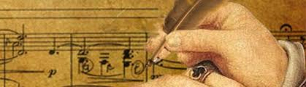

Quote of the day:
“Inspiration comes of working every day.” — Charles Baudelaire
Reflection:
Have you ever felt uninspired about things you have to do? I certainly have. When I feel that way I remember the great composer does not set to work because he is inspired, but rather he becomes inspired because he is working. Beethoven, Wagner, Bach, and Mozart settled down day after day to the job in hand with as much regularity as an accountant gives his full focus each day to his figures. They didn't waste time “waiting” for inspiration before they got busy. They put their nose to the grindstone and dug right into their work, then the inspiration came.
So take courage from Charles Baudelaire that inspiration will come as we take action and set to work.
**

- Reach For the Stars

Quote of the day:
“There is but one cause of human failure. That is man’s lack of faith in his true self.” – William James
Reflection:
The fear of failure often stops us from trying new things. Part of overcoming fear of failure is realizing that no one ever reaches every single goal he/she sets for him/herself.
Sometimes new priorities come into your life, or you realize something is not all that it is cracked up to be. Whatever the case may be, just because you don’t complete a goal doesn’t mean you are a failure. It just means you found out it’s not for you, but you’ll never know that if you don’t give it a try.
Once you understand that it's impossible to meet every goal you set for yourself, it takes the pressure off and will allow you to feel more confident to reach for the stars.
Help yourself to take a chance. Write down one dream you've always wanted to go after but have been too afraid to set goals for yourself. Then, write down the steps you need to take to reach that objective and take the first one.
**

- Calculated Risks

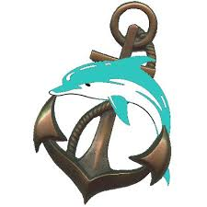

Quote of the day:
“Take calculated risks. That is quite different from being rash.” —General George S. Patton
Reflection:
There is a fine balance between acting too quickly and waiting too long. It is important to carefully make a decision by gathering all the facts available, and then make an informed decision, but once made, swift action should be taken.
Titus, the emperor of Rome understood this principle. His symbol was the image of a dolphin wound around an anchor, which was inscribed on coins during his reign. The anchor represented delay and unchanging conviction. The dolphin was regarded as the swiftest and most mercurial creature of the sea. Together they symbolized the failure that comes from rushing into something, and the failure that is the result of hesitation or undue caution.
Through the years, the dolphin and the anchor have been used as his family crest, with the explanatory motto Festina Lente, "Hasten Slowly." It expresses moderation between two opposing ideas. It means the medium between acting too quickly and waiting too long.
As I see it what the quote and story is saying is we should take time to carefully ascertain the pros and cons of a decision but once a decision is made, action should be taken or as Patton puts it take calculated risks.
**

