Motivational Minutes on Self Worth from 2015
(Also see Self-Care, Thoughts and Attitude files.)

- You Are A Beautiful Wreck

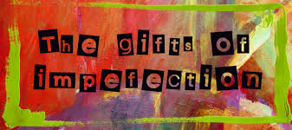

Quote of the day:
“We are all wonderful, beautiful wrecks. That's what connects us-that we're all broken, all beautifully imperfect.” — Emilio Estevez
Reflection:
You are a valuable person just because you exist. You are alive for a reason. Never belittle yourself or listen to your negative self-chatter about how bad you are. No matter where you are from, or what mistakes you have made, or what you do, you are still a worthy person. If you have made mistakes, use them and all your past experiences as teachers, not as a measure of your self-worth. Know that even if you feel broken, you are still very valuable.
If you have not read the book Gift of Imperfection by Brene Brown, it's a great book to help you break the cycle of the shame trap.
Remember, everyone should be treated with dignity and respect, including yourself.
**

- Very Special Person

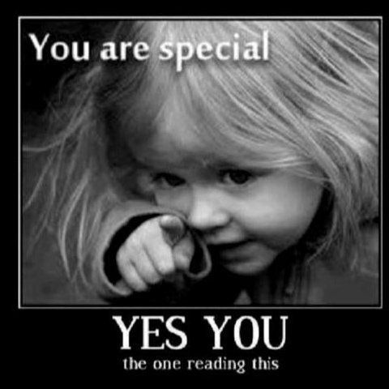

Quote of the day:
“Each person is a V.S.P. (Very Special Person) because we are each created in the image of God.” — Desmond Tutu
Reflection:
Many people don't realize that our self-worth and subsequently our self-care is a major factor in whether or not we do what's necessary to improve our life or not.
I have found that it is important to love, cherish, and value myself and that learning to truly care about myself and honor my well-being is necessary for living up to my potential and helping others to do the same. When I don't, it's difficult for me to dedicate the time and energy to living a positive lifestyle and helping others. The foundation for self-worth is important, as it gives us a reason for living. It provides the fuel that burns our inner-fire and keeps us enthusiastic and hopeful.
If you truly value yourself, you will stop doing things that harm your chances of living a healthy, useful and happy life. Begin making self-acceptance and self-compassion a priority as you work toward becoming the best person you can be.
**

- Physical Flaws
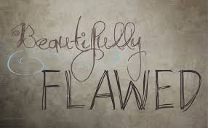

Quote of the day:
“The more you know who you are, the less you let things upset you." — Bob Harris
Reflection:
I often hear people tell me that their physical flaws are the reason why they can't do something. I thought it was interesting when I read that someone analyzed the photos of 90 famous faces whose pictures had been published in the book “The Faces of Greatness” by Yousoff Karsh. Among these men were Picasso, the renowned painter; Thornton Wilder, the great playwright; Richard Rogers, the composer of many popular musicals; Christian Dior, the honored designer. According to the study, 70 of the men were physically unattractive some having obvious blemishes like visible scars, moles, liver spots, etc. But they didn't let their outward appearances define who they were. They knew their value and they shared their talents with the world.
Their blemishes did not stop them from doing great things and neither should yours.
**

- Good News

Quote of the day:
"Everyone has inside of him a piece of good news. The good news is that you don't know how great you can be! How much you can love! What you can accomplish! And what your potential is!” — Anne Frank
Reflection:
Consider the walnut! If you compare a walnut with some of the beautiful and exciting things that grow on our planet, it does not seem to be a marvelous act of creation. It is common looking, rough, not particularly attractive, and certainly not monetarily valuable. Besides, it is small. Its growth is limited by the hard shell that surrounds it, the shell from which it never escapes on its own.
However, this is the wrong way to judge a walnut. Break a walnut open and look inside. See how it has grown to fill every nook and cranny available to it. It had no say in the size or shape of that shell, but, given those limitations, it achieved its full potential of growth.
Just like the walnut, be sure you are judging yourself the right way. How fortunate we will be if, like the walnut, we blossom and bloom in every space of life that is given to us.
Take heart! If one nut can do it, so can you.
**

- How do You Care For Your Valuables?

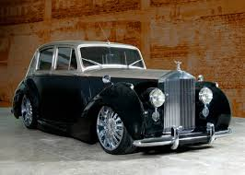

Quote of the day:
“Never forget that you are one of a kind. Never forget that if there weren't any need for you in all your uniqueness to be on this earth, you wouldn't be here in the first place.” — Buckminster Fuller
Reflection:
If you were given a Rolls Royce, a Stradivarius violin, a precious jewel, or something else of great value, how would you take care of it? I think the answer is obvious. You would guard it and care for it to maintain its value.
You are given a life to care for—your own. How do you take care of it? Might I be correct to assume that sometimes you do not care for it as well as you do your other treasures? Every life is a beautiful instrument and work of art. Learn to use it and play it to the best of your ability. And most of all treat your life with the respect it deserves.
You may not have always been treated like a treasured instrument, but it is never too late to polish your finish and tune your strings. When you come to appreciate the preciousness of life, teach others what you have learned.
**

- The Pencil Maker
Quote of the day:
“Do not wish to be anyone but who you are, and try to be that perfectly.” — Saint Francis DeSales
Reflection:
This parable may encourage you to know that you are a special person, with unique talents and abilities.
A pencil maker told the pencil 5 important lessons just before putting it in the box:
1.) Everything you do will always leave a mark.
2.) You can always correct the mistakes you make.
3.) What is important is what is inside of you.
4.) In life, you will undergo painful sharpening, which will only make you better.
5.) To be the best pencil, you must allow yourself to be held and guided by the hand that holds you.
We all need to be constantly sharpened. Only you can fulfill the purpose which you were born to accomplish. Never allow yourself to get discouraged and think that your life is insignificant and cannot be changed and, like the pencil, always remember that the most important part of who you are is what's inside of you.
**

- Step Out Of Your Comfort Zone
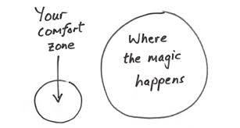
Quote of the day:
“Most of us die with our music unplayed. We should try to step out of our comfort zones and do the things we're capable of.” — Mary Kay Ash
Reflection:
Share your talent with the world. Don’t die with your music unplayed like Mary Kay says.
There was a man who played piano in a bar. He was a good piano player. People came out just to hear him play. But one night, a patron told him he didn't want to hear him just play anymore. He wanted him to sing a song.
The man said, "I don't sing." But the customer was persistent. He told the bartender, "I'm tired of listening to the piano. I want that guy to sing!"
The bartender shouted across the room, "Hey buddy! If you want to get paid, sing a song. The patrons are asking you to sing!"
So he did. He sang a song. A piano player who had never sung in public did so for the very first time. And nobody had ever heard the song Mona, Mona Lisa sung the way it was sung that night by Nat King Cole!
He had talent he was sitting on! He may have lived the rest of his life as a no-name piano player in a no-name bar, but because he was pushed out of his comfort zone to sing, he went on to become one of the best-known entertainers in America.
You, too, have skills and abilities. You may not feel as if your 'talent' is particularly great, but it may be better than you think—and with persistence, most skills can be improved! Besides, you may as well have no ability at all if you sit on whatever talent you possess. The better question is not, "What ability do I have that is useful?” It is rather, "How will I use whatever ability I have?" Don’t wait to be pushed out of your comfort zone, that may never happen, but do as Mary Kay says, STEP out of your comfort zone.
**

- Symphony of Life

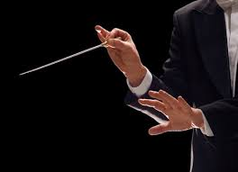

Quote of the day:
“When God made you, he threw away the mold. There never has been or ever will be another person like you.” — Robert F. Kennedy
Consider:
The well known Chinese conductor stood with his arms raised before his orchestra, ready to begin the final rehearsal before the year's most important musical event. He lowered his baton, and the huge hall was filled with the glorious strains of the organ, the mighty echo of the drums, the clash of cymbals and the haunting melancholy of the stringed instruments. To the few people who were privileged to watch the rehearsal, the orchestra had never sounded better. Suddenly, the conductor thundered "Stop!" There was an astonished silence. Then he demanded: "Where is the piccolo?" The piccolo player had kept silent because he thought the absence of his small instrument would go unnoticed, but the trained ear of the conductor had missed the delicate tones of the little instrument because the music was incomplete and imperfect without it.

Some of us may not have many or great talents, but each of us has a role to play. Have you become a silent onlooker thinking that your contribution is not worthwhile? Let’s get back in the symphony of life. We need you.

**

- Express Your Unique Gift

Quote of the day:
"There is but one cause of human failure. That is man’s lack of faith in his true self.” – William James
Reflection:
If you've followed my writings you know that I believe that each of us has something not only unique about us, but that our unique gifts have the potential to provide great value to others. Therefore it is important to find out what our talents are and strengthen them.
We all have some special talent, skill, or gift—something we do or some way we see things that is different or better than anyone else. If you can't figure out what your special talent is, interview your friends, family, and colleagues. They will tell you.
Here are some questions you can ask:
What do you think is my greatest strength?
What is my biggest weakness? (Ask this only if you feel up to it, and ask them to tell you in a constructive way. Do not comment on anything they say. You are simply gathering opinions.)
What do you see as my special talent or gift?
What do I do naturally and effortlessly that is special?
If I were on the cover of a magazine, what magazine would it be, and what would the story be about?
Under what circumstances do I most fully express this gift or talent?
The next step is to begin to honor your gift. Do one thing that will allow you to fully express your unique gift.
**

10. Being Yourself
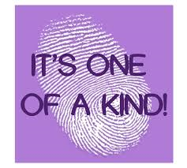
Quote of the day:
“To be yourself in a world that is constantly trying to make you something else is the greatest accomplishment.” — Ralph Waldo Emerson
Reflection:
This quote from Emerson is interesting as in today’s world it’s even harder to be ourselves than it was in his time. But no matter how hard it is, no man or woman has anything about themselves more valuable or precious than their own individuality.
God made us all different, just as each snow flake is different, so are we. Many of us strive for originality and greatly desire to be different from other people. But we often neglect to do the one thing that makes us different, and that is to be ourselves. Instead, we are apt to be imitators of other people and the way they act and think.
Reflect on this thought and see if you are an imitator or being yourself.
**

- We All Have a Purpose to Fulfill

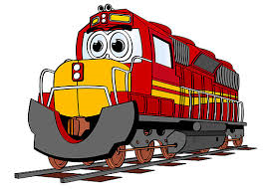
Quote of the day:
“If God had wanted me otherwise, He would have created me otherwise.” — Johann Wolfgang von Goethe
Reflection:
There is a children’s story that illustrates this quote quite well.
The story is about a locomotive that did not want to stay on the tracks. It wanted to wander into the towns that it passed and into the beautiful fields it saw along the way. One day the locomotive decided to leave the tracks, and he did! But when he wandered into town, he created great discomfort among the people. The smoke that belched from the engine dirtied the clothes of the people of the town. The locomotive caused traffic jams and its enormous weight cracked the streets on which it rode. When the locomotive went into the fields, to enjoy the flowers that he saw there, he immediately got bogged down. Farmers had to come with tractors and pull him out. Everywhere the locomotive went he caused trouble, and the more trouble he caused, the more miserable he became. Finally, the townspeople got him back on the track he was created to ride. It was then he discovered that he really could not be happy unless he was on track, following the route intended for him.
This simple story suggests that we each have a path [track] to follow in life. When we wander off our path, we cause chaos and sadness for ourselves, as well as for others. We often are tempted to think that the grass is greener on the other side of the fence, but this is not so. We are all made with certain gifts and talents—and—to fulfill a certain purpose in life. Happiness and contentment come when we stick to our purpose in life and fulfill it with all our hearts.
**

- The Twenty Dollar Bill
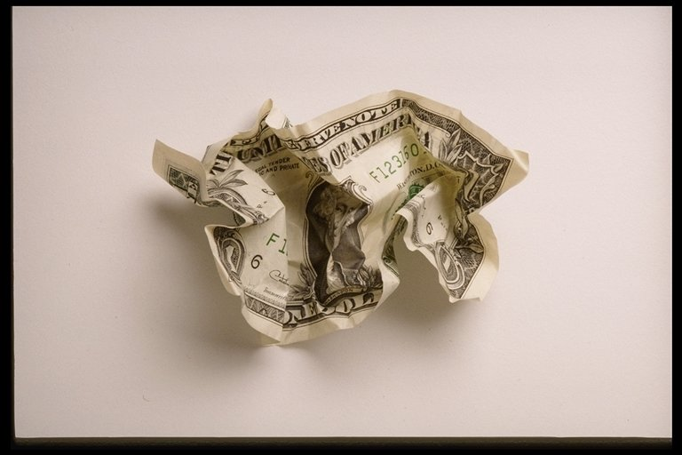

Quote of the day:
“Too many people overvalue what they are not and undervalue what they are.” — Malcolm Forbes
Reflection:
This quote reminds me of a story:
A man said, "I am going to give this $20 bill to one of you." Immediately he had everyone's attention. "But first, let me do this." He proceeded to crumple the bill. He then asked, "Who still wants it?" Every hand went up. "Well," he went on, "what if I do this?" And he dropped the $20 bill on the ground and started to grind it into the floor with his shoe. He picked it up, now crumpled and dirty, and asked again. "Now who still wants it?" Still the hands went into the air. "My friends, you have all learned a very valuable lesson," he said, "No matter what I did to the money, you still want it because it has not decreased in value. It is still worth $20.
Many times in our lives, we are crumpled, dropped and ground into the dirt by the decisions we make and the circumstances that come our way. We feel as though we are worthless, but no matter what has happened or what may yet happen, you will never lose your value. Remember, dirty or clean, crumpled or finely creased, you are still priceless.
**

