Motivational Minutes on Thoughts—Positive and Negative from 2015
(Also see Self-Worth, Gratitude, Risk Taking and Attitude files.)

- Ocean Liners

Quote of the day:
“I keep the telephone of my mind open to peace, harmony, health, love, and abundance. Then whenever doubts, anxiety, or fear try to call me, they keep getting a busy signal--and soon they'll forget my number.” — Edith Armstrong.
Reflection:
This quote has such good advice and reminds me of what Dr. Osler said about ocean liners:
“An ocean liner is built so that the captain can, by pressing a button, lower steel doors separating one watertight bulkhead from another. If the hull is pierced in a disaster, this keeps the ship afloat. In the voyage of life learn how to make doors come down and shut out the yesterdays with all their errors and failures. Learn also to lower another door to shut out the unborn tomorrows so that you can live for this day alone. As you move into the next bulkhead, close doors that will shut out both the past and the future."
In both illustrations our part is to block out any negative input so that our mind stays clear and open to the positive keeping us on the path of growth. What negative input do you need to put a block on?
**

- Detoxify Your Spirit

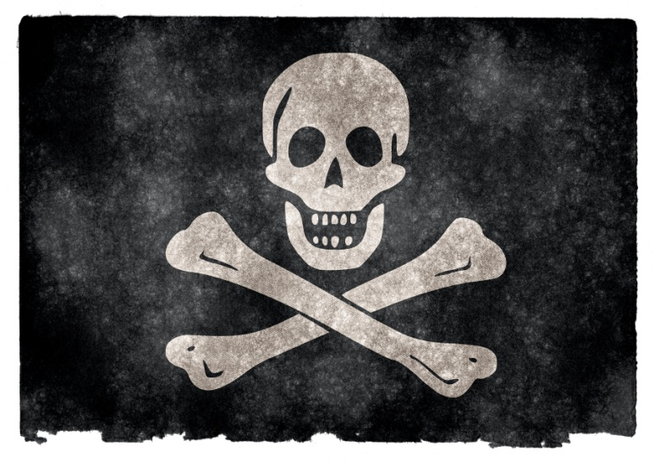
Quote of the day:
“Negative self-chatter, bitterness, anger, guilt, shame, fear, and lack of forgiveness, among others, are spiritual toxins poisoning your heart and mind and must be regularly cleansed.” — Dana Bosley
Reflection:
I am very health conscious. I am careful not to eat poisons and I regularly try to cleanse my body of toxins. I was thinking about how the world in general has become more toxin conscious, fighting against air and other pollutions. Dentists are helping us rid ourselves of mercury poisoning. And today we have laws to protect the public against hundreds of body poisons, with instructions to keep poisons out of the reach of children. Schools and toy businesses are careful not to use led paint. Restaurants, in general, are on guard against food poisoning, and the list goes on and on.
There is an increased general awareness of the harm that poisons can do to our bodies. But what about the toxins and poisons we take into our minds and spirits every day? Statistics show that every single week most everyone hears over 2,000 negative comments, not to mention all the negative self-chatter we tune into, as well as ugly and violent sights we see on a nearly daily basis via the media.
It is my firm belief that we should be as militant to protect ourselves from spiritual poisons such as negative thoughts and bitterness and to be regularly detoxifying ourselves from the negativity that surrounds us that is beyond our control. I feel that cleaning our spirits is just as important as cleaning our body.
Do you need to detoxify your spirit? For ideas on how to do this, read over the Gratitude, Attitude and Quiet Time files.
**
- Habits

Quote of the day:
“You can replace old patterns of self-defeating behavior with new patterns, new habits of effectiveness, happiness, and trust-based relationships.” — Stephen Covey
Reflection:
A friend of mine told me this story.
They used to build bridges by first flying a kite from one side of the river or gorge to the other. Someone on the opposite side caught the kite and tied a little thicker, stronger string to the end of the kite string, and the men who had sent the kite over pulled the new, thicker string back across. The teams on each side kept repeating the process, next with an even stronger string, then a cord, then a thin rope, then a thicker rope, and so on. Eventually they could pull a small steel cable across, then a heavier one, until finally they had a cable across the expanse that was strong enough to support them and their tools and materials. —And it all started with one tiny kite string!
That's how habits are formed, both good and bad. Add a thread every day, and before long you can't break it. Start developing a good habit by taking the first step, however small, in the right direction. Then keep at it until you've built up a routine that can't easily be broken.
**

- The Birds Flying Over Our Heads

Quote of the day:
“Temptations, of course, cannot be avoided, but because we cannot prevent the birds from flying over our heads, there is no need that we should let them nest in our hair.” — Martin Luther
Reflection:
We most likely will never completely get rid of negative self-chatter but we don’t need to let negative thoughts make a home in our minds and take up residence. We need to shoo those negative thoughts away by filling our minds with good, positive, uplifting thoughts, then the negative will fly away. But, if you choose to allow them to hang around and build a nest, it will only bring anguish. Dwelling on the negative will only create havoc in your mind, heart, and spirit—not to mention it will be much harder in the end to get rid of the negative thoughts and their side effects once they have settled in.
So spare yourself a lot of heartache—make it a habit to think positively!
**

- I’m Possible
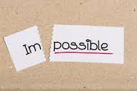
Quote of the day:
“Nothing is impossible, the word itself says ‘I'm possible'!" — Audrey Hepburn
Reflection:
I greatly appreciate this quote and find it gives me great strength when I am faced with a would-be impossibility.
I saw an Adidas ad one time that I thought was interesting and goes along with this sentiment. Here’s what it said:
Impossible is just a big word thrown around by small men who find it easier to live in the world they’ve been given than to explore the power they have to change it. Impossible is not a fact. It’s an opinion. Impossible is not a declaration. It’s a dare. Impossible is potential. Impossible is temporary. Impossible is nothing.
Most of the great work in this world was achieved by men and women who didn't believe that what they were doing was impossible. Is there something that you would like to accomplish in life that the word impossible is stopping you from trying?
**

- Pumpkin in a Jar

Quote of the day:
"As long as a man stands in his own way, everything seems to be in his way.” — Ralph Waldo Emerson
Reflection:
The following story attributed to Earl Nightingale is an example of how we often limit ourselves, or let others limit us.
One time there was a farmer who had planted a crop of pumpkins. Walking through his field when the pumpkins were just beginning to develop, he came across a glass jug, which apparently a passing motorist had thrown into his field. As an experiment, he poked a very small pumpkin through the mouth of the jug, but he was careful not to damage the vine. Months later, when the field was fully developed and about ready for harvesting, the farmer, making one of his periodic inspections, again came across the glass jug. This time it was completely filled with the pumpkin he had put inside. The other pumpkins on the same vine were large and fully developed, but the pumpkin in the jug had not been able to grow beyond the confines of the glass prison and was shaped to its exact dimensions.
What size and kind of jug are you going to poke yourself into or allow someone else to put you into? Don’t let anyone limit you, even yourself.
**

- Log Jam

Quote of the day:
“Your thoughts are the architects of your destiny.” — David O. McKay
Reflection:
We are the sum of our thoughts. We cannot for any length of time behave in a way that is inconsistent with our thinking. You will not be able to change your attitude for the better unless you know what is currently impacting it for the worse.
When professional loggers are floating logs down a river and they discover a log-jam, they climb up a large tree near the river so that they can look over the problem and find the cause. What they’re looking for is the key log that is creating the problem. Once they remove that, the river takes care of the rest. An inexperienced person could spend hours, days, even weeks moving around logs without results.
Similarly, if these words are speaking to your heart, why not step back and find the negative thoughts or values that are jamming up your life. You don’t necessarily need to change all of your thinking—just the few items that are keeping a positive attitude from flowing in you. Pin-point what is jamming things up and then take measures to change that and your life should start flowing again.
**

- Believe Something Can Happen

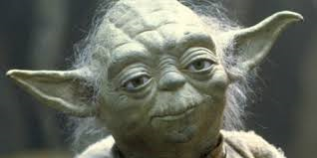

Quote of the day:
“Once we accept our limits, we go beyond them.” — Albert Einstein
Reflection:
In the "Star Wars" movie, The Empire Strikes Back, Luke Skywalker flies his X-Wing Ship to a swamp planet on a personal quest. There he seeks out a Jedi master named Yoda to teach him the ways of becoming a Jedi warrior. Luke wants to free the galaxy from the oppression of the evil tyrant, Darth Vader. Yoda reluctantly agrees to help Luke and begins by teaching him how to lift rocks with his mental powers. Then, one day, Yoda tells Luke to lift his ship out from the swamp where it sank after a crash landing. Luke complains that lifting rocks is one thing, but lifting a star-fighter is quite another matter. Yoda insists. Luke manages a valiant effort but fails in his attempt. Yoda then focuses his mind, and lifts out the ship with ease. Luke, dismayed, exclaims, "I don't believe it!" "That's why you couldn't lift it," Yoda replied. "You didn't believe you could."
That is often our problem in life we don’t believe something can happen. We are limited by our belief. Don’t let your limiting beliefs stop you from reaching your full potential.
**

- Lose Sight of the Shore

Quote of the day:
“You cannot discover new oceans unless you have the courage to lose sight of the shore.” — Andre Gide
Reflection:
Before Christopher Columbus set sail from Spain into the vast unknown, it was believed that the world ended not far beyond Gibraltar. Indeed, this belief was expressed in the Spanish royal motto that read, “Ne Plus Ultra”, meaning "There is no more beyond here." But when Columbus returned from the New World, he had actually discovered new horizons. This made the royal motto meaningless, until Queen Isabella simply eliminated the first word. Thus the royal motto became, “Plus Ultra”, meaning "There is plenty more beyond."
We may think there are no more "new frontiers" left to explore, but look around. They may not be geographical, they may be social, political or spiritual. Wherever there is a need, wherever there is hatred, poverty, prejudice, apathy, despair or hopelessness there is a new frontier to conquer. Yes, there is plenty more beyond! Don’t let your limiting beliefs, fear or short sightedness stop you from discovering what is beyond.
**

- Mental Health

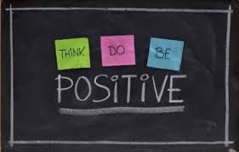

Quote of the day:

"The measure of mental health is the disposition to find good everywhere.” — Ralph Waldo Emerson

Consider:

David H. Fink, a psychiatrist for the Veterans Administration and author of “Release from Nervous Tension” made a study on the stressed and mentally unbalanced. He studied two groups, the first group was made up of thousands of people who were suffering from mental and emotional disturbances; the second group contained only those who were free from such tensions. Gradually one fact began to stand out: those who suffered from extreme tension had one trait in common-they were habitual faultfinders, constant critics of people and things around them. Whereas the men and women who were free of all tensions were the least fault finding.

It would seem that the habit of criticizing is a prelude or mark of the nervous, and of the mentally unbalanced. Take a moment to determine how critical and fault finding you are and take measures to correct that before your stress and tension becomes unmanageable.

**

