Motivational Minutes on Attitude from 2011-2014
(Also see Adversity, Thoughts and Gratitude files.)

- Looming Giants or Adventures

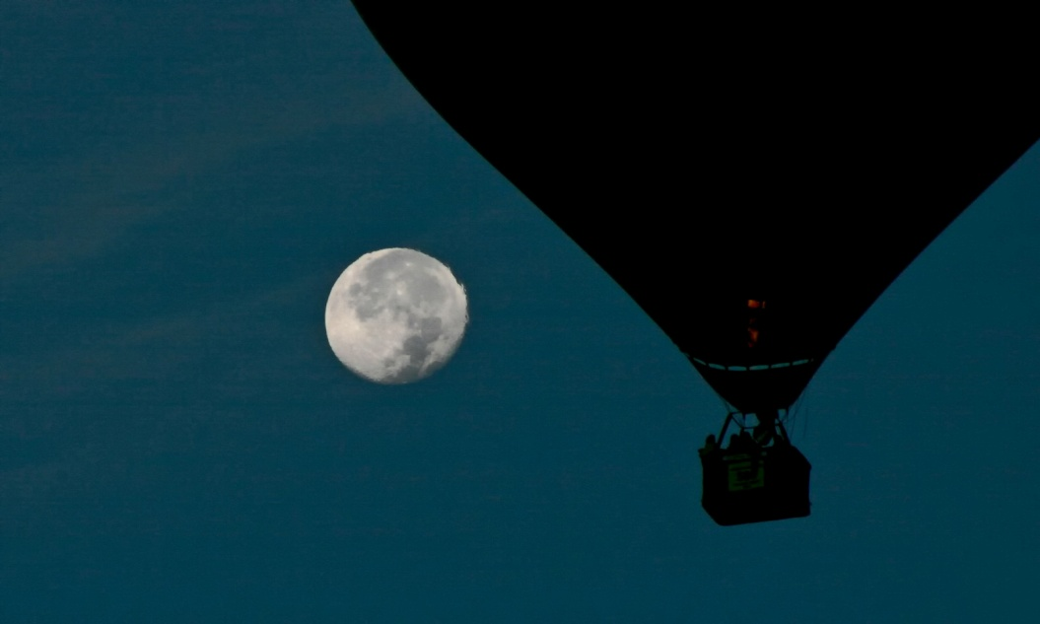

Quote of the day:
“Our attitude toward life determines life’s attitude towards us.” — John N. Mitchell
Reflection:
Our attitudes impact our lives greatly. A wise young woman said: “In absence of great challenge, we feel safe; when everything is clearly in sight, we are at ease. But then, we see the challenge in front of our eyes, and quiver. We see the monsters and pray for deliverance. But I want to look on these things in life, not as fearful, looming giants, but as challenges that are worth pursuing, even if just for the thrill of experiencing them. Life isn’t just about survival. It’s about adventure.”
Periodically take time to assess your attitudes. Do your problems appear like looming giants standing over you or do you see them as adventures? Do you tackle obstacles like a warrior who is happy for the challenge and the chance to test his skills and strength, or do you view difficulties as monsters out to destroy you?
**

- No Impossibilities

Quote of the day:
“I am looking for a lot of men who have an infinite capacity to not know what can’t be done.” — Henry Ford
Reflection:
This quote reminds me of the bumblebee. According to the principles of aeronautical science the bumblebee can’t fly because of the size and shape of its body in relation to its total wing area. However, the bumblebee pays no attention to the seeming impossibility, it simply goes ahead and flies, regardless.
When faced with something your mind is telling you “can’t be done” think about the bumble bee and do it anyway and be the kind of man/woman Henry Ford was referring to, “having an infinite capacity to not know what can’t be done.”
**

- “I Was Blind.”

Quote of the day:
“To be content, just think how happy you would be if you lost everything you have right now, and then got it back again!” — Author Unknown
Reflection:
Sometimes when you are feeling jaded or blasé, you can revive your sense of wonder by merely saying to yourself: Suppose this would be the last time for me to experience this.
A group of visitors at a resort had been watching the sunset from the gallery of the hotel. An overweight, unromantic-looking man had lingered until the last glow faded, and had seemed thrilled through and through by the beauty of it all. One guest, more observant than the rest, wondered about this, and so at supper she said to this man, “You certainly did enjoy that sunset, are you an artist?” “No, Madam, I’m a plumber,” he responded with a slow grin, “but I was blind for five years.”
Few things are commonplace in themselves. It’s our reaction to them that grows dull. Take time to keep the wonder in your life.
**

- Choose to Be Happy

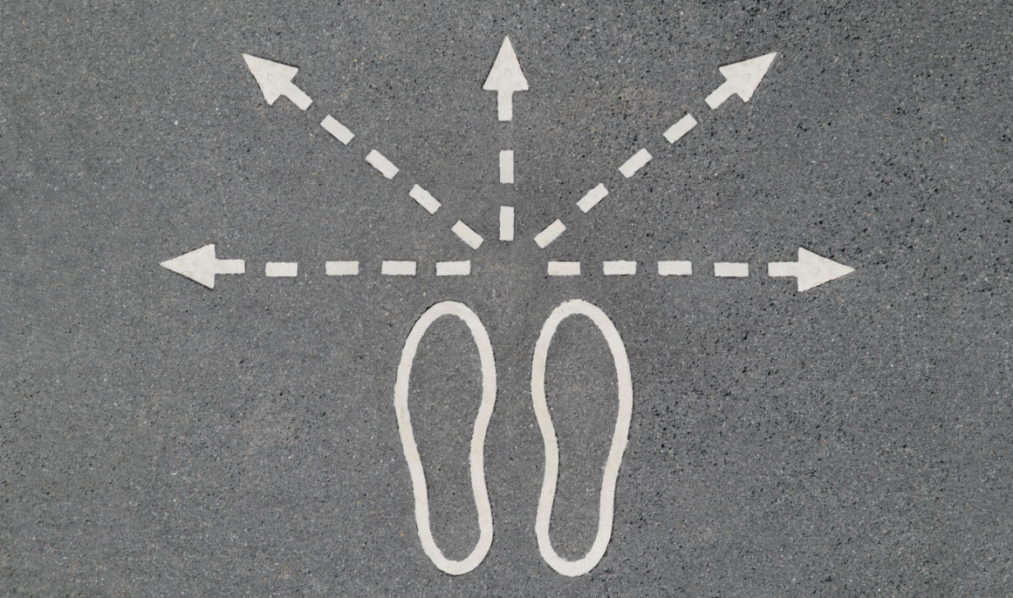

Quote of the day:
“Each morning when I open my eyes I say to myself: I, not events, have the power to make me happy or unhappy today. I can choose which it shall be. Yesterday is dead, tomorrow hasn't arrived yet. I have just one day, today, and I'm going to be happy in it.” — Groucho Marx
Reflection:
We outline a good life according to the attitudes we choose to have. Our attitudes affect our lives and our happiness. If we want to be happy, we must make a conscious decision that we are going to be happy and then do our best to have a positive outlook on life. This way, we can fully enjoy life, no matter what circumstances may come our way.
Are you tired of having your emotions affected by the circumstances in your day? Choose to be happy, hopeful and positive, no matter what is going on around you. Your positive outlook will help you rise above petty negative emotions, and true happiness will find you.
**

- Circumstances May Change

Quote of the day:
“Reflect on your present blessings, of which every man has many; not on your misfortunes, of which all men have some.” — Charles Dickens
Reflection:
I came across that gem of wisdom at a rough time in my life. The thing that amazes me now is how easily I could have missed it. I was feeling happy and fulfilled at the time, satisfied with my life and where it seemed to be taking me. I could have brushed those words aside as not applying to me. I was later glad I hadn't. Things took an unexpected downward turn, and those words became a reference point that helped get me through the next few difficult months.
That little bit of advice helped me realize that while my circumstances had suddenly changed, that didn't change the things that counted most in life. It didn't change who I was or my main goals or values. Therefore it shouldn't rob me of the contentment I'd had before things fell apart.
The happy ending? By focusing on what I still had and not on what I had lost, I made it through that difficult time and came out happier in the end. Try focusing on the good if you find yourself in a rough spot, it will do the same for you.
**

- The Pain Passes But The Beauty Remains

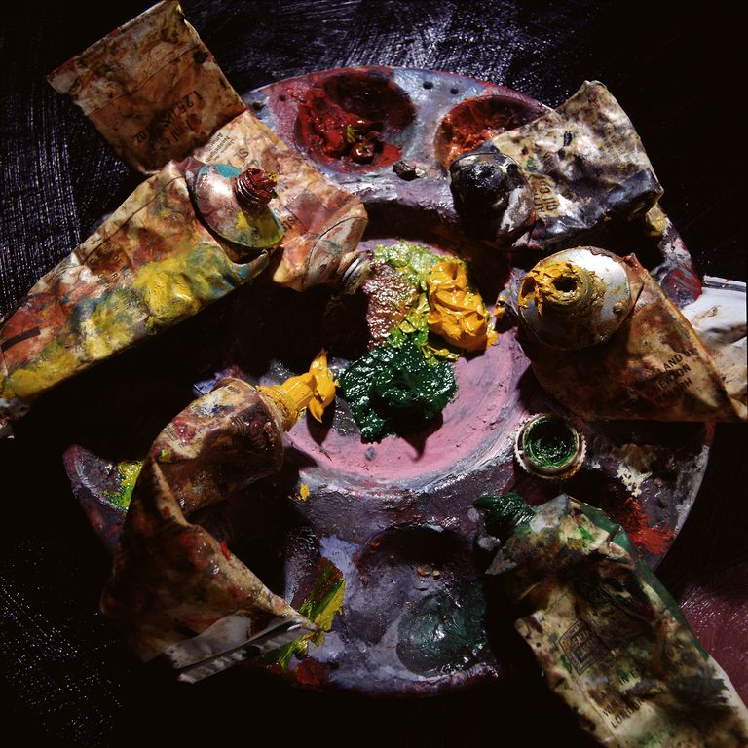

Quote of the day:
"The pain passes, but the beauty remains." — Pierre Auguste Renoir
Reflection:
Here is the story behind the quote.
The great French artist Renoir, in his later years, suffered severely from arthritis, which affected his hands so badly that it was only with the greatest difficulty that he could hold a brush. He struggled on bravely with his painting in spite of the pain.
A friend once asked him why he continued to paint when the physical agony was so great. Renoir replied, "The pain passes, but the beauty remains."
How true that is. Surely there is an attitude here which can be applied to many difficult situations in our own lives.
**

- A Choice of Attitude

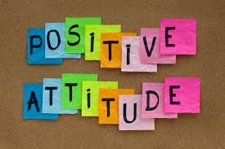

Quote of the day:
“I discovered I always have choices and sometimes it's only a choice of attitude”. — Judith M. Knowlton
Reflection:
We can’t always control our circumstances, but we can control our choices, even if that choice is about changing our attitude in regards to a particular circumstance. The attitude we choose to have towards everything in life is one of the most powerful choices we have. Our attitude can change our outlook on any given thing, person or set of circumstances, it can change us and the way we feel, and it can change the outcome of a situation.
Think about your reactions and your attitude throughout the day and towards all that is part of life. Is it uplifting? Is it hopeful? Does your attitude show defeat, or does it work towards a solution to the problem? If not, make a conscious effort to change your attitude into a positive one and eventually having the right attitude will become a habit and a positive mind-set will be part of you.
**

- Meeting Events

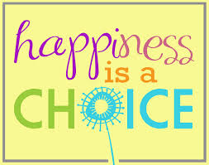

Quote of the day:
“I am more and more convinced that our happiness or our unhappiness depends far more on the way we meet the events of life than on the nature of those events themselves.” — Karl Wilhelm Von Humboldt
Reflection:
There's probably not a person on this planet who is completely satisfied with the way they are. We are either "too fat" or "too skinny," "too short" or "too tall," "too average," "too different," or “too” something. And what about those bad habits, weaknesses, and personality quirks that seem to stand in the way of our happiness, our success, and successful relations with others?
In time, most of us realize that one of the keys to happiness is learning to accept certain things about ourselves that we can't change or that don't really matter, and to major on the things that we can change and that do matter.
Someone wisely summed this up in what has come to be known as the Serenity Prayer: "Lord, give us serenity to accept what cannot be changed, courage to change what should be changed, and wisdom to distinguish the one from the other."
Are there things in your life you need the serenity to accept, the courage to change or the wisdom to know the difference?
**

- Change

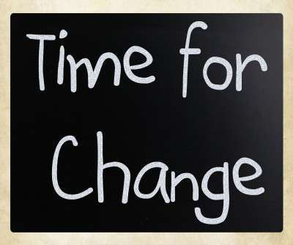

Quote of the day:
“If you focus on the negative in any situation, you can expect high stress levels. However, if you try and see the good in the situation, your stress levels will greatly diminish.” — Catherine Pulsifer
Reflection:
Most people find change stressful and prefer stability and routine to big changes and drama, but the latter seem inevitable. That's unsettling. How can we learn to handle changing circumstances so they don't rock our world so much?
Stay positive. As the quote says, look for the good in the situation and how things can be better. What you've been doing, or the way you've been doing it, may have worked reasonably well so far, but there may be better alternatives.
Understand the issues. Differentiate between the practical aspects and the emotional, the things you have control of and those you don't have control over and deal with each accordingly. Together they may seem overwhelming, but individually they are usually manageable.
**

- Everything Happens For A Reason
Quote of the day:
“I trust that everything happens for a reason, even when we’re not wise enough to see it.” — Oprah Winfrey
Reflection:
I agree with Oprah. I try to live by the idea that all things that come into my life are for a reason and turn out good for me in the end. I recently read the African folktale which illustrates this principle.
The story is told of an African king’s close friend who had a habit of looking at every situation positively and remarking, “This is good!” One day the king went on a hunting expedition giving his friend the job of loading his guns. The friend did something wrong as one gun misfired and blew the king’s thumb off. “This is good!” the king’s friend remarked as usual. “No, this is not good!” the king replied, and he sent his friend to jail.
Later, the king was hunting when cannibals captured him. However, before cooking him they noticed that the king was missing a thumb. The cannibals had a superstition that forbad them from eating anyone who was less than whole, so they sent the king on his way. The king was reminded of the event that had taken his thumb and regretted the way he had treated his friend, so went straight to the jail to release him.
On their reunion the king said. “It was good that my thumb was blown off.” And he proceeded to tell his friend about his brush with death. “I am sorry for sending you to jail for so long,” he said. “That was very bad of me!” “No,” his friend replied, “This is good!” “What do you mean’? “If I had not been in jail I would have been with you and the cannibals would have eaten me.”
The moral: You never can tell what bad situation you are spared from, so be thankful for everything that comes your way, as there is always some good reason.
**
- A Common Denominator

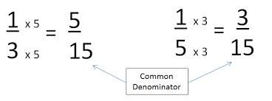

Quote of the day:
“Life is ten percent what happens to you and ninety percent how you respond to it.” — Lou Holtz
Reflection:
Have you ever run across someone(s) that in spite of their circumstances is happy and cheerful? What is it about people like this that leaves us envious—not of their circumstances, perhaps, but of their cheerful dispositions? Like angels in disguise, champions of goodwill seem to say to us, "Join the team!"
In search of their secret, I looked for a common denominator, how these folks manage to not only rise above adversity, but to take others with them. I think I found the answer. They are all genuinely thankful for what they have, and they don't waste time wishing things were any other way.
Let’s take a lesson from these people and respond to our circumstances in a positive, cheerful manner.
**

- Be Happy

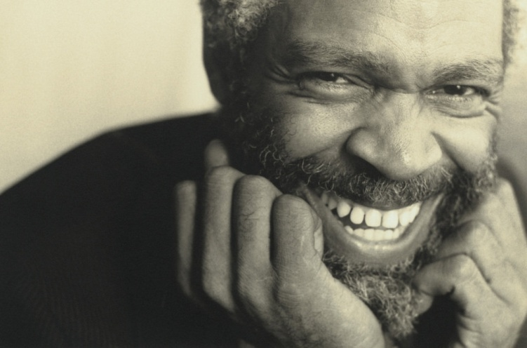

Quote of the day:
“Be happy. Talk happiness. Happiness calls out responsive gladness in others. There is enough sadness in the world without yours.” — Helen Keller
Reflection:
You can’t make the sun come out on a rainy day, but you can change the mood around you.
Most people feel happier and are more upbeat on a warm, sunny day than on a stormy one. You can warm and encourage the people around you by sunny “rays” or good vibes you send their way. But if you’re carrying around a cloud of problems and woes, you’re likely to create a “pressure system” that will dump rain and dampen and darken the day for everyone you come in contact with.
So carry a warm, sunny atmosphere with you wherever you go. Let the sunlight of your happy countenance shine on others and cheer them up.
**

- You’re Billboard

Quote of the day:
“'Tis easy enough to be pleasant, when life flows along like a song; but the person worthwhile is the one who will smile when everything goes dead wrong.” — Ella Wheeler Wilcox
Reflection:
Your face is your own personal billboard along the highway of life. It’s your means of unspoken communication, your first and most powerful “advertisement.”
Many people don’t put enough emphasis on making sure their billboard is displaying the right message. They walk around with their worries or woes or whatever else is on their mind, written all over their face. Their introspection and stress can’t help but show and are bound to affect others negatively. That sort of message is enough to repel all but their most understanding and loyal friends. But other people have a knack for staying cheerful no matter what they are going through. They have a bright countenance that attracts others.
If you want to turn your life around, let your face send a positive message that will lift others’ hearts. Concentrate on having a pleasant facial expression that conveys faith, optimism, kindness, approachability, concern for others, and a joy for living and see what happens.
**

- The Good Life

Quote of the day:
“The good life is not measured by material wealth or possessions. The good life is an attitude, an act, an idea, a discovery, a search. The good life comes from a lifestyle that is so fully developed—regardless of your bank account—that provides you with a constant sense of joy in living.” — Jim Rohn
Reflection:
There is a tendency to see wealth or possessions as the ideal requirements for a good life, when in reality, a good life is achieved with much more than just money. A good life comes with having the right attitude towards life, living it as you would an adventure; being excited about learning; loving and being loved; caring and giving to others and enjoying simple moments such as stopping to enjoy a beautiful view, a baby’s smile, an engaging conversation, or a moment of quiet.
Take a few moments to think about other simple pleasures in life that bring you satisfaction, then take time out each day to enjoy them.
**

- Look For The Good
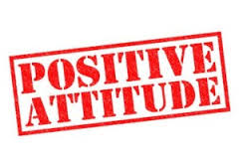
Quote of the day:
“Things turn out best for the people who make the best out of the way things turn out.” — Art Linkletter
Reflection:
Want every day to turn out well, no matter what the circumstances? Here is the secret: Look for the good in every situation. There is a positive way to look at any difficulty or disappointment.
If you are inclined to dwell on the negative, stop! Getting critical or depressed never makes things better. You might feel that you deserve a little self-pity, but you will only drag others down and feel the worse for it. Whereas if you look at even the “bad” things in a positive way, it will help you pull out of the doldrums.
There is more than enough negativity and cynicism in the world today. You can’t counter the global problem, but you can control your own outlook and keep from falling prey to it yourself.
Determine to make the best of bad situations, and you’ll make your own world a happier place. You’ll also attract more friends, because people are naturally attracted to positive people.
**

- Make It A Bad Moment

Quote of the day:
“Make it a bad moment, not a bad day.” — Katherine Mylius
Reflection:
Have you ever had a day that went great and you realized later that it all started when you met someone who was especially nice to you? Maybe it was the way someone smiled at you, or the way they held a door open for you--only a little gesture, but one that had a positive impact on your day. On the other hand, have you ever had a bad day just because you crossed paths with someone who was in a foul mood? Or maybe you had an accident and spilled your coffee. When these bad moments occur there is no need to let them snowball and cast a shadow on your whole day. Don't let one little moment of mishap spoil your entire day but instead, when an accident happens, instantly look for a good and positive take on it, like being thankful that you don't spill your coffee everyday or that you even have coffee at all, or give that grumpy person the benefit of the doubt--who knows what they could be going through? Moment by moment our level of happiness is determined by our attitude, it's a choice we make. Choose to rise above the bad moment, and not let it become a bad day.
Keep the grain of wisdom in the quote above close to your heart. Choose to make each moment the best it can be and when you do have those occasional bad moments be sure they stay that way—simply a bad moment, don't let it turn into a bad day.
**
- The Plan Behind the Problem

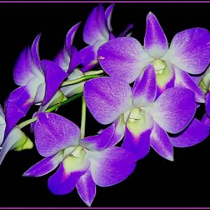

Quote of the day:
“You can choose either to be a skeptic or a believer. Birds were meant to fly. Flowers were meant to bloom. Humans were designed to believe in beauty, in love, in truth, in God.” — Dr. Robert H. Schuller
Reflection:
Happiness starts on the inside. When faced with problems and difficulties, it is our inner man that determines how we’ll handle the situation. We can look at troubles in a positive way and know that there is a purpose and a plan behind that problem, or we can choose the pessimist route and think that our life is falling apart.
The next time you are faced with a negative situation, take a positive stance, even though the situation looks dark at the moment, think of all the good that can come of it, and you will come through it stronger in the end.
**

- In Spite of Adversity

Quote of the day:
“If you can't change your fate, change your attitude.” — Amy Tan
Reflection:
Does our attitude toward life determine our level of happiness? I have become more and more convinced that it does.
I heard this story from a volunteer helping with survivors of the earthquake and subsequent tsunami that devastated parts of Chile in February 2010.
On our first trip to the area, we met a woman who had owned a hair salon. The tidal waves had swept through her shop, leaving total devastation in their wake. When she had dug through the mud where her business had been, she found only one pair of scissors, one buzzer, and one cape. Miraculously, the wave had also spared her large mirror. Thankful that she still had one of each of the items she needed, she cleaned them and reopened for business. She had turned her misfortune into an adventure, and found cause to celebrate in spite of the catastrophe.
When faced with difficult circumstances, many people become embittered and blame others, their circumstance, and even God for their plight. Not so with these and other brave survivors who chose instead to focus on the positive and keep their heads up in spite of adversity. Let’s learn a lesson from them.
**

- Choose To Take On A Positive Attitude

Quote of the day:
“Each day is a new canvas to paint upon. Make sure your picture is full of life and happiness, and at the end of the day you don't look at it and wish you had painted something different.” — Author Unknown
Reflection:
This quote reminds us how important it is to keep a check on our attitudes. We need to train ourselves into forming the habit of choosing to take on a positive attitude as opposed to a negative one. Just as a painter has the choice to paint a beautiful picture, so can we choose how we will “paint” our days—with life, happiness, love and positiveness, or with negativity, criticism, lack of enthusiasm and doubtfulness.
Take a minute or two and think about how you want to paint your day—will you choose vivid and cheerful colors, or gloomy grayish tones?
**

- I Love It

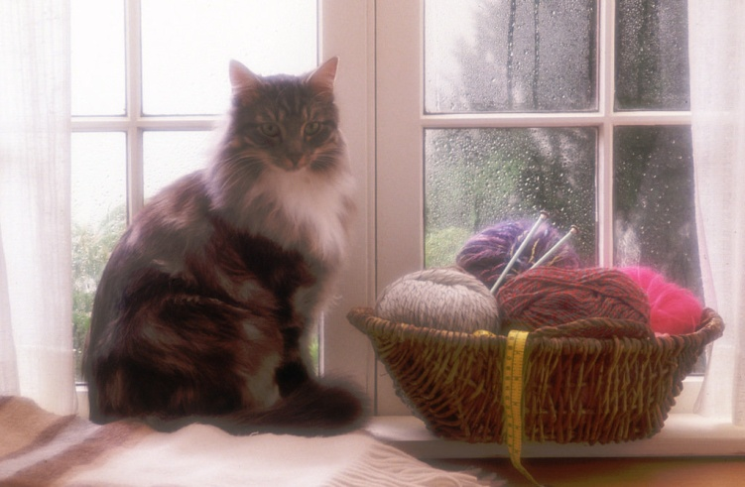

Quote of the day:
“I am still determined to be cheerful and happy, in whatever situation I may be; for I have also learned from experience that the greater part of our happiness or misery depends upon our dispositions, and not upon our circumstances.” — Martha Washington
Reflection:
A 92-year-old woman named Maurine Jones seems to have discovered one of the secrets to happiness. Here's her story:
After Maurine's husband of 70 years passed away, she moved into a nursing home. After waiting patiently in the nursing home lobby for hours, Maurine was shown to her room. As she maneuvered her walker to the elevator, she was provided a visual description of her tiny room, including the eyelet curtains that had been hung on her window." Without hesitation she stated with the enthusiasm of an eight-year-old having just been presented with a new puppy, "I love it." The attended replied, "Mrs. Jones, you haven't seen the room yet." "That doesn't have anything to do with it!" she replied. "Happiness is something you decide on ahead of time. Whether I like my room or not doesn't depend on how the furniture is arranged--it's how I arrange my mind. I already decided to love it.”
Attitude is everything, and as Maurine demonstrates, our attitudes don't have to be dictated by circumstances. We each have a choice. May your daily choices bring you great happiness and fulfillment this year. May you say with Maurine “I love it” before you even see what the year brings forth.
**

- Meaningful Life
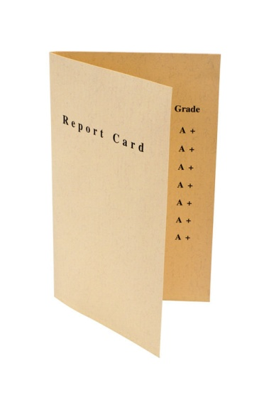

Quote of the day:
“On life's report card, attitude counts, enthusiasm counts, a commitment to lifelong learning counts, hard work counts, and helping others counts. If you go all-out, you will feel the difference in the quality of your life.” — Steve Lodle
Reflection:
In the '60s the Beatles sang a hit song called "Can't Buy Me Love." They could just as well have sung, "Money can't buy me truth or happiness or peace of mind." You can hardly blame people considering that nearly everywhere they turn some new product or personality vies for their attention with the same hollow promise: "This is it—the key to happiness at last!" And you can't blame the hawkers either, they need to make a living too.
Nevertheless, there is a little voice inside each of us that keeps telling us there has to be more to life. The things of this world can bring momentary pleasure and comfort, but they can never truly satisfy our inner self. While some people get caught up in the pursuit of momentary happiness and pay little or no attention to that little inner voice, others can't ignore it.
Which voice are you listening to, and which will you act on?
**

- Choices

Quote of the day:
“Your past is not your potential. In any hour you can choose to liberate the future.” — Marilyn Ferguson
Reflection:
Life is all about the little decisions you make every day. Decisions of the past have had their effect, but every new day can be a new start. No matter what has happened up until now, you have a chance to make the right decisions today.
Don't waste time reliving the pain of past mistakes and wrong decisions. That only saps your power to do what you can do today. You can't change the past, but the future is what you make it, starting right now, so take full advantage of the present.
Learn from past mistakes and put them behind you today. Forgive those who have wronged you and ask forgiveness from those you have wronged. That probably won't be easy, but don't put it off. Do it today! Dream new dreams today. Set new goals today. Spend your time on things that truly count today. Love your family today. Be a friend today. Do things better, starting today.
**

- A Grain of Sand

Quote of the day:
“It is the wounded oyster that mends its shell with pearl.” — Ralph Waldo Emerson.
Reflection:
Did you know that when an oyster gets a grain of sand in its shell and can’t get it out it secretes a substance that covers it. Year after year the oyster adds more layers to cover its irritation, until at last it has produced a beautiful, lustrous pearl of great value.
Our problems are like that grain of sand. They bother us, and sometimes we wonder why we have to suffer the irritation and inconvenience they can be. Like the oyster we can turn our wounds and adversities into precious pearls of inner strength that will become an inspiration to others. For years pearls have been used as a metaphor for something very rare, fine, admirable, and valuable—and so they are, but it takes a little “sand” to make them so.
What wounds in your life do you need to mend and turn into pearls?
**

- Bend With The Wind

Quote of the day:
“Notice that the stiffest tree is most easily cracked, while the bamboo or willow survives by bending with the wind.” — Bruce Lee
Reflection:
That quote reminds me of an experience I had. One day while sitting in the car waiting for someone I was watching a palm tree bend and sway and flow with the wind. It was like a beautiful dance. The more the wind blew the wilder the dance was. It was inspiring to watch the palm so gracefully flow with the change of the wind. The same day as we drove home we passed by a sturdy tree which had been blown over by the same wind sending it crashing into a wall and destroying it.
It got me thinking that life is a lot like those two trees. We can choose either to bend and flow with the winds of adversity, creating an exciting wild dance which brings inspiration to all those watching, or we can be stiff and ridged and be blown over possibly causing damage to those around us.
The choice is ours. I prefer to dance with the winds of adversity. What will you choose?
**
25. The Beekeeper

Quote of the day:
“When everything seems to be going against you, remember that the airplane takes off against the wind, not with it.” — Henry Ford
Reflection:
I buy delicious wild raw honey in the area where I live. A beekeeper told me a story once that reminds me of this quote.
When the little bee is in the first stage, it is put into a hexagonal cell, and enough honey is stored there for its use until it reaches maturity. The honey is sealed with a capsule of wax, and when the tiny bee has fed itself on the honey and exhausted the supply, the time has come for it to emerge out into the open. But, oh, the wrestle, the tussle, the straining to get through that wax! It is the strait gate for the bee, so strait that in the agony of exit the bee rubs off the membrane that hid its wings, and on the other side is able to fly!
I don't know about you but I sometimes feel like that bee when I am struggling to break free from my confinement of troubles and be free to fly. Although it is a struggle for the bee the great effort is necessary in order to rub off the membrane of its wings, otherwise he would not be able to fly. So when I find myself under pressure I remind myself that it is a necessary part of life, and without it I won't be able to fly. Adversity is the thing that makes it possible for me to fly just as the wind against the airplane makes it possible to take off.

