Motivational Minutes on Character from 2011-2014
(Also see Adversity, Forgiveness, Giving and Self-worth files.)

- Character
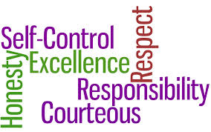

Quote of the day:
“Be more concerned with your character than your reputation, because your character is what you really are, while your reputation is merely what others think you are.” — John Wooden
Reflection:
Good character is that special quality that makes men and women who have it appear larger than life. Character is more than just what a person says—it is what a person is. Words like honorable, honest, trustworthy, dutiful, integrity and fidelity, describe the person with good character in any field of endeavor. Some people think integrity and character are the same, yet they are not. Character moves beyond integrity, while integrity is “not doing wrong,” character moves beyond that into taking action and “doing right”. In other words, integrity refuses to do wrong, but good character is more demanding, expecting people to have the courage to do right. Think about this, and see if you have the courage to go from integrity to character.
**

- Integrity

Quote of the day:
"Like courage, integrity is also a virtue. It, too, is a habit of character, something that exists over a long period of time. People don't have integrity sporadically, showing lots of integrity on Thursdays. Indeed, the whole idea of integrity is that it lasts. Integrity is opposed to the "here today, gone tomorrow" attitude. It is that strength of character that allows us to be true to ourselves, and in particular true to our most basic commitments." — Lawrence M. Hinman
Reflection
Honesty, integrity, and ethics are crucial to building a positive character. So what is integrity? Integrity is being faithful to keep your promises and fulfill your obligations and commitments. It means that when you say you will do something, you do it, without fail. Integrity means that your word is your bond, and that others can count on you. Integrity does not make excuses as to why it couldn't be done; instead, it finds a way that it can, come what may, hell or high water. Integrity is doing the right thing, no matter what it costs you. Integrity does not depend on the situation or the circumstances; it does what it should, what is right, no matter what the situation or the circumstances. Your ethical standards aren't flexible or changeable; they're fixed. Integrity is being honest, not lying or deceiving or knowingly misleading others. Integrity is sincere, truthful, trustworthy, and reliable.
Integrity and honesty are traits respected the world over, just as deceitfulness and lying are universally condemned. Practice being a truth-speaker, a person of integrity, a person who can be counted on to deal with others, squarely, fairly, and with the complete truth as often as you can. Study the list above and compare your actions to it. If you feel you need to improve in some areas it is always better to start sooner than later. Then as Mr. Hinman says, continue to practice to strengthen your character.
**

- I Promise

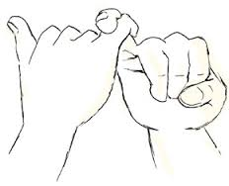
Quote of the day:
“Make sure that your actions and behaviors live up to and reflect the words and ideas, promises and commitments that come out of your mouth.” — Steve Farber
Reflection:
I don’t know about you, but I cringe whenever I hear someone say ‘I promise’. There are so many circumstances that might come up to derail your promise and then in effect, your word is broken.
I have found actions speak louder than words. People don’t judge us on what we say, but on what we do. It is far better to say you will do something if you can, then do it, than to promise something and not be able to complete the task.
Next time you are tempted to make a promise take a moment to think if you can really fulfill that promise or are you just appeasing the situation. Remember the words of Arthur Warwick, “I had rather do and not promise than promise and not do.”
**

- Doing Your Best

Quote of the day:
“The roots of true achievement lie in the will to become the best that you can become.” — Harold Taylor
Reflection:
It is a great feeling when we go all out to be the best we can be at what we are doing. It doesn’t matter if our job at the moment is the CEO of a big company, or mopping the floor. If you always try for becoming the best that you can become at whatever you are doing, you can be certain that you will find success and progress in your life.
Never settle for giving less than you can in anything you do. Doing something better might mean working a little harder, but you’ll go to bed at night with the satisfaction of knowing that the effort you made to accomplish the task was well worth the effort. Think about your life, ask yourself if you are giving your best shot to being the best you can become.
**

- Don’t Go Around Problems

Quote of the day:
“Most people spend more time and energy going around problems than in trying to solve them.” — Henry Ford
Reflection:
The story is told of a king who placed a heavy stone in the middle of the road and then hid and watched to see who would remove it. Men of various social standing came and worked their way round it, some loudly blaming the king for not keeping the highways clear, and others with varied complaints, but all dodging the duty of moving the stone out of the way.
At last a poor peasant on his way to town with his flock of sheep passed by, and contemplating the stone, laid down his load and rolled it into the ditch. Then, turning round, he spied a purse that had lain right under the stone. He opened it and found it full of gold pieces with a note from the king saying it was for the one who would remove the stone.
The moral of the story—it’s far better to go the extra mile to make a difference, to make the effort to solve the problem and remove an obstacle that stands in your way than to go around it. Who knows you may just find a buried treasure.
**

- Someone May Be Watching

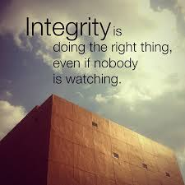
Quote of the day:
“Real integrity is doing the right thing, knowing that nobody's going to know whether you did it or not.” — Oprah Winfrey
Reflection:
I agree with Oprah and want to add that sometimes when we think no one is watching , someone is, which can make a difference in your life for good or bad depending on what choices you have made. Here is one such illustration.
William McKinley, the 25th president of the United States (1897-1901), once had to choose between two equally qualified men for a key job. He was puzzled over the choice until he remembered an incident which occurred long-ago before. On a rainy night, McKinley had boarded a crowded streetcar. One of the men he was now considering had also been on the same streetcar, though he didn't see McKinley. Then an old woman carrying a basket of laundry struggled into the car, looking in vain for a seat. The job candidate pretended not to see her and kept his seat. McKinley gave up his seat to help her. Remembering the episode, which he called "this little omission of kindness," McKinley decided against the man on the streetcar. Our decisions--even the small, fleeting ones--tell a lot about us.
Adapted from Presidential Anecdotes, PAUL F. BOLLER, JR., Penguin Books.
That little omission of kindness cost that man a promotion. Let us learn a lesson from this and always choose to do right even when we think no one is watching as you never can tell if they are or not. As Griffin Bell says, “Always err on the side of doing right. You and only you are responsible for your ethics.”
**

- Sincere
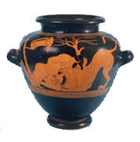
Quote of the day:
“Only those who have learned the power of sincere and selfless contribution experience life's deepest joy: true fulfillment.” — Anthony Robbins
Reflection:
I learned some interesting information about the word sincere the other day. It turns out that “sincere” comes from a Latin word which means "without wax." In ancient times, fine, expensive porcelain pottery often developed tiny cracks when it was fired in the kiln. Dishonest merchants would smear pearly white wax over the cracks until they disappeared, they would then claim the pottery was unblemished. But when the pottery was held up to the sun, the light would reveal the cracks filled in with wax. So honest merchants marked their porcelain with the words “sine cera” —without wax.
This got me thinking what is meant by genuine sincerity: No hidden cracks, no ulterior motives, no hidden agendas and the above quote took on a new meaning.
When was the last time you found deep joy and fulfillment by doing something for someone else with no hidden agendas or ulterior motives?
**

- Doing Right Or Wrong

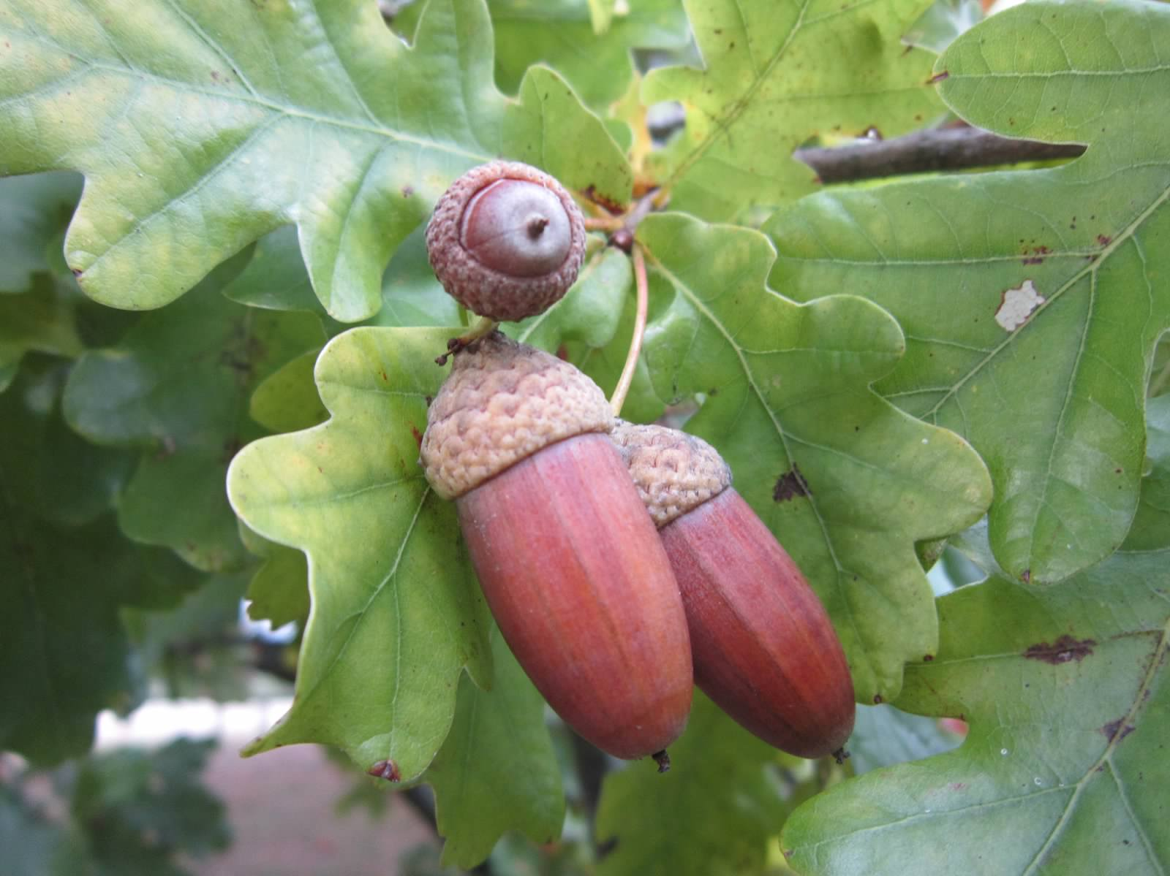

Quote of the day:
“Just as an oak tree grows from a little acorn so does great character grow from a great many decisions that may at the time seem very minor.” — Ben M. Herbster
Reflection:
Every day, we are faced with hundreds, maybe even thousands, of decisions about doing either the right or the wrong thing. If you do a certain thing, you will get there before anybody else does. If you lie just a little bit, you can cut this corner. If you cheat just a little bit, you can pass this test. There always will be those temptations to take the shortcut, the easy path, instead of doing what is right and what is honorable.
The next time you are faced with a seeming little decision, but one that will determine what kind of character you have, think about this quote.
**

- Wanting To Do Right

Quote of the day:
“The measure of a man's real character is what he would do if he knew he never would be found out.” — Thomas Babington Macaulay
Reflection:
This quote reminds me of a story about a pastor who was boarding a bus.
The pastor paid his fare to the driver, who gave him too much change, so he promptly went back to the driver and said, "Excuse me, sir. You gave me back too much change."
The driver replied, "No, Pastor, I didn't give you too much change. I was at your church yesterday. You preached on honesty, so I just thought I would put you to the test."
There are a lot of tests in life to see if we have integrity and character. Integrity comes in where the fear of being caught leaves off. Fear is a fine deterrent, and it has its place. But a far better motive is wanting to do what is right.
**

- Doing the Right Thing
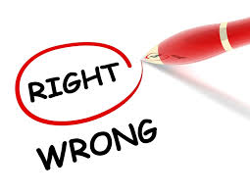
Quote of the day:
"The truth of the matter is that you always know the right thing to do. The hard part is doing it." — Norman Schwarzkopf
Reflection:
In any given situation, when you allow the voice of the higher wisdom that resides within to guide you, it is not past finding out what the right thing to do is. However, the more difficult choice remains, and that is whether or not you will take action and do it.
Do you have specific fears or worries that are holding you back from making the correct choice? Take a moment to acknowledge your fears then assess how you can take positive steps to hit them head-on and move past them. This single step takes courage, but as you determine to do it, you will find strength to carry on.
**

- Peace In Your Heart

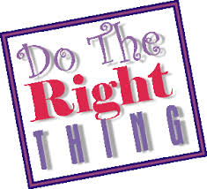

Quote of the day:
"There are no easy answers but there are simple answers. We must have the courage to do what we know is morally right." — Ronald Reagan
Reflection:
It's easy to go with the flow and do what others want you to do. However, it takes character to make a stand for what you believe is the right thing to do.
It is not easy being known as someone with good, strong moral values who isn't afraid to stand up for what they believe, but in the long run it will make you a better person, plus you’ll be able to sleep better at night.
Write down one situation you're facing where the right decision is apparent, but hard to do. Then, settle in your heart that is what you will do in spite of the consequences. In the long run, the peace in your heart will outweigh any negative out comes.
**

- Mistakes Give You Depth Of Character
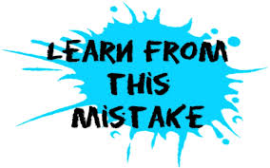
Quote of the day:
“As I look back at my life, it is easy to see that the times when my wisdom and understanding grew to new levels; those times when I approached becoming the person I long to be; it was always the times that followed negative circumstances.” — Vic Johnson
Reflection:
Sometimes you feel that if only you could turn back time, retrace your steps, and undo mistakes, things would be so much better. If only you could apply what you know now to past situations, you could reverse painful experiences and possibly change the course of your life.
But think about it, the truth is, those situations—mistakes included—are probably what have made you the person you are today. It is likely that the most painful and trying circumstances were the ones that gave you the most strength and maturity. It is through your mistakes that you often learn the most valuable lessons. Mistakes help you to be more humble, and therefore, more loving, and that makes you more useful and easier for others to live with.
If you were able to travel back in time and change some of your decisions and actions, you would very likely be unhappy with the results. You wouldn't have nearly as much depth of character as you do today. So, instead of regretting the past, be thankful for what it has taught you.
**

- Who You Are Becoming

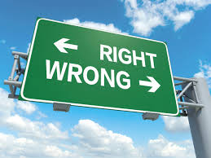

Quote of the day:
"What you get by reaching your destination is not nearly as important as what you will become by reaching your destination." — Zig Ziglar
Reflection:
Sometimes we become so focused on reaching our goals, or our life purpose, that we don't give a second thought to how we get there. Yet it is important that you pay attention to the little things you do along the way of achieving your objectives, because these little things make up who you are and who you will become.
The end result is not always as important as the journey and the things you learn along the way, and who you become because of it. It is far more important to build good character while achieving your goals than it is to obtain your goals by any means.
Consider some goals you've already accomplished in your life, now reflect on two things you learned as you worked to achieve them and how it shaped you. Now think about the aspirations you are currently striving for. Are there any character weaknesses you need to change?
**

- You Are In the Crafting Process
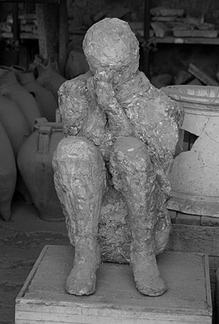
Quote of the day:
“Character cannot be developed in ease and quiet. Only through experience of trial and suffering can the soul be strengthened, ambition inspired, and success achieved.” — Helen Keller
Reflection:
When life is just plain hard, remember you are in the crafting process.
Life is like a sculptor and you are like the marble. A block of marble may not look like much or be worth much in its rough form, but it has potential. It takes quite a bit of hammering and chiseling to create a thing of beauty from that piece of rock. The chisel is sharp, the blows are hard, and it's not an altogether pleasant process for the marble, but the finished product is worth it.
No one benefits much from easy times. Such times are enjoyable and everyone wishes they could last forever, but they don't contribute much to one's character. So when troubles come into your life, don't be discouraged or resentful. Instead, know that there is a plan and a reason that is crafting you into a thing of beauty.
It is hard to imagine this when you are a work in progress. But if you can endure the crafting process, when the sculptor's work is done, you will behold and be pleased with the result—a masterpiece, the thing of beauty that is your life.
**
- Go Beyond the Call of Duty

Quote of the day:
“My philosophy is that not only are you responsible for your life, but doing the best at this moment puts you in the best place for the next moment.” — Oprah Winfrey
Reflection:
If you want to find your life's purpose and reach your full potential, then it is important that you put your all into each task you are working to accomplish.
Review the duties you have to carry out for the day. Write down one extra thing you could have done to make it go better. Then the next opportunity you have, put that idea into practice. Make sure each task gets done in the best way possible.
Find a way to go above and beyond the call of duty for each job you have and you will soon be on your way to finding your full potential.
**

- Habits Dictate Your Life

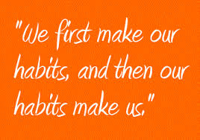

Quote of the day:
"Habits are safer than rules; you don't have to watch them. And you don't have to keep them, either. They keep you." — Frank Crane
Reflection:
Whether you develop good or bad habits, either way, they will dictate your life. Therefore, it stands to reason the best thing would be to develop good habits for maximum assurance that your life will turn out grand.
Why not decide on what habits you want to develop and thus come up with a "plan" for the way you carry out your days, and in turn, the rest of your life.
First, establish what are the most important things you want to achieve in your life. Next, write down three good habits in each area you can establish that will help you achieve your ultimate goals and stay true to your values.
**

- Good Manners Pay
Quote of the day:
“A life lived with integrity—even if it lacks the trappings of fame and fortune is a shining star in whose light others may follow in the years to come.” — Denis Waitley
Reflection:
This short story adapted from McGuffey's Third Reader is a good reminder that manners pay.
Once when there was a famine, a kind, baker sent for twenty of the poorest children in the town, and said, "In this basket there is a loaf for each of you.” The hungry children gathered eagerly about the basket, and most quarreled over the bread, each wanting the largest loaf. At last they went away without even thanking the good gentleman.
Gretchen, a poorly dressed little girl, did not quarrel or struggle with the rest, but remained standing quietly to the side. When the ill-behaved children had left, she took the smallest loaf, which alone was left in the basket, kissed the gentleman's hand, and went home.
The next day the children were as ill-behaved as before, and poor, timid Gretchen received a loaf scarcely half the size of the one the day before. When her mother cut the loaf open, many pieces of silver fell out. Her mother was very much alarmed, and said, "Take the money back to the good gentleman at once, for it must have gotten into the dough by accident. Be quick, Gretchen!
When the little girl gave the man her mother's message, he said, "No, my child, it was no mistake. I had the silver pieces put into the smallest loaf to reward you. Always be as kind, and thankful as you now are. Go home now, and tell your mother that the money is your own."
If we give to others, yield to them to make them happy, or put their wishes above our own, we can sometimes feel like we're losing out. But we're not really. Your character and unselfishness will be rewarded.
**

- Bad Habits

Quote of the day:
"In any family, measles are less contagious than bad habits." — Mignon McLaughlin
Reflection:
How true! Whether you're talking about bad language, bad thinking patterns, bad personal hygiene habits, or any other bad habit—bad habits are easier to pick up than good ones.
Forming good habits can be difficult. It’s human nature to gravitate to the negative, and in today’s world we are constantly exposed to bad habits, so much so, they often come like second nature. It’s a challenge to fight against these negative influences so as not to be a contagious carrier of bad habits. It requires restraint and consistent practice, but it is well worth the effort.
Here is an exercise you can try to help get you started on creating good habits: Write down one bad habit that you do in the presence of others. Next, write down three steps you can take that will prevent you from passing that habit on to others.
**

- Kindness Pays

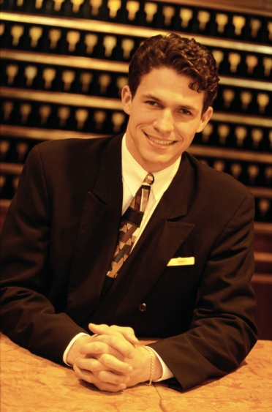

Quote of the day:
“Nobody who ever gave his best regretted it.” — George Halas
Reflection:
You never know when an opportunity will appear. I have found that giving your best in every situation is a great way to be prepared for that opportunity. The following story so aptly portrays this.
One night two tired elderly people arrived at a third class hotel. They approached the night clerk and the husband pleadingly said, “My wife and I have been all over the city looking for a place to stay. The hotels at which we usually stay are all full. We're dead tired and it's after midnight. The clerk answered, "I don't have a single room except my own. I work at night and sleep in the daytime. It's not as nice as the other rooms, but it's clean, and I'll be happy for you to be my guests for tonight." The next morning at the breakfast table, the night clerk recognized the two people, and said he hoped they had had a good night's sleep. They thanked him most sincerely. Then the husband astounded the clerk with this statement, "You are too fine a hotel man to stay in a hotel like this. How would you like for me to build a big, beautiful, luxurious hotel in New York city and make you general manager?" The clerk finally stammered, "It sounds wonderful." His guest then introduced himself. "I'm John Jacob Astor."
So, the Waldorf Astoria Hotel was built, and the night clerk became the manager and in the years to follow was known as the best hotel man in the world all because he was doing his best and so was prepared for the opportunity that appeared.
**
- Own Up To Your Mistakes

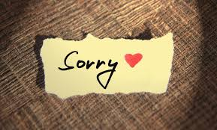

Quote of the day:
"How few there are who have courage enough to own their faults, or resolution enough to mend them." — Benjamin Franklin
Reflection:
This quote is a hard one to live up to. It is so much easier to let a mistake slide than to own up to it, and even harder to admit a character default. It takes a lot of courage to admit when one is wrong and want to change rather than justify oneself. It takes even more courage to take action to fix the wrongdoing.
Think about it, if you do something wrong, isn't it easier to go on without saying or doing anything about it and act as if it never happened than it is to actually admit it and try to fix it?
Here’s an exercise to get you going in the right direction. If you have done something wrong recently, try not to let too much time pass, but admit you are wrong soon after, take the time to communicate with the person you wronged and apologize for the wrong doing as well as try to fix it if at all possible.
**

- What Do You Want To Be Remembered For
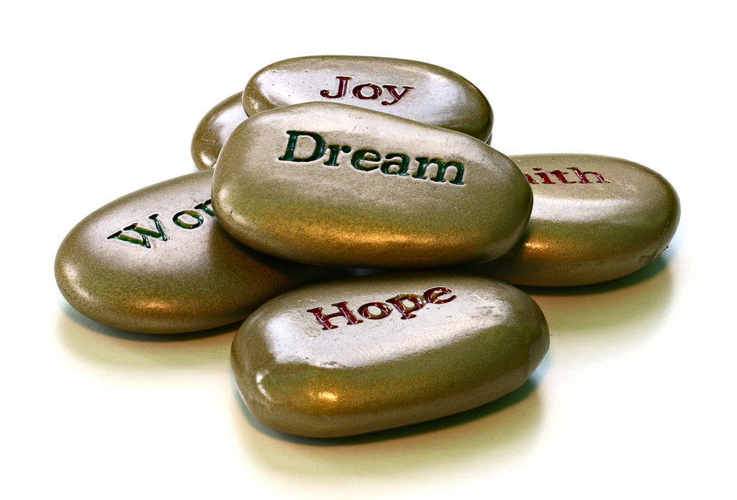
Quote of the day:
"Don't just dream about grandiose acts of doing good. Every day do small ones that add up over time to positive patterns." — Marian Wright Edelman
Reflection:
At the end of your life, what do you want to be remembered for? Periodically asking yourself this question helps you stay focused on the end goal and can aid you in making the right daily decisions that will lead you there. Each day can be a new opportunity to make incremental steps of progress which will lead you towards your desired aspirations.
Think about what you can do today to put your energy towards positive actions that will help bring you closer to your dreams. Your lifelong patterns or habits are built on daily choices you make.
**

