Motivational Minutes on Forgiveness from 2011-2014

- Forgiveness Heals
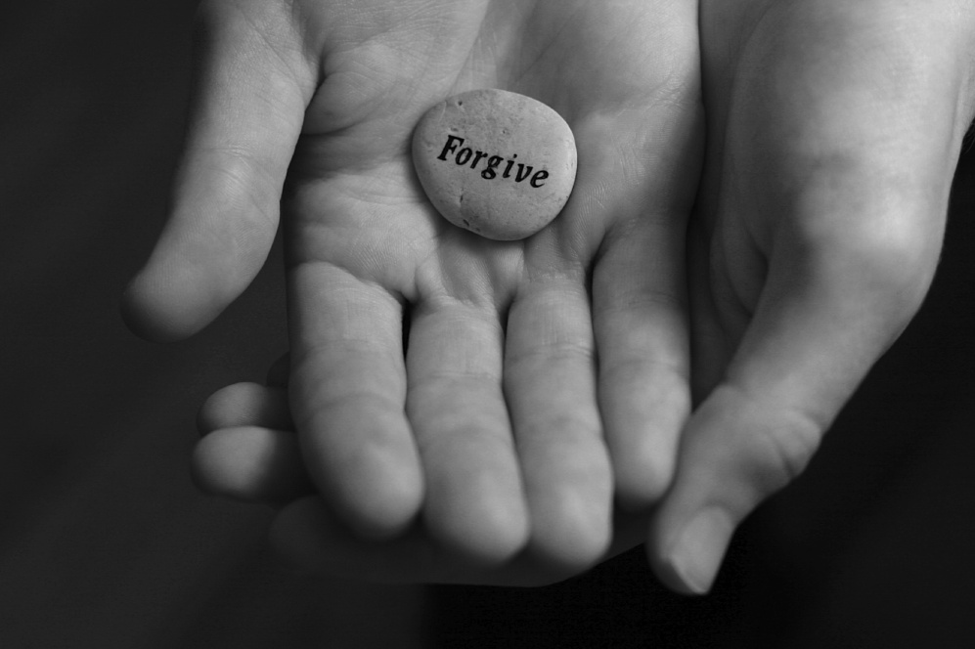
Quote of the day:
“The one attitude which gives rise to hope amidst misunderstanding and ill-will is a forgiving spirit. Where forgiveness becomes the atmosphere, there hope and healing are possible.” — C. Neil Strait
Reflection:
There may be things in your life that you're angry about, things that people have done to you which were wrong. There may have been hurt and lack of care, or hardship that you have experienced, no matter what the cause of deep hurt in your life may be, forgiveness is the road to healing. Forgiving someone doesn't mean that you are saying another was not to blame. It's not exonerating them from their actions if they were in fact wrong. But forgiveness is letting go of weights that try to hold you down in a terrible state of resentment and discontent. Forgiving others is an important step in your own healing, and without it you may not heal. The bottom line is that when you forgive someone who has wronged you, you are then able to get over the hurt and to move on into the future without the events of your past affecting you negatively. The act of forgiveness is really to the benefit of the one who forgives.
I know these are not easy words to accept if you happen to be in the mist of pain, but just as a doctor sometimes has to hurt the patient momentarily by giving them a shot, so these words of truth may also hurt, but they are never-the-less, for your own good. We all need to forgive from time to time. There is no shame in it, but there is great relief and healing when you truly let go and forgive from your heart.
If you are struggling with the thought of to forgive or not to forgive, think about these words carefully.
**
- Don’t Destroy The Bridge

Quote of the day:
“He who cannot forgive others destroys the bridge over which he himself must pass.” — George Herbert
Reflection:
Forgiveness. Often this one word is painful to hear and difficult to imagine.
It’s possible you have no desire to give someone the gift of your forgiveness, perhaps you feel that they are undeserving, or you are not motivated to forgive because you have been denied that gift yourself. If this is the case with you, remember, forgiveness is mercy, not justice. Forgiveness is never deserved, but when you give it to another, even when everything inside of you is screaming that you shouldn’t forgive. Forgiveness is choosing to leave things in God’s hands, and to accept that all people do wrong—including you.
Forgiveness is so important to our personal growth and has stunted people’s progress. No matter how hard it is, do yourself a favor and stop and think about it. Is there anyone you need to forgive? If so work toward doing so.
**

- Forgiveness The Economy of The Heart

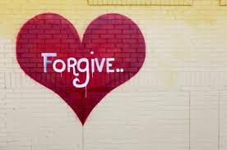

Quote of the day:
“Forgiveness is the economy of the heart...Forgiveness saves the expense of anger, the cost of hatred, the waste of spirits.” — Hannah More
Reflection:
The power to forgive is one of the greatest powers given to man. It is part of the nature and essence of God, and when you exercise it you assume godlike stature. You have the power to forgive and thus rise above the pettiness of mortals.
Choosing to forgive another is one of the hardest things most people ever do, especially to forgive something that is undeserved. It is difficult, because to forgive is not part of human nature. Human nature cries out for revenge and retribution. But why get stuck in human nature?
Whether that person who wronged you deserves forgiveness or not is not the core issue. The issue is you doing the right thing. No one really deserves forgiveness. If others have done wrong, they deserve justice. But forgiveness is greater than justice. Justice is human; forgiveness is divine.
Take time to consider if there is someone you need to forgive.
**

- Avoid The Corrosive Effect

Quote of the day:
“When someone wrongs us, we must learn to forgive and ask God to let His love fill our heart. It’s the only way to keep from being hurt by bitterness, wrath, and anger.” — Henry G. Bosch
Reflection:
You may ask yourself, “Why should I forgive others who have done things that hurt me? Wouldn’t that absolve them from guilt? Why should I let them off the hook like that?”
First, it helps you avoid the corrosive effect that an unforgiving attitude invariably has on those who hold on to it. If you refuse to forgive those who have wronged you, your mind and spirit become fertile ground for all sorts of negative and destructive attitudes, such as hatred, bitterness, anger, and a desire for revenge. You will never be happy in that state of mind. Forgiveness is the antidote, an agent of positive change that can, over time, reverse the damage that was done.
Second, even though those feelings may seem justifiable considering the circumstances, if you entertain them, or worse yet, act on them, you become guilty along with the one who wronged you. Two wrongs never make a right.
Forgiveness doesn’t change the past, but it does make for a much brighter future.
**

- Anger Makes You Smaller

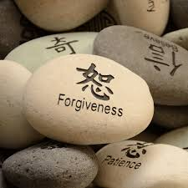

Quote of the day:
“Anger makes you smaller, while forgiveness forces you to grow beyond what you were.” — Cherie Carter-Scott
Reflection:
It’s sometimes hard to forgive when someone’s actions have made things difficult for you on the long term.
I have heard people say, “Some things just aren’t fair. There are people who have done things that benefited themselves at my expense. Now they are in a good situation and I am struggling.”
Sadly, this may very well be true. There are situations where it looks like everything is going great for the one who has wronged you, and things look grim for you, even though you have tried to do the right thing. However, even if you are the one who has suffered, if you will look beyond the “wrong” done to you and you forgive then you will “grow beyond what you were.” You come out better for it in the end.
**

- Don’t Swallow That Poison

Quote of the day:
“Resentment is the poison you swallow hoping the other person will die.” — Carrie Fisher
Reflection:
Making a conscious choice to forgive and forget makes you a wiser and happier person in the long run. Is the wrong that has been done to you worth a lifetime of being poisoned?
Are you holding on to resentment? Do you feel the negative poison of bitterness fomenting in your heart? Sit still in a quiet, peaceful place. Get in a relaxed position, either sitting or laying down, and take a long, deep breath in the following manner: Place your hand upon your stomach. Slowly inhale through your nose, drawing the air deep into your belly, not your chest. As you inhale, feel your stomach expand. Then slowly exhale through pursed lips in order to regulate the release of air. Repeat this process three or four times, after each breath say aloud, “I forgive you ____” (fill in the blank). Feel the anger and resentment moving out of you, making the world a much brighter place for your future.
**

- End the Cycle

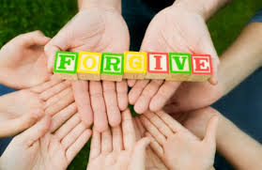

Quote of the day:
“Without forgiveness life is governed by an endless cycle of resentment and retaliation.” — Roberto Assagioli
Reflection:
If you have deep hurt, and at one time or another in our lives we all do, today is a good day to let go of it. Today is a good day to forgive.
Today is also a good day to ask for forgiveness. No one wants others to be thinking back on things they’ve done or said that have hurt them. We all want to be forgiven for the wrong we’ve done. Just think, if you want forgiveness for any wrong you’ve done, then it stands to reason that others who may have done something wrong towards you want the same thing. Others want forgiveness, just as you do.
Take the first step to end the cycle—forgive today.
**

- Forgiveness Benefits You

Quote of the day:
“Forgiveness is almost a selfish act because of its immense benefits to the one who forgives.” — Lawana Blackwell
Reflection:
I have a friend who recently shared a lesson on forgiveness with me that illustrates this quote.
My friend attended a seven day retreat. One day he said something to another attendee who appeared to be very angry and upset at his comment. My friend felt bad to think he could have offended this other person. He couldn't get out of his mind how he had upset this person and he continued to punish himself feeling regret and wishing he wouldn't have done what he did. He was miserable and not enjoying the retreat experience from this time on.
Finally he thought, "This is crazy, I am in this beautiful place and I am torturing myself with regret because of one comment when I should be enjoying this experience.” So, he came up with a plan.
He closed his eyes, visualized the person he had offended, and sent them his deepest apologies; he wished them well and sent them positive, loving energy with all his heart. He also sent himself positive energy and forgave himself. Immediately, he felt different—he went from regret and sadness to being full of love and energy. It worked so well that he reviewed other situations he needed to forgive. He felt better each time he went through this process.
He knew intellectually that forgiving himself and others was important. He knew holding resentment was detrimental to making money, having a great marriage and everything else in his life. The truth is, he had not forgiven others and he had not forgiven himself despite the fact that he thought he had. When he truly wished them well and wished them success and love, even the really bad ones, it changed everything.
**
- Forgiveness Exercise

Quote of the day:
“Forgiveness is the way to release fear and gain peace of mind." — Gerald Jampolsky
Reflection:
I know that forgiveness is hard to do and even if we want to forgive we sometimes don’t even know how. I found the below exercise to be helpful. Try it yourself and see if it doesn’t help you to release your desire to hold on to those things you should be letting go of.
Take a potato and write on it the name of a person who has fallen from grace with you. Do this for everyone who has raised your ire and never received your forgiveness. When you've finished, gather all your potatoes together and place them in a sack. Keep this sack next to you at all times: Take it to work. Take it to lunch. Take it everywhere you go. And always have it with you at home. How long would it take for you to grow tired of carrying this burden around? How long would it take your potatoes to sprout into other things, fester and smell? Wouldn't it be nice to be free from the weight, stench, and constant reminder of hurt, disappointment, heartache, and anger? By hanging on to things that are unpleasant, we create more anguish for ourselves. When you forgive someone, you free yourself from an oppressive load of negativity. Forgiveness allows you to create peace in your life.
Adapted from the Afterhours Inspirational Stories Web site.
**

- Hold on Judgment

Quote of the day:
“If we could read the secret history of our enemies we should find in each man's life sorrow and suffering enough to disarm all hostility.” — Henry Wadsworth Longfellow
Reflection:
Regarding forgiveness, consider this: When someone does something that you feel is not right or hurtful, try to recognize that people often act a certain way based on something that is going on in their life that you may be unaware of. Someone may do something that seems to you very selfish, but it isn’t nearly as bad or selfish as you’re assuming. Most likely you don’t know the complete scope of the situation they’re in. You don’t know the thought processes that they’re going through.
I know I’ve sometimes pre-judged a situation. I’ve wondered why someone acted a certain way, or said something that seemed hurtful, and I’ve thought negatively about them only later to find out that they had been quite sick, or something major was going on in their life, or in the lives of their loved ones, and they were really going through tough times. They were experiencing difficulty, and due to that, they weren’t at the top of their game. The actions that looked selfish to me, may have been a consequence of their difficult situation.
It’s important to have compassion, and to understand that each person is like a universe in themselves, we don’t always know what’s going on in someone else’s universe. So it’s wise to not be judgmental, but forgiving.
**

- Grudges

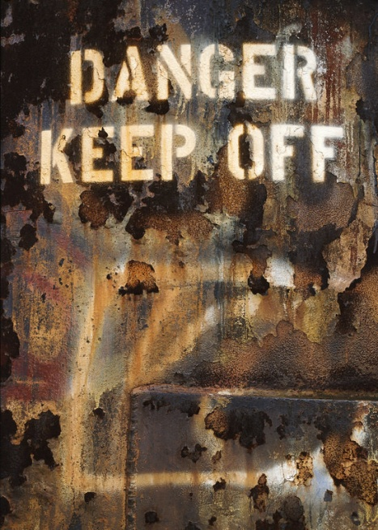

Quote of the day:
"Hanging onto resentment is letting someone you despise live rent-free in your head." — Ann Landers
Reflection:
When we continue to hold grudges against people, we are allowing them to control us. This is because when we are mad at someone for something he or she did and we don't let it go, we continually replay what happened over and over in our minds. In essence, by continuing to replay the event, you are giving that person control over your thoughts and emotions.
Make the decision today to let go of a grudge you've been holding against someone and see what a difference it makes in your life.
**

- Unresolved Grief

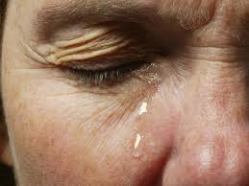

Quote of the day:
“There is no moving beyond loss without some experiences of mourning. To be unable to mourn is to be unable to enter into the great human lifecycle of death and rebirth—to be unable, that is, to live again.” — Eric Lifton
Reflection:
I’ve noticed in my research that unresolved grief can be a great hindrance to our happiness and stunt our growth as well as prevent us from moving on and living a meaningful life. We all have experienced grief in one form or another, to some degree whether it be a loss of a loved one, a job, a pet, health, belongings, a public tragedy, a divorce, or any other sort of loss. It is important no matter what form grief comes into your life that you process it. If you let it build up too much it’s not healthy for you physically, mentally or spiritually.
We all grieve differently but no matter how you grieve you have to allow yourself to do so, to feel the loss and then to release it, be healed and start living again. This may mean a measure of forgiveness both of yourself and/or others as well as other uncomfortable things necessary to recovery. Depending on how much grief you have you may need to receive help from a professional grief counselor either in person or through books. Whatever you decide it is important to not hang on to grief too long so it doesn’t hold you back from completing your journey and mission.
Are there losses in your life that are holding you back that you need to deal with?
**

