Motivational Minutes on Giving from 2011-2014
(Also see Making a Difference and Kindness files.)

- The Pig and the Cow

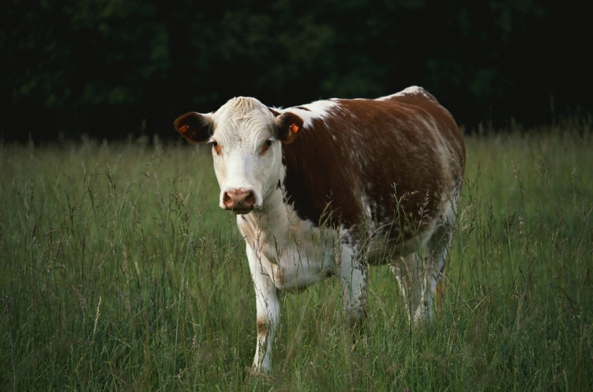

Quote of the day:
“Do all the good you can, by all the means you can.” — John Wesley
Reflection:
This is a cute story, based on truth.
A rich man said to his minister, "Why is it everyone is always criticizing me for being miserly, when everyone knows that I have made provision to leave everything I possess to charity when I die?"
"Well," said the minister, "let me tell you about the pig and the cow. The pig was lamenting to the cow one day about how unpopular he was.
‘'People are always talking about your gentleness and your kindness,' said the pig. 'You give milk and cream. But I give even more. I give bacon and ham—I give bristles and they even pickle my feet! Still no one likes me. I'm just a pig. Why is this?'
The cow thought a minute, and then said: 'Well, maybe it's because I give while I'm still living.'"
Are you giving while you live?
**
- Giving

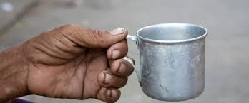

Quote of the day:
“He who does good to another also does good to himself." — Seneca
Reflection:
I’m ashamed to confess that, having lived in third world countries for years, being faced daily with beggars, and the overwhelming feeling that no matter how much I give, it’s never enough, I allowed my heart to harden a bit, being in a financial slump myself at the time.
Thankfully the spirit of giving was able to get through to me, and the next time I saw a beggar sitting on the ground I knelt beside him and apologized that I didn’t have much money to give him, but I said what I had I would give. I wish you could have seen the smile that suddenly lit up his face. He gave me such a warm look of gratitude, it definitely made my day. Each time I take the time to stop for a beggar, to listen to their story of misfortune—seeing their response, so warm and grateful, softens my heart. Clearly, I receive more than I give.
Whenever I start to feel a bit hardened to giving, I think back on this initial lesson learned and I'm moved to keep loving and to have a merciful outlook for those who, for one reason or another, have resorted to begging, knowing that in doing good to another I am also doing good to myself.
**

- A Spirit of True Generosity

Quote of the day:
“You do not have to be rich to be generous. If he has the spirit of true generosity, a pauper can give like a prince.” — Corrine U. Wells
Reflection:
Here is a practical way to apply this quote; something you can use right away in your quest to become more giving:
Be generous toward those with less and not envious of those with more. We tend to look at others who may be wealthier than ourselves and think, "I sure wish I had what he has." That kind of thinking breeds envy and jealousy rather than contentment.
To break this cycle, I would suggest being generous to those who are less fortunate than yourself and this will remind you of how good you really have it.
**

- Corrie ten Boom

Quote of the day:
“The measure of a life, after all, is not its duration, but its donation." — Corrie ten Boom
Reflection:
Corrie ten Boom’s story is a triumphant one. A young Christian woman imprisoned by the Nazi’s in WW II for helping Jew’s to escape. Corrie was put in a concentration camp and endured extreme cruel conditions that would have killed most people, yet in the midst of that great adversity something clicked within her spirit which caused her to shine with brilliant love to pour out comfort and hope to her fellow prisoners. Years later when released, Corrie’s life blossomed even further in a continual ministry of reconciliation and healing post WW II. She gave above and beyond to others during her life on earth, even through the worst circumstances.
Do you spend more time thinking about how you can get more for yourself than you do thinking about what you can do for others? Try taking 10 minutes today and write down five ways in which you can give to help enrich others lives and bring them hope. Remember, your giving needn’t be through giving material things alone, it could be through little acts of love and kindness that go a long way to make someone’s day.
**

- Be Generous
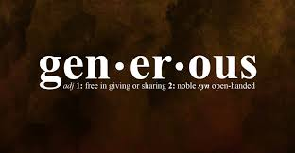

Quote of the day:
“The more you give, the more you live.” — Bob Dedman
Reflection:
If you put your trust in the economies and financial institutions of this world, or if you think worldly financial schemes will bring you happiness, you're doomed to disappointment. That's because those systems are based on selfishness, and selfishness ultimately leads to unhappiness. Even if you achieve financial success by those means, as a few do, you will never be truly happy knowing that your success came at the expense of others.
Share with others, even if you don't have much yourself. Those who give unselfishly will be rewarded with more, but those who hold back from helping others when they could, for fear of not having enough for themselves, cut themselves off from the blessings that are waiting for them if only they would give.
You may not have millions to give away, but you can start somewhere. Every little bit counts!
**

- No One to Divide With

Quote of the day:
“The secret of human happiness is not in self-seeking but in self-forgetting.” — Theodor Reik
Reflection:
This reminds me of the story of an orphan boy named Billy who sold newspapers on the street.
One day a man stopped to buy a paper, and while the man was searching his pocket for a coin, he asked Billy where he lived.
"In a shack down by the river," Billy replied.
"Who lives with you?"
"Only Jim. Jim is crippled and can't do no work. He's my pal."
"Then you'd be better off without Jim, wouldn't you?" the man ventured.
Billy's answer came with some scorn. "No sir, I couldn't spare Jim. I wouldn't have nobody to go home to. An' say, mister, I wouldn't want to live and work with nobody to divide with—would you?"
If you think about it, aren't we all like Billy? Don't we all need a friend—someone to talk to and do things with, who can share our thoughts and feelings and experiences, our ups and our downs, someone we can "divide" with? If you are looking to be happy, maybe take a tip from Billy and the above quote and instead of being self-seeking, start being “self-forgetting”.
**

- Modest Needs Foundation

Quote of the day:
“If you have much, give of your wealth; if you have little, give of your heart.” — Arab Proverb.
Reflection:
I read the following story and was very inspired by it. May it inspire you as well on your quest toward generosity.
Keith Taylor lives below his means in an effort to help others make it to their next payday. He created the Modest Needs Foundation. In addition to his personal contribution of $400 a month, Taylor has received over $10,000 in donations from people who share his vision. So far, the organization has provided assistance to dozens of people across the U.S. Amounts ranging from $17.50 to $1,000 have been used to help families buy groceries, pay medical bills, and cover education expenses. Those who have experienced Keith's generosity believe he is "proof that people are inherently good at a time when it seems to be such a rare and unusual trait." Anyone can apply for help. Taylor says he will continue to help people as long as he has money. He believes "you don't have to be rich to help other people."
Adapted from USA Today.
What a great story. What are you doing to help people in your community?
**

- Fatten Your Purse

Quote of the day:
“The more treasure you give … the more treasure will return to you. But few people perceive this simple truth. Most try to keep as much as they can for themselves and give little away. That’s why their purses refuse to fatten.” — Toyotomi Hideyoshi
Reflection:
I couldn’t agree with Mr. Hideyoshi more, and his words illustrate my number one financial tip. Time and time again when I have found myself in a financial bind, the first thing I did was to look at how much I was giving. It has never failed that when I have given, even when I lacked and it was to my own hurt, I received it back again, and often with interest. It is a law of the Universe that the more you give the more you receive. The Universe never seems to fail to compensate.
So if you would like to “fatten your purse” like Mr. Hideyoshi says, then why not try giving more and see what happens.
**

- You Don’t Have To Be A Millionaire To Give What You Have

Quote of the day:
“No one has ever become poor by giving.” — Anne Frank
Reflection:
This story goes right along with the quote and puts skin on the principle. It’s one of my favorites. I've since tried putting this wise counsel into practice myself—it really works!
It was in the early 1970s and my wife and I were living in London on a shoestring budget, staying at the cheapest boarding house we could find and spending as little money as possible. We had gone for a coffee at our favorite restaurant, and were chatting with our friendly waitress. She had taken the job in order to support her family since her husband had become ill but she didn’t complain. “I wish I had enough money to give these dear people what I know they need. This poor waitress works so hard and I know she’s not making as much as she needs. We don’t have much money ourselves, but we could tip her a pound. You know I always wished I was a millionaire so I could really give like I’d like to.” “You don’t have to be a millionaire to give what you’ve got,” the voice in my heart spoke. “You’ve got five pounds, so why not give them all to her? Give what you’ve got and you will get in return!” And so I did. I began giving double tips to the waitresses, the bus drivers, and to the newspaper venders. From that moment we began to receive the benefits of giving. As we gave sacrificially from what we already had then more came back to us. Soon we began receiving more money for our living expenses.
How much have you given lately? Let the universe give through you and you’ll soon find the universe gives you more. Try it!
**
- Live A Perfect Day

Quote of the day:
“You have not lived a perfect day, even though you have earned your money, unless you have done something for someone who will never be able to repay you.” — Ruth Smeltzer
Reflection:
I thought this quote was very interesting, and I heartily agree! I have found that there is great joy in giving, especially to those who cannot repay you. Besides the joy you receive in giving to those in need, it is also sound financial counsel.
King Solomon, one of the wisest, not to mention the richest man in the world at his time, said, “The generous soul will be made rich, and he who waters will also be watered himself.” In other words, the more generous you are with your riches, the more it will come back to you. Seeing the plight of the poor and coming to their aid is a sure way to reap blessing and benefits.
Why not try giving to someone who cannot repay you today and see what happens.
**

- The Two Twins

Quote of the day:
“It is possible to give away and become richer. It is also possible to hold on too tightly and lose everything.” — Hebrew Proverb
Reflection:
The following legend is something to think about. Although a legend, it conveys a profound truth.
There was once an abbey which had a very generous abbot. No beggar was ever turned away and he gave all he could to the needy. The strange thing was that the more he gave away, the richer the abbey seemed to become.
When the old abbot died, he was replaced by a new one with exactly the opposite nature—he was mean and stingy. One day an elderly man arrived at the monastery saying that he had stayed there years before and was seeking shelter again. The abbot turned the visitor away, saying the abbey could no longer afford its former hospitality.
"Our monastery cannot provide for strangers like it used to when we were wealthy," he said. "No one seems to make gifts towards our work nowadays."
"Ah, well," said the stranger, "I think that is because you banished two brothers from the monastery."
"I don't think we ever did that," said the puzzled abbot.
"Oh, yes," was the reply. "They were twins. One was called 'Give' and the other, 'It shall be given unto you.' You banished 'Give', so his brother decided to go as well."
**

- Giving Makes You Stronger
Quote of the day:
“Giving is the highest expression of potency. In the very act of giving, I experience my strength, my wealth, my power. This experience of heightened vitality and potency fills me with joy. I experience myself as overflowing, spending, alive, hence as joyous. Giving is more joyous than receiving, not because it is a deprivation, but because in the act of giving lies the expression of my aliveness.” — Erich Fromm
Reflection:
I think this is an interesting quote, and to go along with it I read an interesting study about how the benefits of giving make you stronger. The study said:
The Journal of Social Psychological and Personality Science, published research involving two studies which compared moral behavior and physical strength. In the first, participants were given a dollar note and told either to keep it or to donate it to charity. They were then asked to hold up a 5 pound weight for as long as they could. Those who donated to charity could hold the weight up for almost 10 seconds longer on average.
In a second study, participants held a weight while writing fictional stories of themselves either helping another, harming another, or doing something that had no impact on others. As before, those who thought about doing good were significantly stronger than those whose actions did not benefit other people.
Are you showing and/or improving your strength by giving?
**

- The Beggar and the Maharaja

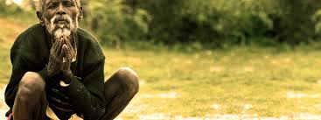

Quote of the day:
“Charity gives itself rich; covetousness hoards itself poor.” — German proverb
Reflection:
There is a well known fable in India of a poor homeless beggar who lived in a State ruled by a Maharaja.
The beggar set out every morning to beg by the roadside with his beggar's bowl. For merit, passers-by threw grains of rice or copper coins his way. One day he heard that the Maharaja himself would be coming that way. That raised his hopes, as he said to himself, “Surely, the Maharaja will give me nothing less than a gold coin." The following day he took up his usual position by the side of the road, and patiently awaited the Maharaja's coming. Patiently the beggar waited, until almost sunset when he heard the Maharaja coming. Stepping into the road, he approached the Maharaja begging for alms. Instead of giving him anything, the Maharaja extended his hands and asked the beggar to give him something. Extremely disappointed and disgusted at a wealthy ruler begging from a poor beggar, he counted out five grains of rice from his bowl and placed them angrily in the hands of the Maharaja. “Namaste,” said the Maharaja, and continued his journey.
Filled with sadness, the beggar returned home and began to clean the rice he had received that day. A small glittering object attracted his attention. Picking it up, he saw that it was a grain of gold. Laying it carefully to one side, he went on winnowing until he found another glittering golden grain, then another—a fourth, then a fifth golden grain was found, but no matter how long he searched after that, there were no other golden grains.
Then the truth dawned on him. Five grains of rice given to the Maharaja had brought him in return five grains of gold. “What a fool I was!” he exclaimed regretfully, “If I'd known I would have given him all of it.”
I have experienced so many times, that the more I give the more I receive and the more I hold back the less I receive. Let us take a lesson from the beggar not to hoard ourselves poor but to give ourselves rich by giving, expecting nothing in return, and you will experience riches of mind and spirit, and often materially, too.
**

- Celebrate Christmas All Year

Quote of the day:
“I will honor Christmas in my heart, and try to keep it all year.” — Charles Dickens
Reflection:
A Christmas Carol, written by Charles Dickens in 1843, has been retold in numerous versions and forms. It is a timeless story and is much more than an account of a mean, miserable old man—Ebenezer Scrooge—who changes his ways after a Christmas Eve visitation by three spirits. It is a reminder that it is only when we give to others that we truly celebrate the spirit of Christmas.
Giving may be material, like a beautifully wrapped present or a monetary gift to someone in need, but true giving is more than that; it extends to sharing ourselves.
Why not make your celebration of Christmas extra special this year by not only giving at Christmas, but by giving all year long? You may even want to start by giving to one of the projects on the Radical Giving site. You could even consider giving a gift to the needy in the other person's name.
**

- Caring For Our fellow Humans

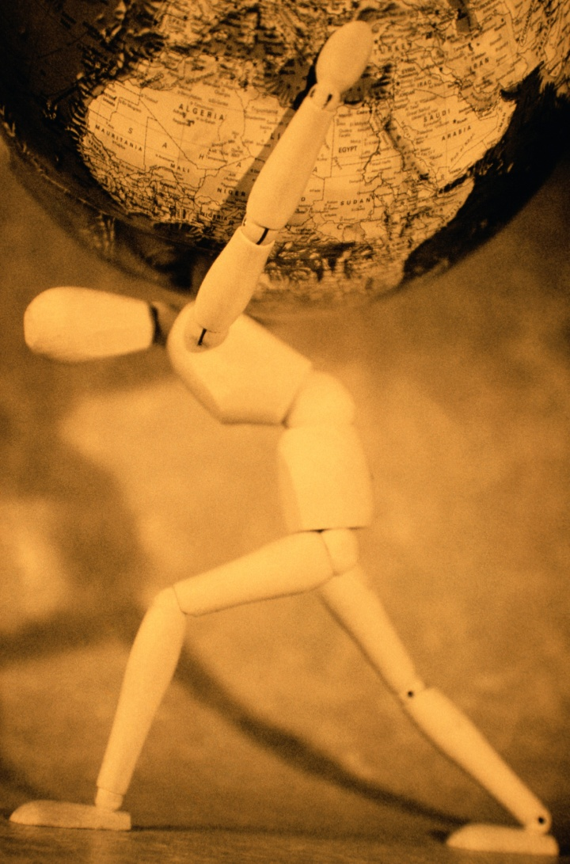

Quote of the day:
“The earth has grown old with its burden of care, but at Christmas it always is young.” — Phillips Brooks
Reflection:
I agree, it certainly does seem that sometimes the need is overwhelming and the burden of caring for our fellow humans is heavy. At times, I am tempted to feel discouraged that there is too much to do and I have so little to give compared to the great need.
Yet how true is the latter part of this quote. Christmas is a time when I feel young and my strength is renewed when I remember not just the duty of giving, but what great happiness and satisfaction it brings.
Why not try giving to someone who you know cannot repay you and see if the joy of giving does not rejuvenate you?
**

- Enjoy the Greatest Of All Pleasures

Quote of the day:
“Giving is the greatest of all pleasures.” — Author unknown
Reflection:
How true!
Gift giving is a timeless tradition and a wonderful way of showing love. However, modern marketers have somehow found a way to take the pleasure out of giving. They have invented so many days to celebrate with gift giving, and they come around so fast that it's sometimes hard to remember which one we're shopping for or why.
So the next time you want to by a gift to show someone how much you love them, stop for a moment, and recall the most memorable gifts you have ever received and why you still hold them dear. Were they the things you could see and hold, or the love those gifts were wrapped in?
As an unknown author wisely said “The best gifts are tied with heartstrings.” If you put the love back into giving, the pleasure and joy will follow.
Happy giving.
**

