Motivational Minutes on Gratitude from 2011-2014

- Gratitude

Quote of the day:
“The more you recognize and express gratitude for the things you have, the more things you will have to express gratitude for.” — Zig Ziglar
Reflection:
Here is one practical step to applying the above quote. Something you can use right away in your quest for becoming more thankful.
Give thought to the many blessings that you have. Living in a consumer culture, most of us are fully aware of what we do not have and how we absolutely must have "it." But how often do we reflect upon the things we already have? Take some time each day and think of one or two things that you have that you may typically take for granted, and then take a moment and give thanks for those.
I incorporate this simple practice into my reflection time. I find it both refreshing and uplifting to review a list of things that I'm thankful for. Try it, and see what it does for you.
**

- Pause To Reflect On The Blessing

Quote of the day:
“If you don’t get everything you want, think of the things you don’t get that you don’t want." – Oscar Wilde
Consider:
When we pause to reflect on the blessings that enrich our lives, even the small and most obscure ones, something deep within us changes for the best. Taking a minute to reflect on the joys, big or small, that come our way or exist in our life can lead to feelings of happiness, positive energy and good health.
Take a moment now, close your eyes and think about something that you are grateful for. Think of the things that have brought you happiness last week. You’ll probably find a gem that brings a smile to your face and peace to your heart. Give thanks for that and watch how the rest of your day changes.
**

- Attitude of Gratitude

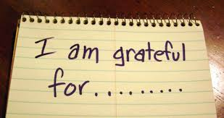

Quote of the day:
“Of all the attitudes we can acquire, surely the attitude of gratitude is the most important and by far the most life-changing.” — Zig Ziglar
Reflection:
You may say this is fine, but what about when bad things happen? The following story is one of my favorites, and this example is one that I try to remember and follow when bad things happen to me.
Matthew Henry, the famous scholar, was once accosted by thieves and robbed of his purse. He wrote these words in his diary:
"Let me be thankful first, because I was never robbed before; second, because, although they took my purse, they did not take my life; third, because, although they took my all, it was not much; and fourth, because it was I who was robbed, not I who robbed.”
In every situation there is always something to be thankful for. The next time something bad happens, why not look for the positive in it.
**

- Gratitude

Quote of the day:
"Ignorant men don't know what good they hold in their hands until they've flung it away." — Sophocles
Reflection:
Many people get so caught up in what they don't have that they overlook everything that they do have. It's important that we take the time to reflect on everything we've been blessed with and be grateful lest you forget them and lose them.
Write down ten things that you've been blessed with. Include some things that others can't put a value on. Read over this list each morning to remind yourself of the things you have to be thankful for, and feel free to keep adding to your list.
**

- The Taste Berry

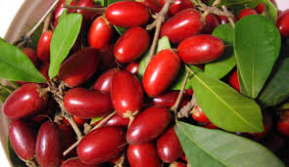

Quote of the day:
“Gratitude unlocks the fullness of life. It turns what we have into enough, and more. It turns denial into acceptance, chaos to order, confusion to clarity. It can turn a meal into a feast, a house into a home, a stranger into a friend. Gratitude makes sense of our past, brings peace for today, and creates a vision for tomorrow.” — Melody Beattie
Reflection:
I was talking to a friend today who was telling me about a magic fruit that comes from Africa. He said that when eaten every sour or bitter thing consumed afterwards is turned to sweet. I remember reading a story about this many years ago, and the fruit was called the taste berry. I imagine it is the same fruit. I can only think that the power of gratitude is like this fruit, when used, it turns every sour or bitter situation to sweetness.
Like William Arthur Ward said, “Gratitude can transform common days into thanksgivings, turn routine jobs into joy, and change ordinary opportunities into blessings.” Be faithful to use your magic fruit of gratitude daily and turn even the sourest circumstances into sweetness.
**

- Rejoice In What You Have

Quote of the day:
“People who live the most fulfilling lives are the ones who are always rejoicing at what they have.” — Richard Carlson
Reflection:
Have you ever felt down or have the blues or in the dumps? No matter what you call it, we all get down at times, and sometimes it seems nearly impossible to snap out of it. However, no matter how low we sink, gratitude and thanksgiving are always there to come to the rescue and throw us a lifesaver, but we have to grab on to it and use it.
When everything seems to be going wrong, it seems easier said than done to be thankful, but giving thanks really does work! Not only will an attitude of gratitude and thankfulness for what you have pull you out of the doldrums, but taking a positive, grateful stance will nearly always keep you from getting down in the first place.
Kiss the blues goodbye as you praise your way to victory!
**

- Appreciating What You Have

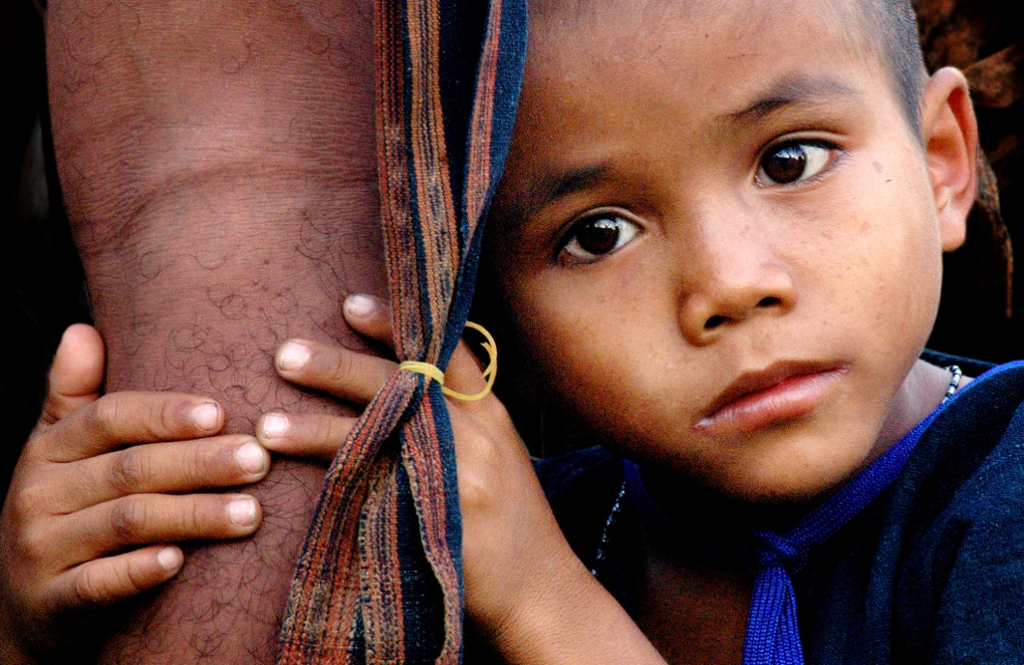

Quote of the day:
“We tend to forget that happiness doesn't come as a result of getting something we don't have, but rather of recognizing and appreciating what we do have.” — Frederick Keonig
Reflection:
I read the below stats a while back and was reminded of it by the above quote.
If you woke up this morning with more health than illness, you are more blessed than the millions who will not survive this week.
If you have never experienced the danger of battle, the loneliness of imprisonment, or the pangs of starvation, you are ahead of 900 million people in the world.
If you have food in the refrigerator, clothes on your back, a roof overhead and a place to sleep...you are richer than 75% of this world.
If you have money in the bank, in your wallet, and spare change in a dish someplace, you are among the top 8% of the world’s wealthy.
If you can read this message, you are more blessed than over two billion people in the world who cannot read at all.
If you hold up your head with a smile on your face and are truly thankful, you are blessed because the majority can, but most do not.
These stats certainly make me want to count my blessings. How about you?
**
- Thankfulness

Quote of the day:
"Thankfulness is the beginning of gratitude. Gratitude is the completion of thankfulness. Thankfulness may consist merely of words. Gratitude is shown in acts." — Henri Frederic Amiel
Reflection:
Many people tend to show their thankfulness by saying the words, "thank you" which is well and good, but that is just the first step. Why not take it a step further?
When we are truly grateful for something, we should not only say “thank you” but do something to demonstrate our gratitude and not just depend on our words to convey it. Like the old saying goes, “actions speak louder than words.”
To help get you going with the second step, try this exercise. Stop and reflect on something that someone did or said to you today that you appreciated. Now, in addition to saying “thank you”, reach out to convey your sense of gratitude and appreciation by doing something nice for that person.
**

- That’s Life

Quote of the day:
“The more you praise and celebrate your life, the more there is in life to celebrate.” — Oprah Winfrey
Reflection:
When thinking about the above quote I was reminded of something I read a while back. The author, who I don’t recall, has a wonderful attitude about how to view life.
- When something goes wrong, we often say, “That's life!” But life is so much more than the little things that don't turn out the way we wish they had.
- Waking up each morning with eyes that see and ears that hear—that's life!
- Talking with a child and catching a glimpse of the world through those innocent eyes—that's life!
- Pausing in the middle of a hectic day to watch a bird soar or a butterfly flit among the flowers—that's life!
- Chatting with an old friend and remembering just how special that friendship is—that's life!
- Receiving an unexpected word of encouragement—that's life!
- Holding a newborn baby and catching his first smile—that's life!
- Walking in nature, taking in its sights and sounds, and breathing that fresh air—that's life!
- Lying down to sleep at night and thanking God for all the blessings that the day brought—that's life!
What a positive and grateful spin to take on viewing life instead of a negative one. Take some time to reflect on how you are viewing life. If you feel you are fitting more into the category of having a negative spin on life, try turning things around—look at life through the eyes of appreciation and see how your vision changes.
**
- The Value of …

Quote of the day:
“It is not good for all our wishes to be filled; through sickness we recognize the value of health; through evil, the value of good; through hunger, the value of food; through exertion, the value of rest.” — Greek saying
Reflection:
Even the bleakest of circumstances can be turned into thanksgiving. When you are able to “give thanks” in the toughest of times, that is when your difficulties take on meaning. Peace comes to your heart when you turn your eyes away from your troubles and toward the things that are right in your life.
Try to be thankful for your hardships by thinking of positive aspects about your difficulty. For example, say to yourself, “I am thankful for this sickness as it shows me the value of health. I’m thankful that I’m not always sick. I’m thankful for the health that I do have. I’m thankful that my health is not as bad as it could be. I am thankful that I can grow in character because of this difficulty.”
**

- Take Time To Look For The Beauty

Quote of the day:
“Beauty is God's handwriting.” — Anne Louise Flint
Reflection:
If you keep your eyes open for the positive and beauty of your surroundings, you will find it.
Here’s an illustration that reflects the principle of the quote.
A young man who was an amateur artist, but who had to spend most of his time living and working in a city, often resented his drab surroundings and longed for the freedom and beauty of the countryside. One day, as he walked down a narrow alley, a gleam of sunlight burst through a gap in the buildings, illuminating a tiny, dirty, but golden-haired, child playing with a doll on a doorstep. Here was a picture indeed! In that moment he made a resolution: every day on the way to work he would try to find at least one subject for a picture. To his amazement, what had formerly seemed dull and unattractive streets became alive with "pictures"—children playing, clothes on a line fluttering in the breeze, a pot of flowers on a window-sill, some antique railings casting a shadow in the sunlight—the inspiration was endless.
You may not be a budding artist, but the principle still holds true. Take time to look for the good and beauty in the commonplace and you will find it. The more you live in the moment in a positive state of mind the more joy you will find and the happier you will be.
**

- Two Pockets

Quote of the day:
“Give thy mind more to what thou has than to what thou hast not." — Marcus Antonius,
Reflection:
I've put the following idea from F.W. Boreham to the test and found that it works!
He tells of the happy soul whose home is the Other End of Nowhere. He has two pockets. One has a hole in it and the other is carefully watched that no hole develops in it. Everything that he hears of a hurtful nature—insult, cutting remark, gossip, unclean suggestion, or any such thing—he writes on a piece of paper and sticks it into his pocket with the hole. Everything which he hears that is kind, true, and helpful, he writes on a piece of paper and puts it in the pocket without the hole. At night he turns out all that is in the pocket without the hole, goes over all that he had put into it during the day, and thoroughly enjoys all the good things that have come his way that day. Then he sticks his hand into the pocket with the hole and finds nothing there, so he laughs and rejoices that there are no evil things to rehearse.
Often times we do the reverse. We place the negative things in the pocket without the hole—only to mull over them again and again, and we put the good things in the pocket with the hole so that they are quickly forgotten. Think about this—which would you prefer to do?
**

- Ask The Question

Quote of the day:
“Gratitude creates the most wonderful feeling. It can resolve disputes. It can strengthen friendships. And it makes us better men and women.” — Gordon B. Hinckley
Reflection:
The next time you are with a friend, ask them what they are most thankful for. You will be amazed at the answers you receive and you will create a meaningful bond with your friends as you focus on this powerful question.
It doesn’t have to be some big accomplishment. You may find your more grateful for your garden, or your fishing spot, than for your doctorate. You don't even have to feel grateful before you generate results. Just begin stating whatever you would be grateful for if you could be, even if you don’t feel it right now. List as many things as you can think of and pretty soon you and your friends will have created an uplifting atmosphere, one that gives you a new perspective on your life, with good feelings and new energy.
**

- Little Things Matter

Quote of the day:
"Just as millions of snowflakes pile up to create a blanket of snow, the 'thank yous' we say pile up and fall gently upon one another until, in our hearts and minds, we are adrift in gratitude." — Daphne Rose Kingman
Reflection:
Little things matter. A dripping tap soon fills a bucket until it is overflowing. The same is true of anything in life, and developing appreciation is no different. Appreciating the many small things in your day will lead to greater and greater levels of gratitude and happiness. When someone smiles at you, when you receive a small compliment, when the bus is on time, when a friend sends you a nice SMS message, these are all things to be thankful for.
A little bit of gratitude every day can, over time, make a big difference to our level of happiness and well being. Think of five things you are thankful for and start building your “blanket of snow.”
**

- Count Your Blessings

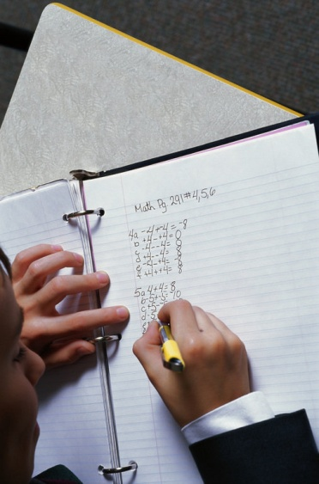
Quote of the day:
“The hardest arithmetic to master is that which enables us to count our blessings.” — Eric Hoffer
Reflection:
The path to victory and miracles comes through praise, thankfulness, gratefulness, gratitude, or whatever you want to call it. No matter what you call it, by practicing it you will get the same results, because this is a law of the spirit.
Gratitude will lift your own spirit. As you dwell on the good and speak of the good, then good surrounds you. Even if you are thankful when you don't feel like it, it lifts you up and soon you will feel like it. Having a grateful attitude is always blessed and rewarded.
And the big bonus is—having a thankful attitude helps those around you. When you demonstrate your thankfulness, it lifts others spirits, encourages them and engenders positiveness.
Before going to bed think of at least five things you are thankful for. Continue this every night with a different five things each time and you will be amazed at how your life will change.
**

- Count Your Blessings

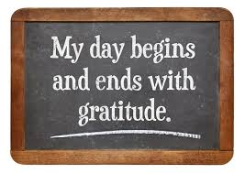

Quote of the day:
“Be thankful for what you have; you'll end up having more. If you concentrate on what you don't have, you will never, ever have enough.” — Oprah Winfrey
Reflection:
We live in a society of lack. We wake up in the morning feeling like we didn’t get enough sleep. We worry about not having enough money or the right love relationship and on and on it goes.
When you wake up in the morning, try counting your blessings first thing. This will set the tone for the day and put you on the right track to receive abundance instead of lack. Be thankful for the things you already have, including the things that are to be treasured above material items—the things that money can't buy.
Value and give thanks for those things above all, and you'll have the key to abundance, no matter what your seeming “lacks” may be.
**

- Attitude of Praise

Quote of the day:
“You can't always change your situation, but you can always change your attitude.” — Larry Hargraves
Reflection:
Problems are part of life, and sometimes it seems that we can't get on top of them long enough to catch our breath. How can we overcome our problems before they overcome us?
This longing to be able to put aside all our problems and worries and to feel free is a longing everyone experiences at one time or another. Unfortunately, there is no magic bullet to make problems disappear at the bat of an eye. What we can do is learn to control the effect that our problems, both real and imaginary, have on us.
One sure-fire way is to adopt an attitude of praise and gratitude even in the rough times. No matter how badly things are going or how seemingly hopeless the situation, it is always possible to find something to be thankful for if you look hard enough.
That positive, appreciative attitude will lighten your burdens and help you bear them. Embracing a positive outlook no matter what is going on around you, brings on inspiration and renewed strength. It gives you wings to rise above your problems and the doubt, fear, and worry that accompany them. Maintaining an attitude of praise may not completely remove the problems you're facing, but it will give you a much better outlook and perspective on them.
**

- Thanksgiving

Quote of the day:
“Thanksgiving Week comes, by statute, once a year; to the honest man it comes as frequently as the heart of gratitude will allow.” — Edward Sandford Martin
Reflection:
Thanksgiving is a holiday celebrated in the U.S. the last week of November, and is traditionally the beginning of the Christmas season. It is a week to celebrate the blessings and the things we are thankful for in our lives. However, like the quote so eloquently suggests, we should not only be thankful on a special dedicated week, but every week of our lives.
In these unique times in which we are living, many people may be struggling to find things to be thankful for. Something that helps me remember to give thanks, is reminding myself that there is always someone else worse off than me. Why not take a moment to think of one or two things you are grateful for, once you get started in this direction, you’ll soon see that your list will begin to snow ball.
**

- Thanks Is The Highest Form of Thought

Quote of the day:
“I would maintain that thanks are the highest form of thought, and that gratitude is happiness doubled by wonder." — Gilbert Keith Chesterton
Reflection:
I agree that thanks is the highest form of thought. I read an interesting article the other day by Jessie Richards that goes along with this. Here is the part that most impressed me:
I went for a run and had an epiphany. “I am thanksgiving” perfectly embodies the kind of person I want to be, the way I want to live my life, what I want to be known for. I want to live in that state of being grateful and I want to voice it. All the time. “I am thanksgiving” goes a step further than simply being thankful or being grateful, which can be done rather passively. So I now proudly affirm that thanksgiving is not just something in which I participate on occasion, or in the back of my mind. May gratefulness and thanksgiving always be a part of who I am and permeate everything I say and do. I am thanksgiving, and I’m always going to smile about something!
I think this is a marvelous concept! I also want to strive to be able to say “I am thanksgiving” and always have something to be grateful for.
**

- True Value

Quote of the day:
“It is good to have money and the things that money can buy, but it’s good too, to check up once in a while and make sure you haven’t lost the things money can’t buy.” — George Lorimer
Reflection:
This quote reminds me of a story.
One day a wealthy father, took his son on a trip to the countryside with the express purpose to show him how poor people live. They spent a day and a night on the farm of a very poor family. When they got back from their trip, the father asked his son, "Did you see how poor people can be and what did you learn?"
The son answered, "I saw that we have a dog at home, and they have four. We have a pool that reaches to the middle of the garden; they have a creek that has no end. We have imported lamps in the garden; they have the stars. Our patio reaches to the front yard; they have a whole horizon." When the little boy was finished, his father was speechless. His son added, "Thanks, Dad, for showing me how 'poor' we are!"
How true, it’s all a matter of perspective! If you have love, friends, family, health, good humor and a positive attitude towards life—you are richly blessed! These are all things that money can’t buy. You may have all the material possessions you can imagine, provisions for the future, etc., but if you are poor of spirit, you have nothing!
Are there any things in your life that you take for granted?

