Motivational Minutes on Making a Difference from 2011-2014
(Also see the Giving file.)
Changing the World
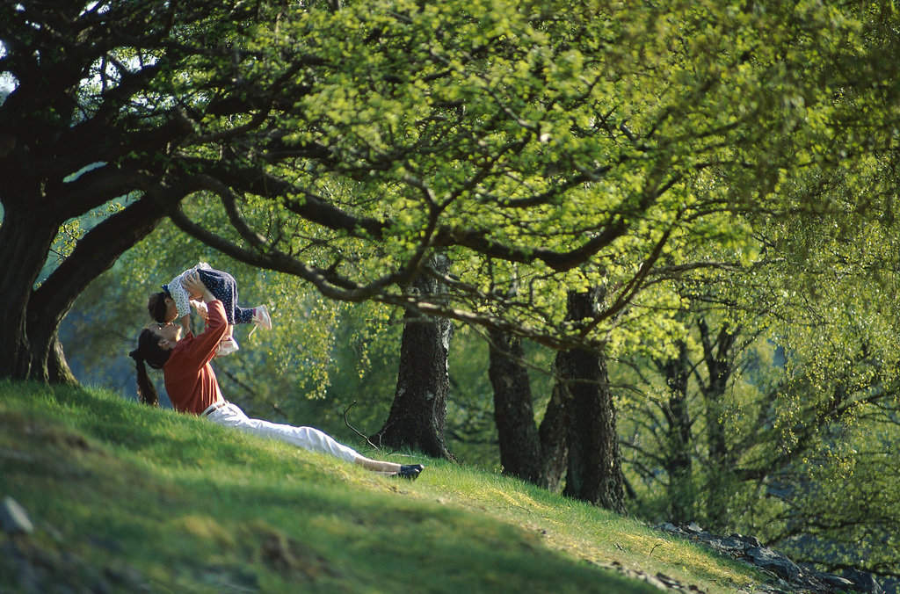
Quote of the day:
“Someone's sitting in the shade today because someone planted a tree a long time ago.” — Warren Buffet
Reflection:
This quote jogged my memory about a story that always encourages me about how even one person can do a lot to change the world no matter how bad things look at the time.
In 1923, a young man was on a walking tour in France. The area was barren and desolate of trees. There was little farming being done because of the lands poor condition. The villages were rundown and many of the people had deserted the countryside because of the situation. The young traveler ended up staying at the cottage of an old shepherd. He observed that the shepherd was spending his evening hours sorting nuts. Once sorted, the shepherd would put them in a knapsack, and as he led his sheep to graze the next day he would plant the nuts along the way. The young visitor said to the shepherd, "It will be years before these trees ever get to where they could do you any good! You might not even live long enough to see them grow!" But the shepherd replied, "Yes, but some day they'll do somebody some good and they'll help to restore this dry land." Twenty years later when the young hiker returned to the area he was astounded at the change. It was now covered with a beautiful natural forest of all kinds of trees! Grass, shrubbery, bushes and berries were flourishing, and the wildlife had returned. The soil was moist and the farmers were cultivating the land once more. The efforts of one man brought an entire region back to life again, restoring its economy, its wildlife, its agriculture, its water, its soil, and even its population--all because of the foresight, diligence, patience, sacrifice, and faithfulness just to do what one man could do, day by day.
So if sometimes you're discouraged with the way the world is, don't give up! Reflect on this lesson from the shepherd. One man made a big difference, and so can you.
**
- Making a Difference

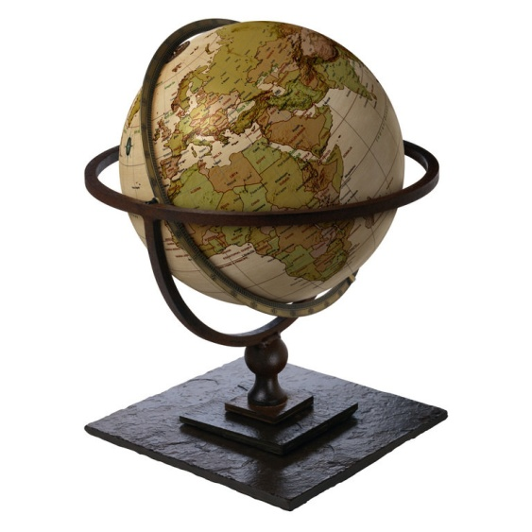

Quote of the day:
“However much I am at the mercy of the world, I never let myself get lost by brooding over its misery. I hold firmly to the thought that each one of us can do a little to bring some portion of that misery to an end.” — Albert Schweitzer
Reflection:
Sometimes we're discouraged and think, "Well, who am I? What can I do? The world's problems all seem so hopeless and impossible! It looks like there's nothing one person can do to change things for the better, so what's the use of trying?" And we're tempted to just give up and let the world go to Hell, which it seems to deserve!
You may not be able to change the whole world, but you can change your part of the world. If you have changed one life, you have changed a part of the world, and you have proven that there is hope that it can all be changed! The world can be changed, starting even with one person, just one person--maybe you!
**

- Chain of Kindness

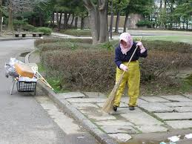

Quote of the day:
“If you'd stop to think about it, you'd probably be surprised at how many thoughtful little things you could find to do for others that would cost almost nothing and take almost no time. Become a master of the five-minute favor.” — Shannon Shayler
Reflection:
Become a master of the five-minute favor—I love this idea. It reminds me of something I saw on Youtube recently called the “Chain of Kindness”. A city worker stops to help a young boy pick up his papers and it causes a ripple effect—the boy in turn helps an elderly woman, and the woman helps someone else, and on and on the chain of kindness goes until it finally goes the full circle returning to the city worker who started the chain. That one five-minute favor influenced a wide range of people and caused a ripple effect that changed one part of the world for the better.
If you are looking for a way to change the world around you, start your own chain of kindness by doing a “five-minute favor” and then watch to see how it comes back to you.
**

- Cause and Effect

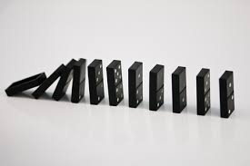

Quote of the day:
“Today is only one day in all the days that will ever be. But what will happen in all the other days that ever come can depend on what you do today.” — Ernest Hemingway
Reflection:
Life is a great cycle of cause and effect. Everyone makes choices every day, and everyone's choices affect others. The combination of everyone's choices and the effect those choices have on others makes the world what it is.
Every problem can be traced to some unloving or selfish choice someone made. Selfishness and lack of love are the major cause of problems in the world today. People either don't see how their wrong choices affect others, or they don't care enough to do things differently.
You may feel that the world is too messed up, that too many wrong choices have been made, that it doesn't matter much what you do, that it's hopeless. But that's not true. Just as every problem can be traced to a wrong decision, every solution begins with a wise and loving decision to do the right thing, the loving and unselfish thing.
A little bit of love can go a long way, and each act of love makes a difference. One act of kindness or unselfishness can start a whole chain reaction of events that will, in the long run, make life much better for a lot of people. So don't despair because there is so much suffering and grief and wrong in the world. Instead, do what you can to make things right and encourage others to do the same. The world won't change in a day, but you can make a difference if you try.
**

- Light Your Part of The World

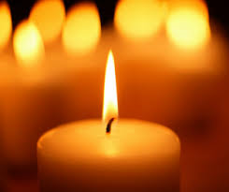

Quote of the day:
“I always wondered why somebody didn't do something about that; then I realized I was the somebody.” — Lily Tomlin
Reflection:
When we look at the world situation, there's very little reason to hope. What can you do to help make a difference? You're just one person, after all, and have very little influence—or do you? You may not sit at the negotiating table where decisions are made, but you can change situations around you through your attitude and actions and you can influence everyone you come in contact with.
A song that was popular some years ago put it like this: "If everyone lit just one little candle, what a bright world this would be!" You may not be a light to the whole world, but you can light your part of the world. We all can. If we all do our little part and shine our lights together what a bright light that will be and than we will be that “somebody doing something about that.”
Stop and think if there is something you need to be doing that you always wished somebody would do something about.
**

- What You Do Makes a Difference

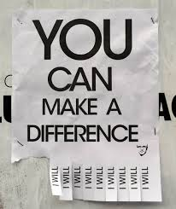

Quote of the day:
"Act as if what you do makes a difference. It does." — William James
Reflection:
This is certainly a quote to live up to, as everything you do or say makes a difference in someone's life.
Remember that your actions, no matter how small or insignificant they might seem to you, influence the world and people around you. One word or action on your part could inspire another person to act in a similar way, and depending on the nature of that act, it could have negative or positive repercussions for that person and/or a larger group of people.
Take a moment and write down one thing you did today. Then write down the effects that one action had on your life and those around you. Did it impact them for good or for bad?
I don’t know if it will for you, but this exercise helped me take notice and be more careful about the things I do and say, realizing my actions really can make a difference, either for better or worse, in other’s lives.
**

- I Am Only One

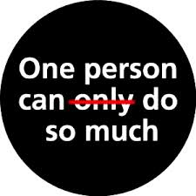

Quote of the day:
“I am only one, but I am one. I cannot do everything, but I can do something. And I will not let what I cannot do interfere with what I can do!” — Edward Everett Hale
Reflection:
Most people have great respect for Mother Teresa, yet they think they could never be like her; they could never be so saintly or make such a difference in the lives of so many. Maybe not, but the tragedy is that because they don’t think they can, they don’t even try.
What they fail to realize is that Mother Teresa didn’t set out to become a living saint or a Nobel Peace Prize laureate. And she didn’t start out ministering to multitudes of the poorest of the poor. She simply saw the need nearest her and responded. We can all do that.
Don’t let what you can’t do interfere with what you can do.
**

- Take Stock
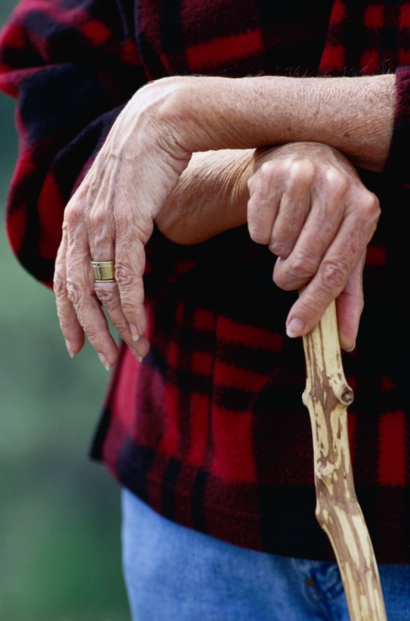
Quote of the day:
“It is not length of life, but depth of life.” — Ralph Waldo Emerson
Reflection:
This quote reminds me of something I heard a terminally ill lady say. “I’ve been so busy with life that I haven’t had time to think. I realized while lying here that I barely know my husband, my children, or my mother-in-law, who also lives with us. I’ve been wrapped up in caring for them—shopping and cooking, doing their laundry, cleaning up after them, helping them with their homework—and yet I can’t say that I really know what they are thinking or what they are going through. I can’t tell you when the last time was that I had a deep conversation with any of them.”
I often hear people say that they want their loved ones to be happy, and that is why they need to work so long and hard. Unfortunately, the more successful they become, the busier they get and the less time they have to spend with their families—and the less they gain from their investment. While the dying woman’s motives may have seemed noble at the time, the life she led hadn’t been able to satisfy the needs of their loved ones’ hearts, or her own for that matter, when the time came to take stock of the things that really matter.
When we make time to help others, to participate in their lives, to share in their victories and struggles, to have heart-to-heart interaction with them we are making time to love. When was the last time you made time for those you care about?
**

- Making an Impression

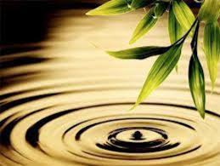

Quote of the day:
"Blessed is the influence of one true, loving human soul on another." — George Eliot
Reflection:
Whether you realize it or not, your life will make an impression on a lot of people before you die.
This impression may be positive or negative. Therefore, it is up to you to decide the kind of difference you want to make in the lives of those you touch. Will you be a positive or a negative influence? Will you build up or tear down? Will you be loving and encouraging or critical and condemning? Will you be a burden or a blessing to others?
If you want to be a force for good, think about the people in your life and write down the name of one person with whom you want to make a positive difference. Then create a plan of action regarding how you are going to make that difference and get started today!
**

- It Made a Difference to This One

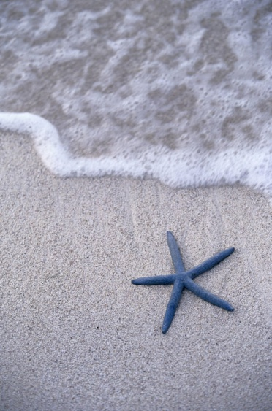

Quote of the day:
"If you can't feed a hundred people, feed just one.” — Mother Teresa
Reflection:
I’m reminded of the story about a boy who was walking on a beach which was covered with starfish.
The starfish had washed up in the tide. In an effort to save the fish, the boy started throwing them back in the ocean one by one. Someone passed by and said to the boy, “You’ll never be able to save them all, your efforts can’t make a difference.” The boy looked up and wisely replied, “I may not be able to save them all, but to this one, it made a difference.”
There are so many needy situations in the world today, so much so, it seems overwhelming at times. You may ask yourself, “The needs are so great. How can I make a difference against such odds?” Well, even if you make a difference in one person’s life, you’ve made a big difference like the boy made a difference to the one starfish he helped. Reach out to help someone today.
**

- Don’t Wait To Start Improving The World

Quote of the day:
“How wonderful it is that nobody need wait a single moment before starting to improve the world.” — Anne Frank
Reflection:
Every person has his or her own destiny to fulfill. Some people realize what their purpose is at a young age and others don't know what it is until later in life, however, we will all make a difference in some way to someone by the time our life is over.
It is up to you to decide if you are going to make a positive or negative difference.
Write down three things in your life that you feel will make some kind of difference in the world for good. They can be things that will influence all of humanity or even just one person. Either way is fine, but once you have determined the three things, take one step toward each this week!
**

- A Chance To Help Others

Quote of the day:
"I can do things you cannot, you can do things I cannot; together we can do great things." — Mother Teresa
Reflection:
Recently I read a passage from George Burns and was so inspired by it I had to share it with you.
“If you were to go around asking people what would make them happier, you'd get answers like a new car, a bigger house, a raise in pay, winning a lottery, a face-lift, more kids, less kids, a new restaurant to go to—probably not one in a hundred would say a chance to help people. And yet that may bring the most happiness of all.
“The point is, it doesn't have to be anything that extraordinary. It can be working for a worthy cause, performing a needed service, or just doing something that helps another person.” — George Burns
What good advice from Mr. Burns. Why not think about what you can do to help others?
**

- Influence

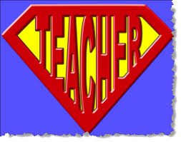

Quote of the day:
"A teacher affects eternity; he can never tell where his influence stops." — Henry Brooks Adams
Reflection:
As we all know, teachers make lasting impressions on the students they teach. Most of us have heard of amazing stories of changed lives just because one teacher had faith in their student and instilled in them the desire and courage to reach their full potential. But what we may not stop to realize, is that we are all teachers in one way or the other. Everyone has influence on others either for good or for bad.
You can choose to make a difference and have a positive influence on others. If this is your intent, it is important to be mindful of your words and actions, as you never know whose life you will affect. Make a point to regularly say positive, encouraging and uplifting statements to those you come in contact with.
**

- No Regrets
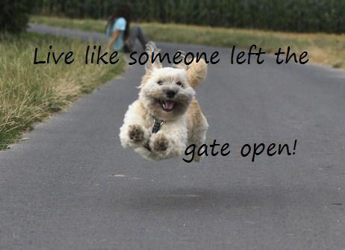
Quote of the day:
“Live as you will wish to have lived when you are dying.” — Christian Gellert
Reflection:
Have you ever wondered if you would have regrets at the end of your life and how you can minimize them? I have. I came across an article by a lady who cares for the terminally ill and her discovery of the top five regrets people have at the time of their passing. I'm sure there are others, but this list may help you, as it has me, to start reflecting on the importance of life and to set your priorities straight now rather than later.
1. Courage to live a life true to themselves, not the life others expected of them. It is important to do at least some of the things we want to do because the moment that we lose our health, it is too late.
2. Not to have worked so hard. It is possible to not need the income that we think we do.
3. The courage to have expressed their feelings. Many people suppress their feelings in order to keep peace with others which causes some to develop illnesses relating to the bitterness, resentment and lack of forgiveness.
4. That they had stayed in touch with their friends. When we are faced with our approaching death, the physical details of life fall away and the importance of love and relationships become crystal clear.
5. That they had let themselves be happier. What others think of us is most likely a long way from our mind but the moments of happiness we missed or let slip by might be.
Do any of these ring true in your heart? If so, do something about it today so that you won't have any regrets.
**
- Living A Life That Matters

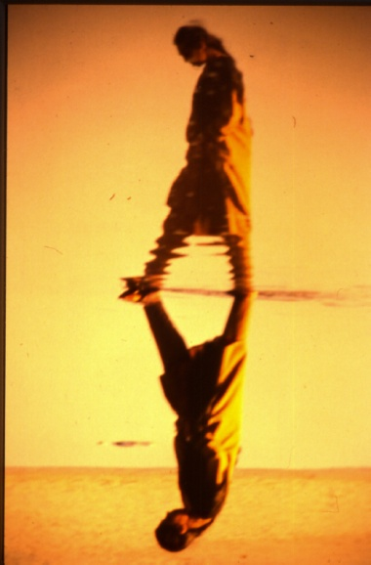

Quote of the day:
“We are not human beings having a spiritual experience. We are spiritual beings having a human experience” – Pierre Teilhard de Chardin
Reflection:
We are coming to the end of the year. I hope through the quotes and stories I have shared that I have impressed upon you the importance of building up others, building self-worth, building character, giving forgiveness, gratitude, taking quiet time and giving because ready or not, sooner or later someday it will all come to an end for all of us. There will be no more moments to enjoy. Your hopes, ambitions, plans and to-do lists will expire. The wins and losses that once seemed so important will fade away. It won’t matter where you came from or what social station you held. It will not matter what you owned. It won’t matter whether you were beautiful or brilliant or not. Even your gender and skin color will be irrelevant.
So what will matter? How will the value of your days be measured? What will matter is not what you bought, but what you built; not what you got but what you gave. What will matter is not your success, but your significance. What will matter is not what you learned but what you taught. What will matter is every act of integrity, kindness, generosity, compassion or sacrifice that enriched, empowered or encouraged others.
Living a life that matters doesn’t happen by accident. It’s not a matter of circumstances but of choice. So choose wisely. What sort of difference will you make this coming year?
**

