Motivational Minutes on Quiet Time and Enjoying the Moment from 2011-2014.

- Look For Potential Not Flaws

Quote of the day:
“We spend January 1st walking through our lives, room by room, drawing up a list of work to be done, cracks to be patched. Maybe this year, to balance the list, we ought to walk through the rooms of our lives...not looking for flaws, but for potential.” — Ellen Goodman
Reflection:
Take a few minutes to reflect on the past year. Consider: these three areas of your life:
- your work or studies
- your home life and relationships with family and friends
- your personal life, which includes your physical, mental, and spiritual wellbeing

In each of these areas what are you most thankful for from the past year? Don't limit yourself to only one or two things for each area. You may want to jot them down for future reference.

Then take a few more minutes to reflect on the coming year. In terms of these three areas of your life, what are your aspirations for the coming year? Write those things down in point form so you will have them to refer to as the year progresses and be reminded to be thankful when they come to pass and for your next New Year reflection.
**
- Examine Your Life

Quote of the day:
“The life which is not examined is not worth living.” — Plato
Reflection:
I understand that examining one’s life can be difficult at times, but the personal growth and benefits derived from this practice is well worth the effort. Writing down your daily experiences along with the lessons you have learned will make you wiser and more capable to deal with the next set of lessons, and it may possibly help you make fewer mistakes the next time around. This habit can also help you develop self-awareness that will help you clarify your values and priorities, as well as keep you more focused on the things that truly matter.
Another benefit is that it can actually help you heal from past wounds, limiting beliefs and general confusion. It gives you the opportunity to vent or simply ‘mind dump’ making space for new, positive, creative thoughts. This examining, can provide you with a central place where you can record your insights on important issues, note key success strategies that have worked for you, and commit to all the things you know are important to achieve for a high-quality professional, personal, and spiritual life.
**

- Creating Order

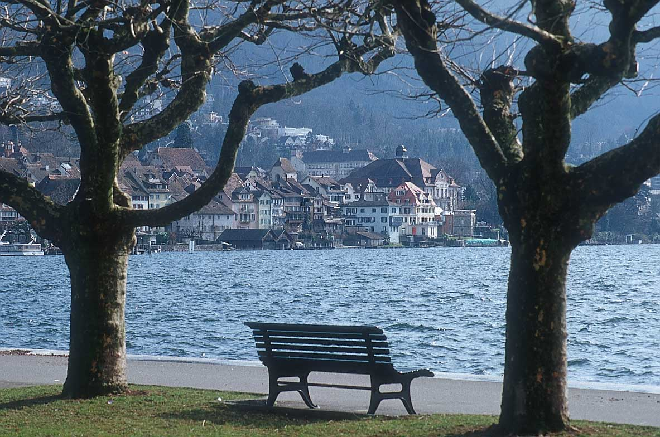

Quote of the day:
“We need quiet time to examine our lives openly and honestly... spending quiet time alone gives your mind an opportunity to renew itself and create order.” — Susan Taylor
Reflection:
Never before has the world been so fast paced. From the minute we wake to the minute we fall into bed at night, we have the opportunity to go full speed ahead and never slow down. However, if we’ll take some time out every day in which we can be quiet and reflect, we will free our hearts and minds up from the tyranny of the “urgent” and the rush rush.
Regularly set aside time for yourself, for quiet reflection. If you’ll keep up with this daily “time out”, those moments when you can get quiet and appreciate the calm, you’ll soon notice it makes a difference in your life. It will bring comfort to your heart and peace to your soul. And remember, it’s most often in those quiet times where great ideas are born, and where great accomplishments begin.
**

- More Precious Than Jewels

Quote of the day
“The words that enlighten the soul are more precious than jewels.” — Hazrat Inayat Khan
Reflection:
Starting your day off on the right foot determines how the rest of your day plays out. Some say the first 30 minutes to an hour after you wake up is the most important part of the day. Seeing as these early morning moments are so important, and realizing that this time has a significant influence on the quality of every minute that follows, it is key that you use this time wisely.
I personally have a morning ritual. The first thing I do before getting out of bed is give thanks for four or five different things. After cleaning up, I read some inspiring, uplifting, positive material, followed by writing in my journal, including writing one or two affirmations to keep in the forefront of my mind during the day. I then spend a short time meditating or praying. All this takes about 30-40 minutes, which I gladly set aside, as I have seen what great benefits this practice has on my life personally.
You may feel that you don’t have so much time to spend, but I assure you if you fill your mind with good and positive thoughts first thing in the morning—only the best of thoughts that motivate you to take good, positive action—you will notice that the rest of your day will consistently unfold in the most marvelous ways. Like the quote says, by taking in “words that enlighten the soul” you will find they “are more precious than jewels”.
**

- Start Your Day Off Right

Quote of the day:
“Morning is an important time of day, because how you spend your morning can often tell you what kind of day you are going to have.” — Daniel Handler
Reflection:
Taking time first thing in the morning in reflection and meditation will give you power and strength of spirit. Consistently taking this time will help you gain wisdom and love to share with others. Without this strength of spirit you limit yourself to your own little world and meager resources. Your human strength is apt to run out before the day has scarcely started, your own thoughts can get in the way. But when you get alone in quiet meditation, you open boundless new possibilities.
It seems easier to carry on in your own energy than to work at being quiet where you can receive inner strength, but that's not so; you really make it harder for yourself when you try to go along in your own strength.
So take a little time each morning to quiet yourself and enter into peace. As you practice, it will become easier.
**

- Find the Magic

Quote of the day:
“I have always been delighted at the prospect of a new day, a fresh try, one more start, with perhaps a bit of magic waiting somewhere behind the morning.” — J. B. Priestly
Reflection:
It is important that you set your mind and spirit on the right track before you face the day. If you start your day rushed, hurried, angry, irritated, or in any other negative mindset, then most likely your whole day will be the same, but the contrary is just as true. If you start your day with gratitude, positiveness and inspiration, then most likely that is how your day will go.
Do yourself a favor, take a little time each morning to quiet yourself, and see if you won't gain strength for the day. Make it part of your morning routine and as you stick to it, it will become easier, and you will come out better for it in the end.
**

- Solitude

Quote of the day:
“When from our better selves we have too long been parted by the hurrying world, and droop. Sick of its business, of its pleasures tried, how gracious, how benign in solitude.” — William Words Worth
Reflection:
When was the last time you carved out a chunk of time to enjoy the power of solitude—to restore, refocus, and revitalize your mind, body, and spirit?
All of the great masters mention the reoccurring theme of the importance of taking time to be quiet, to meditate, reflect, or to think about their works, be it art, music, science or literature, etc. They seemed to have all arrived at the same conclusions, that taking time to reflect is very beneficial.
Saying that you “don't have enough time” to be silent on a regular basis, is a lot like saying you are too busy driving to stop for gas—eventually it will catch up with you.
**

- Content of Your Life

Quote of the day:
"We have become addicted to having, rather than being, and confusing our needs with our wants. Studies show that if you place high value on those things, you are more likely to suffer depression, anxiety, addictions, and personality disorders. We cannot carry on consuming in this manner and feel confident our great-grandchildren have any future." — Oliver James
Reflection:
To many of us, what we buy, where we shop, how often we shop, how much we have to spend, and how our buying affects others' perception of us, means a great deal—in many cases probably too much.
The issue is not whether we have one car or three, or whether or not we own the latest mobile phone, laptop computer, or iPod. Nor is it whether we shop at a designer store or hunt for used bargains on eBay. What matters is not the content of our closet or garage, but the content of our lives.
Now is a great time to stop, reflect, and think about the content of your life.
**

- Take Time To Think

Quote of the day:
“To take time to think is to take time to live.” — Nancy Kline
Reflection:
When do you take time for quiet reflection? If you think you can’t possibly allot time for this in your busy day, why not try something radical? Study over your schedule and see how you can carve out some time to be alone.
Perhaps you can cut down on time watching TV, or time spent on the Internet. You might consider arranging your schedule so you can rise early enough to have some time of quiet before you start your day. There is something very special about rising before the hustle and bustle of the day begins—a deep sense of peace fills the air if you stop long enough to notice, and in these quiet moments alone, you hear things that you otherwise don’t notice during the day.
If you just can’t manage taking this time in the morning, set some time aside in the evening. This practice can have an immense impact on your life. Fewer decisions have the power to transform your life as does the habit of taking time to get alone and quiet, to meditate, pray, reflect, or simply sit still and listen to the quiet.
**

- Take Time To Be Happy

Quote of the day:
“You can always find reasons to work. There will always be one more thing to do. But when people don't take time out … they stop being happy.” — Carisa Bianchi
Reflection:
When life feels like a tiny, windowless room and its four walls are closing in, you can create a window of escape through taking time alone to get quiet, reflect and meditate.
I know it is not easy to take this time, but the benefits are great. As you read and meditate on positive, uplifting things, it gives you the opportunity to see life through new eyes. The warm sunshine of peace will melt away the tension. Like a breath of fresh air, you’ll discover clarity of mind. New vistas will open before you. You will see things from a positive perspective and you will thrill to the new possibilities and challenges before you. You will find fresh inspiration and creativity. That stifled feeling will give way to exhilaration and a passion for living.
With benefits like that you can’t afford not to take the time.
**

- Enjoy the Moment

Quote of the day:
“Learn as if you were going to live forever. Live as if you were going to die tomorrow.” — Mahatma Gandhi
Reflection:
If today was your last day in this life and you knew it, how much time would you want to spend on something that means absolutely nothing in the overall scope of eternity? If you were dying of a terminal illness‚ if you knew that your life would be over when you went to bed tonight, what would you spend your last moments doing? Your minutes and hours would be valuable to you. You would have much more to do in those remaining hours than you could fit in, so you would be forcing yourself to choose things that are most important to you.
It's easy to lose perspective in the day-to-day rush of things. It's strange how the most unimportant things seem so important. Our negative self-chatter prevents us from doing many of the things we value and feel are important but if we would live each day as if it were our last‚ our priorities would be clearer.
Stop and think if your negative thought patterns are stopping you from learning and living life to the full. If they are, start doing something about it today.
**

- Celebrate The Day

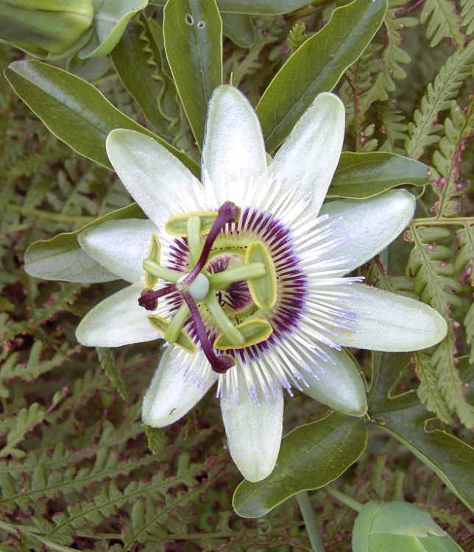

Quote of the day:
“I've learned that if I don't celebrate the exquisiteness of each day that I've lost something I'll never get back.” — Sally P. Karioth
Reflection:
Many of us spend nearly all our time thinking of the past or planning for the future. We find it hard to spend time in the present. If often we get so focused on reaching our destinations, we may neglect to enjoy the ride. I know I'm guilty at times of getting so focused on completing certain tasks, knocking things off my to-do list, and simply being busy. I have to make a conscious effort to take time to enjoy the process, each step along the way, but when I do, it is so worth it, and it makes the journey so much more fun.
No matter where you are or what you are doing stop and think of one thing that you relish about this moment. Is it the quietness of the day? Or perhaps the fact that you have a chance to be alone, to sit still, and to read these words? Is it that you feel healthy and strong? Or is it the beautiful passion fruit flower that you just stopped to admire? Think about some of the joys of this moment--perhaps things that you wouldn't naturally notice or consider joys. Choose abstract pleasures, the ones that take real thought and consideration. Savor the good feeling. Now try to do this more often throughout the day. Slow down and enjoy life.
**
- Grow Brave By Reflection

Quote of the day:
“The real man smiles in trouble, gathers strength from distress, and grows brave by reflection.” — Thomas Paine
Reflection:
How true! It is very important to take time to reflect and think, but not to worry or fret. The kind of reflection that I’m talking about is taking time to feed the inner you. Just as your body needs to be fed, your spirit needs food too, and the best food for your soul is positive, uplifting, motivating, praiseful words. I have found that taking time out each morning to read positive material, reflect and/or journal has helped my life tremendously.
Try setting aside at least 20 minutes each day for inspirational reading, reflecting, and writing. For some, it may be difficult to reserve this time; if this is the case with you, try starting with only five minutes reading the Motivational Minutes and thinking about the quote and commentary. If you have more time, write a little about your own conclusions, as this will help you to put your thoughts into action. If you aren’t able to fit this in daily, then try for three days each week and build up from there. Whatever you decide, it will be easier to follow through if you establish a definite time slot in your day and make this quiet reflection time part of your routine.
**

- Get In Touch With The Silence Within Yourself

Quote of the day:
“Learn to get in touch with the silence within yourself and know that everything in this life has a purpose.” — Elisabeth Kübler-Ross
Reflection:
In today’s busy world, people are often too busy to stop and get quiet long enough to think, reflect, or meditate. It reminds me of the story of the mother who went to visit her son in the city.
He rushed here and there and he was so busy that he only had time for, "Hi, Mom" and "Goodbye, Mother!" He was so terribly busy. One day she said to him, "Son, when do you do your thinking? When do you take time to reflect?" That came as an entirely new thought to him.
Many of us are the same. We are too busy to stop and take time in quiet meditation. And we don't necessarily have to be living in the fast lane to miss taking time to reflect about the deeper things of life. There are more than enough things in life to keep us occupied every waking moment, but we miss the best things when we fill up on matters of little real consequence.
If this comes to you as a new concept, why not take some time to “learn to get in touch with the silence within yourself” and discover “that everything in this life has a purpose.”
**

- Tank Up

Quote of the day:
“People often say that motivation doesn't last. Well, neither does bathing; that's why we recommend it daily.” — Zig Ziglar
Reflection:
I agree with Zig Ziglar that taking time daily to maintain our inner well-being is important. Maintaining our spiritual lives through having quiet time, quality input, and good living is as important to our happiness and well-being as filling our car's gas tank and servicing our vehicles is to safety on the road. When we work at keeping our spirits in good shape and are mindful of our strengths, we can respond better to whatever situation we find ourselves in.
Filling up the gas tank is like taking time to fill up on positive input. A grateful attitude is like shock absorbers, it will lessen the bumps in the road. Maintaining a proper perspective is like good car alignment, it will keep us on the straight and narrow. Just like a car can at times become faulty and need maintenance lest it cause an accident, our spirit also needs maintenance. If we don't regularly keep a check on our spirit, it can get knocked out of whack by rocks and potholes in the road of life—problems, disappointments, loss, and so on. And if that spiritual misalignment is not corrected, when we hit another particularly rough spot, we could lose control, veer off the road, and wind up upside down in a ditch.
It is important to keep a check on your attitudes, perspectives and values, and this takes time—time in quiet reflection, time to tank up on positive input and giving thanks. Keep your spirit tuned and have a happy journey.
**

- Start Your Day On the Right Foot

Quote of the day:
“The evening of your day starts in the morning.” — Author Unknown
Reflection:
Here are some suggestions for starting your day on the right foot:
- Vocalize four to five things you are thankful for.
- Read some positive, uplifting material.
- Journal.
- Take time to reflect or meditate.

These things will give you power and strength for the day.
I know it seems easier to simply jump right into the day rather than to take this “quiet time” in the morning in order to receive inner strength. Yet hitting the ground running at the start of the day makes our lives harder in the long run.
**

- Beauty Planted In the Human Soul

Quote of the day:
“A man should hear a little music, read a little poetry, and see a fine picture every day of his life, in order that worldly cares may not obliterate the sense of the beautiful which God has implanted in the human soul.” — Johann Wolfgang von Goethe
Reflection:
I agree with von Goethe that it is important to refresh our souls with the wonder and beauties of God's world. He has given some excellent advice and I would encourage you to take time during the holidays to spend more time in quiet reflection, to listen to heart stirring music, to read a little poetry, to be inspired by beauty, to renew your wonder for the coming year and to wash away the worldly cares and ugliness of the past year.
**

- The Past Is Gone
Quote of the day:
“… On the first of January let every man gird himself once more, with his face to the front, and take no interest in the things that were and are past.” — Henry Ward Beecher
Reflection:
In the closing scene of Shakespeare's, The Tempest, Prospero says of Alonzo: "Let us not burden our remembrances with a heaviness that's gone!" Vivien Larrimore gives similar advice in her poem, Keys.
I've shut the door on yesterday
Its sorrow and mistakes:
And now I throw the key away to seek another room
And furnish it with hope and smiles
And every springtime bloom.
I've shut the door on yesterday
And thrown the key away.
Tomorrow holds no fears for me,
Since I have found today.
Why not talk to yourself about the past by saying, "The past is gone. There is nothing I can do to change it. So why waste my strength wrestling with the past when I need all my power to grapple with the vital issues of today!"
**
- The Gift

Quote of the day:
“Yesterday's history, tomorrow's a mystery, today is a gift, that's why they call it the present.” — Babatunde Olatunji
Reflection:
Find value in every moment, and look for meaning in everything you do. Living in the past can lead to regrets, and living in the future can make us feel anxious. This moment, right now, is the most important time of your life. Don't forget what a gift it is to you. Like the above quote reminds us, it is a present.
Enjoy the moment and rediscover the world around you. Take time to look closer at the things that surround you. When I do this, I find some of my favorite things are the dew drops on the grass that look like diamonds as they reflect the sunlight, the rays of the evening sun coming through the window which casts a soft golden glow around the room, the moon light shimmering on the lake, to name a few. I also enjoy savoring my food—even thinking about how my tastes have changed and how I enjoy trying new foods. These are simple ideas about how to enjoy the moment, yet there are thousands of other ways—as many as each minute of the day.
Life is a mystery, as well as an adventure with countless things to discover and rediscover. Don't let it slip by you unnoticed. Take time to fully enjoy the gift of life by living in the present.
**
- Enjoy The Best Things In Life

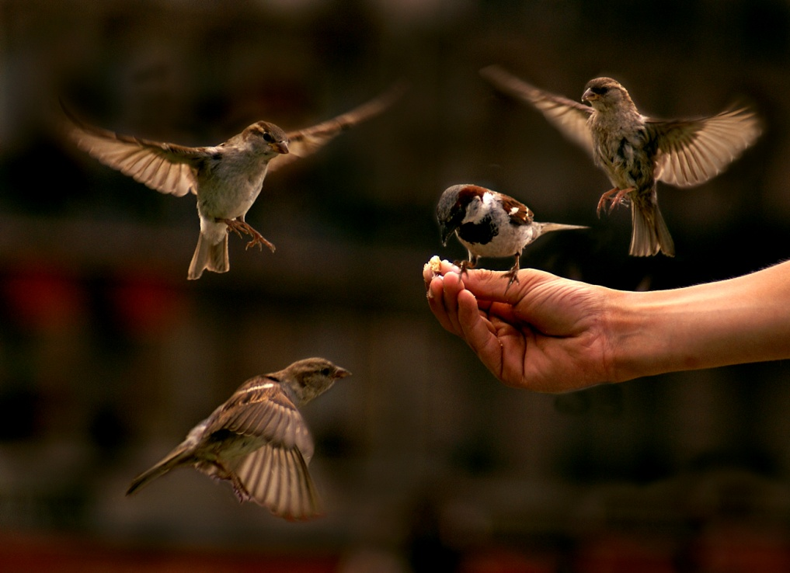

Quote of the day:
"Once we discover how to appreciate the timeless values in our daily experiences, we can enjoy the best things in life." — Harry Hepner
Reflection:
Some of the best things in life don't cost any money to enjoy. These things include our health, friends and family. However, sometimes we get so focused on money and materialistic things that these "hidden" gems are often overlooked.
Think about your life. Make a list of the things that are the most important to you. Chances are that you'll find that the "most important" things in your life are not tangible items and that you are in fact a wealthy person. Realizing this, you can then begin to truly “enjoy the best things in life and appreciate the timeless values of our daily experiences.”
**

