Motivational Minutes on Risk Taking and Taking Action from 2011-2014
(Also see Thoughts and Goals files.)

- Taking Action

Quote of the day:

“You contain within yourself a unique combination of talents and abilities which, properly indentified and applied, will enable you to achieve virtually any goal you can set for yourself.” — Brian Tracy

Reflection:

This is a great quote and a key. However, no matter what your talents or abilities are, if you don’t take action and put them to use, they will not prosper you.

Please realize that action is the key to making positive changes in your life. Without action, no matter how much knowledge you have, no matter if you know what the right thing to do is, it won’t do you any good.

Inaction will not result in fulfillment, taking action will! So act today. Like Jim Rohn says, “The best motivation is self-motivation.”

What action can you take today to make progress toward one or more of your goals?
**

- Risk Taking

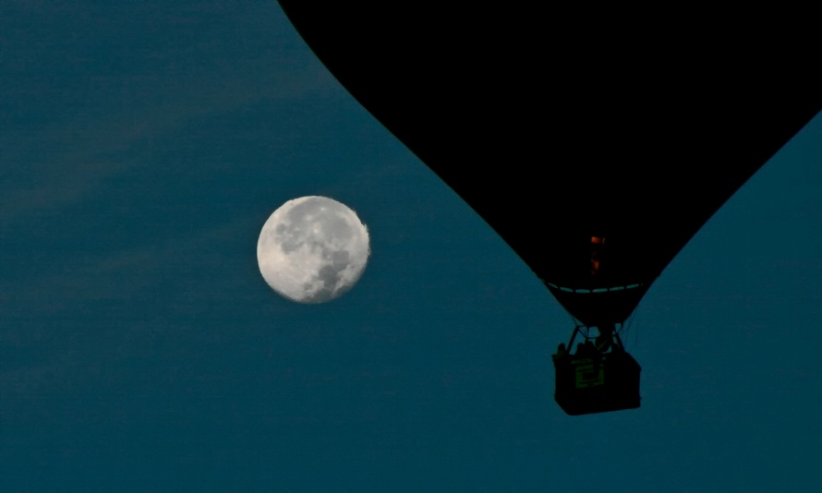

Quote of the day:

“Life is either a daring adventure or nothing.” — Helen Keller
Reflection:

What is holding you back from living your life as a daring adventure? Do you have fears that need to be conquered? Have you accepted mediocrity as your fate as opposed to living by the old adage, “nothing ventured, nothing gained”? If so, take a few moments to ask yourself if it’s time for you to take life by the reins, make some positive steps towards conquering your fears, and start living life to the full.

Think about what you want to accomplish, and then go after it. Ask yourself if you need to seek out the help of others to help you get to where you’re going. If so, determine who that might be, possibly the help of your spouse, a business colleague, a Life Coach, a spiritual counselor, etc. Make the choice that you will not give up before you reach your goal. You can make your wildest dreams come true, if you'll just hang in there and go after them.
**

- Don’t Let The Possible Danger Stop You

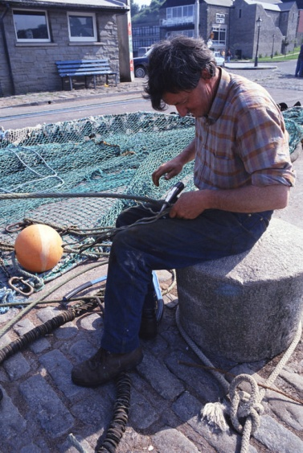

Quote of the day:

“The fishermen know that the sea is dangerous and the storm terrible, but they have never found these dangers sufficient reasons for remaining ashore.” — Vincent Van Gogh

Reflection:

Many things in life are dangerous, in fact most things are. However, we shouldn’t let fear of taking a risk stop us from taking the necessary action to achieve our dreams just because we are afraid we'll fail along the way.

Like the quote says, if the fisherman would allow the fear of a storm to stop them they would never catch any fish. The same is true for you, if you allow the fear of failure to stop you from trying you will never reach your dream.

I’m not suggesting you need to be foolhardy and not count the cost and prepare for any possible dangers, I’m encouraging you to not let the dangers stop you from considering and preparing and overcoming them by taking the proper precautions.
Why not think about a dream you’d like to achieve in your life time and then think about what may be holding you back. Sometimes stopping long enough to face and acknowledge your fears is enough to get you headed in the right direction, then solutions often appear that you hadn’t thought of before.
**

- Do Something Different

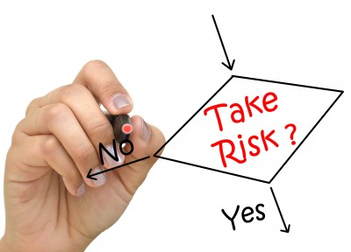

Quote of the day:

“The universe will reward you for taking risks on its behalf.” — Shakti Gawain

Reflection:

Trying something new and taking risks can be scary. But the minute you determine to step out to do something new, the universe is ready to help you and to go to work on your behalf. That includes things like sending someone your way who can help you, or guiding you to helpful books to read on the subject, or helping you to decide on the best course of action to take.

How do you think the great inventors came up with their new machinery, formulas, and solutions to problems? By thinking about how to improve things, by experimentation, by trying new ideas, and by having the guts to do things differently than they had been done before.

Try changing something that you have wanted to change for a long time. Do something different and see what new opportunities open up to you.
**

- Go Out On a Limb

Quote of the day:

“Why not go out on a limb? Isn’t that where the fruit is?" — Mark Twain

Reflection:

Moving beyond our own personal limiting beliefs and fears is not always easy. When standing at the threshold of our limitations often our first reaction is to hesitate, even shy away from any attempt of launching out into the unknown, the difficult, or anything that would stretch us beyond our comfort zones. Our fear seems to immediately kick-in and we are tempted to listen to the inner negative voice above the calmer, steadier voice of faith and confidence.

As you’re heading towards your goal, if fear comes knocking at your door, stop a moment and take stock of your situation. Is your goal consistent with the voice of truth within you? Do you have inner peace knowing the goals you’re shooting for are what you’re supposed to do? If the answer is yes, then trust that you will be given guidance at the exact time and hour you need it; then go ahead and climb out on that limb, trust, and expect success.
**

- Turn It Around

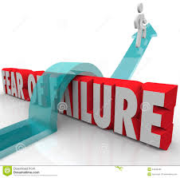

Quote of the day:

“It is not because things are difficult that we do not dare, it is because we do not dare that they are difficult.” — Seneca

Reflection:

Margo Robinson dared and kept daring until she realized her goals. She walked over the fear of failure. Here is her story.

Margo Robinson had no future. She had worked hard at turning around years of personal misfortunes and bad choices, but a professional life still eluded her. The odd jobs she was able to get never amounted to much, and she hungered for meaningful work--she just didn't know where to begin. That all changed the day Robinson took a job in the financial aid office of a trade school. For the first time, she had a sense of clarity about her life and her career path. That path eventually paved the way to a job at a mortgage bank. Although she had no lending experience, Robinson was the only candidate who didn't cancel her interview on the day of a winter storm. That kind of determination impressed the bank's management so much that they offered Robinson the job that very day. Within a few months, Robinson closed $1 million in accounts.
Adapted from Black Enterprise.

What things seem so difficult to you that you dare not do them? Why not take a risk. The worse that could happen is you might fail and find out where it's not at on your journey to finding out where it is at.
**

- Do It Anyway

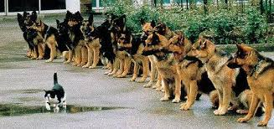

Quote of the day:

“Feel the fear and do it anyway.” — Susan Jeffers

Reflection:

This quote has been a tremendous help to me. I have found that whenever I want to make a major change for the better all hell breaks loose. One of the main obstacles is fear. It comes in looming over me like a bigger than life giant, taunting me and reminding me of all the reasons I shouldn't take the risk of change, of how I shouldn't rock the boat, that things are going okay and this change could make things turn for the worst. Or, that I'm not good enough to take on the new, who do I think I am to try something different? All these excuses and fears sound trivial as I put them on paper now, but at the time it is always of great magnitude and intensity. When these fears come upon me I have found it helpful to do as Susan suggests, “feel the fear” which I do by writing it down, and then just go ahead and do it anyway no matter how much fear I'm feeling.

The point is that the fear always comes, so just feel it, but don't let it stop you from making the change, or doing the project, or following your dreams. The worse thing that can happen is that you will fail and that's not always bad.

So feel the fear and do it anyway.
**

- Don’t Settle For The Ordinary

Quote of the day:

“If you are not willing to risk the unusual, you will have to settle for the ordinary.” — Jim Rohn

Reflection:

So often we do things because that is the way we have always done them. I enjoy reading about the men and women who wouldn't settle for the ordinary but instead they took risks to try to improve their lives and the lives of others. One such story is of Murray Spangler.

Murray Spangler, a department store janitor in Canton, Ohio, took pride in his job even though the dust made him wheeze and cough. Many men would have given up and quit. Instead, Spangler set out to find a better way to clean floors. "Why not eliminate the broom," he wondered, "... maybe something that would suck up dust ... ?" Spangler's question led to a crude but workable vacuum cleaner, which he induced an old friend in the leather business to finance. The friend's name was H. W. Hoover.

Thank you Mister Spangler for your willingness to not just settle for the ordinary, but to risk the unusual.
**

- Marbles In a Jar

Quote of the day

“We can't choose whether we will get any more time, but we can choose what we do with it.” — John Maxwell

Reflection:

Here is the story that goes along with the quote from John Maxwell's book “The Maxwell Reader.”

"Let me tell you something that has helped me keep a good perspective on my own priorities. You see, one day I sat down and did a little arithmetic. The average person lives about seventy-five years. Now then, I multiplied 75 times 52 and came up with 3,900, which is the number of Saturdays that the average person has in his lifetime. "It took me until I was fifty-five years old to think about all this in any detail," he continued, "and by that time I had lived through over 2,800 Saturdays. I got to thinking that if I lived to be seventy-five, I only had about a thousand of them left to enjoy." He went on to explain that he bought 1,000 marbles and put them in a clear plastic container in his favorite work area at home. "Every Saturday since then," he said, "I have taken one marble out and thrown it away. I found that by watching the marbles diminish, I focused more on the really important things in life. There's nothing like watching your time here on this earth run out to help get your priorities straight."

I love this story and taking it to heart, I've put my own jar of marbles on my desk to remind me of my priorities. Why not give it a try yourself.
**

- Hitting the Target

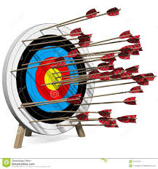

Quote of the day:

“Far better it is to dare mighty things, to win glorious triumphs, even though checkered by failure, than to take rank with those poor spirits who neither enjoy much nor suffer much, because they live in the gray twilight that knows not victory nor defeat.” — Theodore Roosevelt

Reflection:

If you have tried and failed at something at least it means you have tried. You have a goal and a purpose. You may not hit the bull’s eye of the target every time, but you will eventually have success because you are doing something. Those that don’t try for fear of failure are never defeated, but they never win either.

Sometimes the things we most want seem to come with the most risk—the risk of rejection, disappointment, or failure. But if you play it safe, and never let your desire see the light of day, you often risk something even greater—the opportunity to experience the joy that comes from expressing your unique talents and gifts. And worse, by not taking the risk, you can be left with a haunting inner voice that will forever sing the song of "if I only had."

Consider taking the risk. It is better to have tried and failed than to have never tried at all.
**

- Keep Trying

Quote of the day:

“You can't hit a home run unless you step up to the plate. You can't catch fish unless you put your line in the water. You can't reach your goals if you don't try.” — Kathy Seligman

Reflection:

If you don’t try new things, you’ll never know what else you might be good at. What you may think you’re not suited for may turn out to be something you actually enjoy and are gifted in. You never know until you try.

Look at babies, they are always trying new things—learning to eat, to talk, to walk, etc. You were made to explore, to learn and discover. Why stop once you reach adulthood?

People might tell you that something can’t be done, but don’t let anyone else’s thinking, much less your own mindsets, hinder you from accomplishing what you have in your heart to achieve. Don’t accept defeat before you even try. Give yourself a chance. Believe that anything is possible. Reaching any worthy goal will be hard work, but if you determine to see it through, even those things which might seem impossible today will become reality in your life.

What new things could you try that you have been hesitant to try?
**

- Take Action

Quote of the day:

“It is important to realize that action is the key to making positive changes. Without action, knowledge is lost.” — Norman Vincent Peale.

Reflection:

How true! I have found no matter how good an article I read, a book, a study course or program I enroll in, whatever it may be, unless I actually take action and start applying the various points learned, then it doesn’t do me any good. The “knowledge is lost” to me.

The next time you read or hear something that rings true in your heart write it down and start acting on it. See what happens. You may find it is better to put small bits of knowledge to use rather than accumulating vast amounts of knowledge and never using any of it.

Don’t be surprised if you start to really make progress and see positive change.
**

- Don’t Drag Your Feet

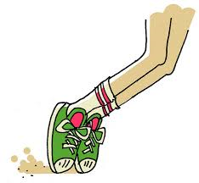

Quote of the day:

"Be slow to resolve, but quick in performance." — John Dryden
Reflection:
It's important that you take the time to actually think about all of your options before you make a decision. However, once you have come to a decision, don't drag your feet in following through with it. If you lose momentum you may never get around to it, then the time and effort you put into the decisions will have been wasted. Lack of action is one of the biggest down falls in not accomplishing your goals.
What decisions have you made but haven't followed through with? Stop now and follow through on at least one and then move on to the next even if it takes a few days to accomplish this.
**

- Stay Focused

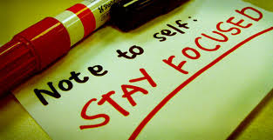

Quote of the day:

“No steam or gas drives anything until it is confined. No life ever grows great until it is focused, dedicated, disciplined.” — Harry Emerson Fosdick

Reflection:

It is a wonderful thing to have lots of creative ideas. However, if you don’t have landing gear in place you may find so many ideas can be more of a hindrance than a help. Like the quote implies—it is just a bunch of hot air, but if you can harness those ideas and focus on one or two at a time, that energy can really take you places.

There are so many intentional and unintentional distractions that can get in our way of doing the most important things. It is important to discipline yourself to stay on task. If you need help to focus, set an alarm to ring on the hour. When the alarm sounds, do a focus check by asking yourself: Are you doing what you most need to be doing right now? Is what you are doing going to bring you closer to your end goal?

Then deliberately re-commit to not just what you are going to do over the next hour, but also re-commit to who you are going to become. This will help you stay focused and on track.
**

- Unused Potential

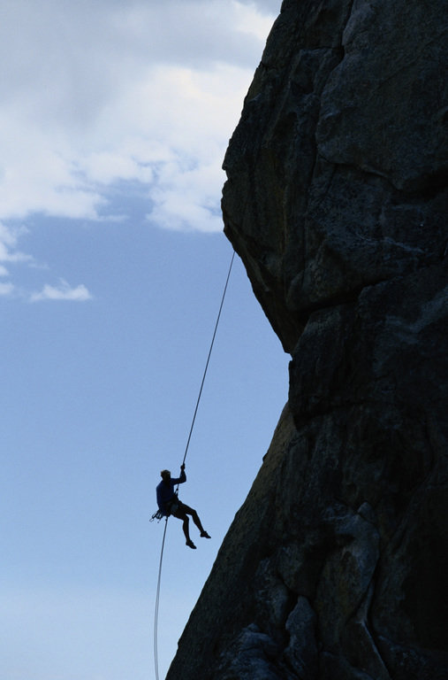

Quote of the day:

“Adventure isn’t hanging on a rope off the side of a mountain. Adventure is an attitude that we must apply to the day to day obstacles of life, facing new challenges, seizing new opportunities, testing our resources against the unknown, and in the process, discovering our own unique potential.” — John Amatt

Reflection:

Itaipu Dam, on a stretch of the Paraná River that forms the boundary between Brazil and Paraguay, is the world's largest operational hydroelectric power plant. In 1995, a decade after it opened, the U.S. magazine Popular Mechanics listed it as one of the seven wonders of the modern world. By 2000 it was generating over 90 billion kilowatt-hours of power each year, enough to supply 93% of the electrical power consumed by Paraguay's 5.5 million people and 20% of that consumed by Brazil's 184 million. That's a lot of power! The river flowed there for thousands of years before the dam was built. This means that the potential for all that power was also there, untapped, until someone set out to harness it.

Our inner potential can be likened to that river: There is tremendous potential there, but it doesn't do us any good until we acknowledge its existence, recognize its possibilities, and learn to use it. If we've gone all of our lives without tapping into our potential power, and if we've managed okay and have been relatively happy, maybe things will work out fine if we continue as we have. Maybe this wouldn't be so bad. But we would never know what we would be missing—which is a lot!

If you're looking to get more out of life why not tap into your unused power and potential.

