Motivational Minutes on Self-Care from 2011-2014

- Support Team

Quote of the day:

“Surround yourself with only people who are going to lift you higher.” — Oprah Winfery

Reflection:

It is important to have a support team of people surrounding you who encourage you. When you make the decision to try something new, you’re expanding your mind and abilities, however, you are also in a delicate position and it is important to surround yourself with positive, uplifting people who have faith in you.

You are like a balloon and your support team is like the air. Until air is blown into the balloon, it’s just a flat, thin piece of rubber—a motionless balloon. But once it’s filled with air, it takes on a new shape and it’s ready to float up into the sky. It’s energized by the air that was pumped into it.

You have the potential to do whatever you want, but it is important to make sure that the people you are surrounded by are helping you to fly up toward new horizons and not poking and popping your balloon.

**

- Exercise

Quote of the day:

“To keep the body in good health is a duty.... Otherwise we shall not be able to keep our mind strong and clear.” — Buddha

Reflection:

Some of us think that we have no time to exercise, and, I'm sorry to say that I have thought that way at times. However, exercise is important not only to our physical body but also to our state of mind. When we are doing physical activity it releases endorphins into our body, which increases our sense of well-being and makes it easier to approach the challenges of life positively. After considering the major benefits of exercise I'm of the same opinion as Stephen Covey when he said, “We don't have time not to [exercise]. We're talking about three to six hours a week - or a minimum of thirty minutes a day, every other day. That hardly seems an inordinate amount of time considering the tremendous benefits in terms of the impact on the other 162 - 165 hours of the week.”

If you don’t already have an exercise program, why not start by taking a walk today and begin to keep your “mind strong and clear”.
**

- Friend Finding

Quote of the day:

“When you choose your friends, don't be short-changed by choosing personality over character.” — W. Somerset Maugham

Reflection:

It is important who your friends are as they will influence you on many different levels. It's not easy to choose good friends for many different reasons, however the quote above offers good advice.

In addition, there is a fable by Aesop who is believed to have been a Greek slave in 6th century B.C. that might help in friend finding.

A hungry wolf saw a mountain goat eating some grass very near the edge of a high cliff. "My dear friend Goat," cried the wolf in a very concerned voice, "Aren't you afraid you will get dizzy and fall and hurt yourself?" But the goat just kept on eating the grass. The wolf tried again. "Isn't it terribly windy up there so high with no shelter at all?" The goat went on plucking the grass. "Besides," shouted the wolf, "I am sure that you will find the grass down here is much sweeter!" The goat finally looked down and replied: "Friend Wolf, are you really so concerned about me? Or are you only interested in me because you want me for your own dinner?"

Watch out for people who pretend to love and care for you and may even flatter you with nice words, but are only in the relationship for themselves and what they can get out of you.

**

- It’s Doable
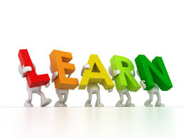

Quote of the day:

“We learn to do something by doing it. There is no other way.” — John Holt

Reflection:

Learning isn't always easy. Sometimes you feel as if you'll never be able to learn a certain thing, or you get frustrated because you feel that you're not making enough progress. But learning isn’t time wasted, even if you don’t progress as fast as you would like. You always reap benefits from the process of learning, whether you’re learning a new skill, a new method or way of doing things, or whether you are experiencing a time of personal growth in your life. The resultant progress will outweigh the growing pains and the sacrifices of time invested in learning.

If something you’re learning seems daunting, instead of giving up, try setting smaller goals for yourself. As you progress through the smaller goals, you will eventually see that what you thought was too difficult is doable after all.
**

- Affirmations

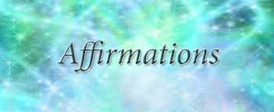

Quote of the day:

“Affirmations are like prescriptions for certain aspects of yourself you want to change.” — Jerry Frankhauser

Reflection:

Most of us battle negative thinking at some point in our lives. We put ourselves down for real or imagined faults and weaknesses, or we compare ourselves negatively to others. The use of positive statements, called affirmations, that you can repeat to yourself is a proven technique for overcoming negativity. The key is believing that what you are affirming is possible, because once you believe that a certain thing is possible, it is. It takes practice to focus on the positive, but in time you will see results.

As we learn to apply positive affirmations to ourselves and everyday situations, we begin to see ourselves and life in a more positive light allowing more positive things to come into our lives.

Start using affirmations today and see what changes come about in your life.
**

- Simplicity

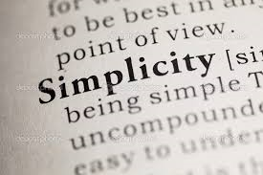

Quote of the day:

"Simplicity is a very rare thing in our age." — Ovidius Naso

Reflection:

This remark was penned about two thousand years ago by the Roman poet, Publius Ovidius Naso (43 bc–17 ad), known to the English-speaking world as Ovid.

Imagine what Ovid would say if he could see the way we live today! Wealth and accomplishment were the generally accepted measures of success even in his day, but in this era with the overload of information, rapidly advancing technology, with celebrities and sports icons, and internet marketing multi-millionaires now raising the bar and setting the pace, most of the rest of us feel unprecedented pressure to do more, know more, earn more, own more, go farther, and get there faster—"doing" and "knowing" have crowded out "living" and "loving."

Is this the way life is supposed to be, or the way it needs to be? How does the pressure to keep pace with the race for accomplishment and knowledge affect the areas of our lives that matter most? When we achieve a measure of this kind of success, does it bring us genuine happiness and lasting satisfaction? Or, does it merely perpetuate the cycle, and keep us going so fast that we don't notice that life is passing us by? Are the quick successes worth the stress? Is the pace worth the price?
**

- Journaling

Quote of the day:

“A journal is a place where we give expression to the fountain of our heart, where we can unreservedly pour out our passion.” — Donald S Whitney

Reflection:

I thoroughly enjoy journaling and find it has been a tremendous help to me. When I'm feeling upset or any other negative or unsettling emotion, journaling almost always helps. It gives me space to pour out what I really think, and often seeing my thoughts in black and white gives me a sense of perspective and helps me work through things. It helps me to become more aware of my thoughts and feelings and helps me stay accountable to my values, boundaries and goals. It is a place to record the lessons, failures and accomplishments as well as to see my progress. And it is an excellent place to write the wild ideas, dreams, imaginings, schemes, and inspirations! And the weird thing is sometimes those things come true. It is also a place to record my gratitude list which is always a boost. I also have a symbol system so if I want to return to an idea, gratitude or lesson, I can, without wading through the muck that got me there.

Stop and think, if you currently keep a journal, or have kept one in the past, what benefits has journaling brought you? If you've never kept a journal why not start now and experience your own benefits.
**

- Personal Mission Statement

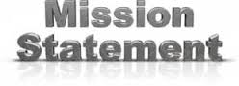

Quote of the day:

“Who we are, in turn, determines what we do. Our system of values is so much a part of us that we cannot separate it from ourselves. It becomes the navigating system of our lives.” — John Maxwell

Reflection:

I recently wrote a mission statement for myself. I'm sorry to say it was late coming in life as this concept had never occurred to me before, but better late than never. I reflected on my values and what things I wanted to stay true to. I included things like always thinking positively, living with integrity, building up others at every opportunity, being generous among others.

Often people justify improper behavior by complaining that society's values have changed. The fact is, basic values have not changed. People still know the difference between good and bad. It simply takes courage to live your life according to good principles in the face of whatever challenges arise. You can live up to your moral values if you question yourself before you do something. Ask yourself, "Is this right?" Regardless of background, nationality, religion or other differences, people universally recognize good moral values, such as honesty, fairness and respect. Once you know yourself and your principles are set, you can communicate them to others, act on your values and live according to your convictions as well as take responsibility for your decisions. This is where a personal mission statement comes in handy.

Whatever your values are, try putting the things you want to live up to down on paper. For me, creating my personal mission statement has been a tool to keep me true to my values. It is something I can refer back to whenever I am feeling confused on what direction to take next in my life.
**

- Book Reading

Quote of the day:

“Books were my pass to personal freedom. I learned to read at age three, and soon discovered there was a whole world to conquer that went beyond our farm in Mississippi.” — Oprah Winfrey

Reflection:

There’s not a single person on earth who can’t benefit from learning something new. It’s those who acknowledge this, who step out of the boundaries of what they know and what they are comfortable with, and who stretch themselves and determine to learn new things—these are the ones who make a difference in the world. They aren’t satisfied with sitting back and observing, but are looking for new worlds to conquer—and conquer they do!

What new books are you reading and learning from?
**

- Lego

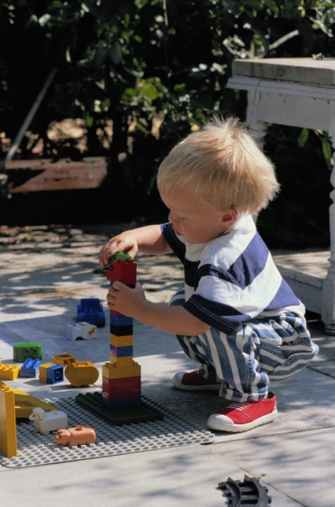

Quote of the day:

“All things are difficult before they are easy.” — Dr. Thomas Fuller

Reflection:

What a true saying! I know that with the big changes in my life in the last few years, I’ve had to learn a whole new set of skills which has not been easy.

I was comforted by a story that my friend sent me about her youngest son who tries to copy his older brother as he attempts to make Lego creations. Some days he just feels like all he can do is break what’s made, or sprinkle Lego on the floor. The younger fellow so desperately wants to be able to pick up those pieces and turn them into a fun car or airplane to play with. He tries putting the pieces together, but it never seems to work the way he has envisioned.

This is much like what happens to us when we try new things. We tend to only see the way things are now, the way we are now, the problems we face now, the challenges we’re facing right now that seem to go on and on. It behooves us to learn a lesson from this little fellow and his Lego—just give things time and gain some experience and eventually things will be different. You’ll learn. Things can and will change and improve, and when this happens, suddenly you’ll be able to do it and you’ll look back with a smile wondering what all the fuss was about.

Whatever it is that you are trying to do, just keep at it. You can do it, and things will get easier!
**

- Simplicity

Quote of the day:

“Make everything as simple as possible, but not simpler.” — Albert Einstein

Reflection:

It's when you can't find joy in the everyday things of life that you become complicated and lose the human touch. You exchange depth of character for a labyrinth of complex thinking. You sap a heart that is sensitive to the things of the spirit for mere head knowledge.

Simplicity is a gift. Everyone starts out with it, but as some people grow up they discount this gift because they associate it with ignorance, naiveté, immaturity, and a lack of sophistication. They prefer to weave a web of complexity to cover it. The gift of simplicity remains for those who have the humility and wisdom to value it and claim it as their own.

There is much to discover throughout life but you will always find that the most profound truths, the greatest beauty, and the most outstanding wisdom are expressed simply.

**

- Hugs

Quote of the day:

“Be a love pharmacist: dispense hugs like medicine—they are!” — Terri Guillemets

Reflection:
I read an interesting article a while back from Dr. Virginia Satir, a well known author and psychotherapist. In the article she is quoted as saying, “The recommended daily requirement for hugs is: four per day for survival, eight per day for maintenance, and 12 per day for growth.” I have to confess, I don’t even come close to receiving or giving that many hugs even though I’m a hug advocate. She goes on to say, "Our pores are places for messages of love, and being able to have physical contact is very important."

Take time today to get and dispense your daily medicine by giving out eight hugs and if you want to do some growing, give out 12.
**

- Synchronicity

Quote of the day:

“A thousand unseen helping hands,” Joseph Campbell calls these breaks. I call them synchronicity.” — Julia Cameron

Reflection:

If you start to notice when something happens that makes your life easier, when something you need magically appears, or when you receive an act of kindness from a stranger, this is what is called synchronicity, answer to prayer, coincidences, miracles, serendipity, confirmations, to name a few.

I have found that these synchronicities are important and worthy to take note of, or write about in your journal. By writing these experiences down you will start to notice them more and the clues they are giving you to guide your journey. Eventually you may even come to believe in the magic of synchronicity and begin to expect seeing them in your life at every turn as confirmations that you are on the right track.

During this next week pay close attention to the coincidences that occur in your life and take time to think about what they are telling you.
**

- Stress

Quote of the day:

“Before you agree to do anything that might add even the smallest amount of stress to your life, ask yourself: What is my truest intention? Give yourself time to let a yes resound within you. When it's right, I guarantee that your entire body will feel it.” — Oprah Winfrey

Reflection:

So much of our stress comes from unnecessary duties we take on, or allow others to place upon us, the things we feel like we should do. In the coaching world we have a saying, “Don’t should on yourself.” That means don’t pressure yourself by doing the things you feel like you should do unless they really are things that are in line with your values. Periodically take time out to honestly evaluate all that you do and ask yourself, “Is this something I should or something I want to do?”

If you are feeling stressed and can’t seem to accomplish all that you’ve set out to do, write down your to-do list in order of priority. Then go through each task, duty and obligation, and ask yourself, “Is this really a priority for me? Is this important to me or someone else’s expectation?” “Is this something someone else thinks I should do or something I find joy in?” Then major on the things that are important to you.
**

- Try Something New

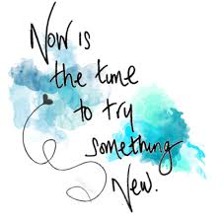

Quote of the day:

“Learn from yesterday, live for today, hope for tomorrow. The important thing is not to stop questioning.” — Albert Einstein

Reflection:

Do you feel like you’re at a dead end in some particular aspect of your life? Are you dissatisfied? Here’s something that will give your life a lift:

- Go out and try something new!
- Make the commitment to learn something that you’ve always wanted to learn.
- Ask questions.

Not only is this apt to give you a new lease on life, it will remind you that you’re not at the end of your journey, but that a new journey has just begun.

**

- Activate the On Switch

Quote of the day:

“It’s what you learn after you know it all that counts.” — John Wooden

Reflection:

When you choose to learn, you activate an “on switch” in you. That creates a vacuum which will be filled! When you're willing to learn new things, it makes you more useful and versatile.

When you adopt an open, flexible, hungry-for-more attitude, you become like a multi-purpose tool. You become like a technological tool that spans generations because its features and functions keep getting upgraded. A quality tool like that will always be prized.

Have you stopped learning or are you endeavoring to be the “quality tool” that will always be useful and versatile?
**

- Learning

Quote of the day:

“The man who graduates today and stops learning tomorrow is uneducated the day after.” — Newton D. Baker

Reflection:

Our soul is like a furnace that needs fuel to keep burning brightly, and stepping out to learn is fuel for that furnace. The process of learning helps to keep your spirit alive and moving forward. Learning is exciting for your spirit. It’s energizing. It creates vitality.

When you make the effort to learn something new, your spirit grows and expands, whether your attempts at the new are successful or not. That’s because you’ve made the decision to have an open mind to receive the new.

What new thing are you learning?

**

- Change

Quote of the day:

“There is nothing permanent except change.” — Heraclitus

Reflection:

I noticed an old deserted public telephone booth today and it made me think. Ten or twenty years ago, these booths were a vital means of communication. Long replaced by cell phones that are more convenient and capable, these relics are no longer worth the trouble, either to keep up or to tear down.

Those old phone booths strike a sad chord in me. They remind me of people who are stuck in the past because they couldn't or wouldn't adapt to the new. Any of us can become like that. If we focus on the past instead of the present and future, we will get out of touch with the world around us and be left behind. The world is ever changing, and we need to be ready to change with it, to learn new skills and continually strive to make progress.

Don't be afraid of change.
**

- Dreams

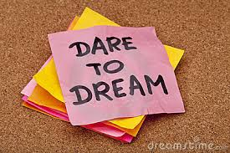

Quote of the day:

“Learn how to be happy with what you have while you pursue all that you want.” — Jim Rohn

Reflection:

I love the good advice in this quote. In today’s world we are bombarded with encouragement to follow our dreams, but at times that can be discouraging when matched up with reality.
However, if you can learn the art of doing the best you can where you are and with what you have, then the journey to your dreams will be more satisfying.

When you do this, you will find more joy with how things are as you patiently labor to make them better.
**

- Growth

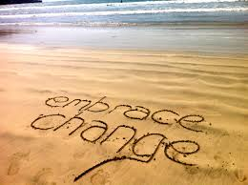

Quote of the day:

“If we don't change, we don't grow. If we don't grow, we aren't really living.” — Gail Sheehy

Reflection:

Are you set in your ways, or do you embrace new ideas? Do you welcome suggestions from others? Are you open to learning and trying new things? Are you willing to change things if someone else finds a better way?

It’s often easier to keep doing things the old way than it is to change, or at least it can seem so at first. Change takes time and effort, but good changes are worth it in the long run. You shouldn’t resist change, but you shouldn’t go to the other extreme either of changing things just for the sake of change.

Take the first step toward embracing change this week by trying something new. For example try a new food, go to a new place, learn something new or do something you have never done before. Change may not be as bad as you think. Try it, you might just like it.
**

- Priorities
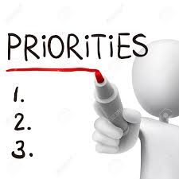

Quote of the day:

“Learn how to separate the majors and the minors. A lot of people don't do well simply because they major in minor things.” — Jim Rohn

Reflection:

Do you feel like there's so much that you need to do each day, so much that you want to do, and so much that others expect of you?

It won't stop on its own, but you can break the cycle and take control. You don't have to remain entangled in the unending struggle to do more and have more. Life doesn't have to be a daily crisis. You don't have to be the prisoner of unrealistic expectations.

The root of the problem is simple: You try to do too much, more than is humanly possible, and you put your mind, body, and spirit under pressure they were never meant to handle. It's time to reassess.

Determine what things mean the most to you—your primary long-term goals and responsibilities, and what things are essential to achieve those objectives. Channel your energies into those things, and let go of the rest. Once you've done this, the pressures that once seemed unbearable will start to dissipate.

