Motivational Minutes on Self Worth from 2011-2014
(Also see Thoughts-Good and Bad, Gratitude, Attitude and Self-Care files.)

- Lift Yourself By Your Thoughts

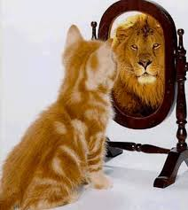

Quote of the day:
“We lift ourselves by our thought. If you want to enlarge your life, you must first enlarge your thought of it and of yourself. Hold the ideal of yourself as you long to be, always everywhere." — Orison Swett Marden
Reflection:
Our thoughts are very important, yet we often think that they don’t matter much, because they seem small and invisible and therefore of no consequence. But the truth is, our thoughts really have the power to make or break us. Through the thoughts we think about ourselves, we can conclude that we are valuable, or we feel worthless.
Make an effort to think positively about yourself. You are unique. There is no one who is exactly like you in the whole history of humanity. That in itself makes you of great value!
**

- Self-Worth
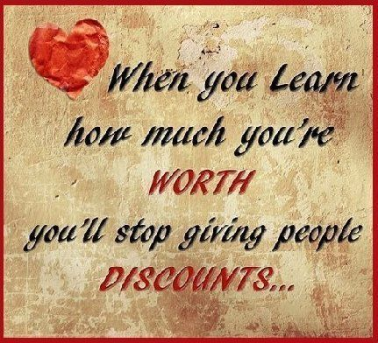
Quote of the day:
“You get the best out of others when you give the best of yourself.” — Harvey Firestone
Reflection:
I have found that the way you feel about yourself has a huge effect on the way you treat others, and on the kinds of choices you make. Your self-worth or self-esteem includes the value you place on yourself as a person, your achievements, your place in the world, and the way you think about how others see you. How much you value yourself is how much you will value others.
Many people suffer from low self-esteem and I understand there are many reasons for that--being harshly criticized, ridiculed, ignored, or made to feel inadequate, among a few. Fortunately, no matter what your experiences have been up until now, you can improve your self-esteem, and the self-esteem of those around you. First and foremost it is your choice to believe that you are worthy because you are. Once you have made that decision here are a few tips to help reinforce your conclusion:
- Spend time with people who like you and care about you.
- Do things that you enjoy and that you do well.
- Develop your talents.
- Reward yourself for your successes.
- Make good choices for yourself, and take responsibility for yourself and for your actions.
- If you've made a mistake, apologize immediately.
- Always do what you believe is right.
- Write positive traits about yourself in a journal.
- Give and receive compliments with sincerity.
**

- Celebrate Yourself

Quote of the day:
“Love yourself first and everything else falls into line." — Lucille Ball
Reflection:
Gratitude is a discipline and is something wonderful to incorporate into your life. When you are giving thanks, do not overlook being thankful for the wonder of yourself. Besides being grateful for the things that surround you, be sure to show a little appreciation for what an amazing person you are. We all have inner qualities or ways of being that serve us and others and they deserve to be acknowledged and appreciated, too.
Why not have some inner gratefulness and be thankful for the inner things that are often overlooked. Such as your commitment to personal and character growth, or the discipline of taking quiet time to reflect, the courage to take risks and conquer your own limiting beliefs, or your dedication to building up others, and the list goes on.
Celebrate and be thankful for the inner gifts you have and the ones you are developing—for they are of great value and are what shape your amazing life.
**
- Imagine Yourself Succeeding

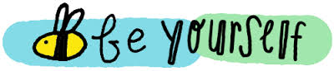

Quote of the day:
“To be nobody-but-yourself in a world which is doing its best, night and day, to make you everybody else–means to fight the hardest battle which any human can fight.” — E.E. Cummings
Reflection:
It's often said that winning is better than losing. Success is infinitely preferable to failure. But when the emphasis is always on winning, we become overcautious and fearful of making mistakes. When the emphasis is on competition, winner skills develop at the expense of empathy, co-operation and compromise, the real life arts essential to human success.
Perhaps the most devastating effect of the “success ethic” is what we come to believe about ourselves—that we are valued for what we can produce or achieve, rather than for who we are. It is no wonder that we begin to think that being loved depends on winning.
The best motivators and coaches know that one reason to recognize achievement is to help people concentrate on images of themselves succeeding, and that such mental exercises have an undeniable effect on performance. Make a list of your achievements and talents and take pride in what only you have to offer the world.
**

- Don’t Sell Yourself Short

Quote of the day:

“If I could buy you for what you think you're worth and sell you for what you really are worth, I'd make a FORTUNE!” — Author Unknown.

Reflection:
How true, so often people think so little of themselves. This quote reminds me of the saying, “selling yourself short“. Don’t let your limiting beliefs, lack of forgiving yourself, regrets, remorse or the gremlins of negative self-chatter sell you short one moment more. Fight that negativity with everything in you. And remember, each of us are very special, created exactly the way we are supposed to be—each unique, each priceless and precious. Remember this the next time you are tempted to sell yourself short.
**

- Who You Think You Are

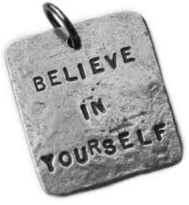

Quote of the day:
"The best books are yet to be written; the best paintings have not yet been painted; the best governments are yet to be formed; the best is yet to be done." — Dwight D. Eisenhower
Reflection:
I agree completely. The best is yet to be done—by you! There are enough buried reserves of capabilities and talents in you for you to achieve your wildest dreams.
However, who you are will always be consistent with who you think you are. That means if you believe you are not (fill in the blank) then you never will be. However, if you believe you are (fill in the blank), then you will be. This side of the coin is actually the truth, but as long as you don't think it or believe it, then the other side of the coin will hold true.
Stop thinking about what you aren't and concentrate on what you are. You are unique and special and most of all, irreplaceable. Remember no man or woman has anything about him more valuable or precious than his own individuality. Celebrate that uniqueness. Let the world see the hue that is you.
**

- Self-Consciousness

Quote of the day:
“We probably wouldn't worry about what other people think of us if we could know how seldom they do.” — Olin Miller
Reflection:
When it comes to being self-conscious or rather getting over self-consciousness most coaches will tell you just be yourself. Relax into who you are so that you shine from the inside out and don't worry about what others think. I know that is a lot easier said than done.
Learning to be fully ourselves without being concerned about the reactions, judgments, or expectations of others is a life-long process. Regardless of how confident and self-possessed you are, there will always be times in life when we feel vulnerable and afraid to be ourselves. The important thing to remember is that self-consciousness is not about others it's about you! Self-consciousness comes from the habit of judging ourselves, and the harsher we judge ourselves the more self-conscious we become. So we have to ditch that hardness on ourselves and think more about what we have to contribute, we all have something special to share. The more we can become our own best champion, supporter, and cheerleader the better able we'll be able to fully and joyfully express our own uniqueness. It begins with treating ourselves with love, respect, kindness, and compassion.
How self-conscious are you? What area(s) in your life do you need to treat yourself more gently?
**

- The Search For Self
Quote of the day:
“Always be a first-rate version of yourself, instead of a second-rate version of someone else.” — Judy Garland
Reflection:
Some things never change. For example the question "Who am I?". That search for self is universal.
The thing that has changed in the last generation or two, though, is where people are looking for the answer. For many it's not so much a search to find values and a purpose to base their lives on, as a search for an identity, an image, with a heavy emphasis on individuality.
Never has there been so much importance put on expressing individuality as in today's commerce-and media-driven world. I did a quick search on the Internet and found 153,000 sites telling me how I could express my individuality, and most of them were selling something.
What most people don't seem to realize is that in our quest for individuality, we end up models of conformity—walking advertisements that promote other people's ideas, tastes, creativity, and enterprise.
But stop and think. Are those surface things what make up the real you? Or is it the inner you, your spirit and the values motivating you and guiding your actions that determine the real you? What do you want to be known and remembered for—the image you project, or the positive influence you have on others?
**

- Celebrate the Differences
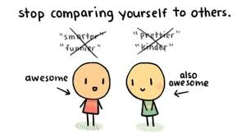

Quote of the day:
“Today you are You, that is truer than true. There is no one alive who is Youer than You.” — Dr. Seuss
Reflection:
How true this quote is! And because of this, why not rejoice in your uniqueness? We all have unique gifts, strengths, and talents. Sometimes we overlook our amazing qualities because we are distracted by our weaknesses and are comparing ourselves with others. It can be damaging to our self-worth when we look at others who have everything we don't have, or when we compare ourselves to people with different creative gifts and qualities. The truth is, we are each very special, with unique talents, and we are all different. Celebrate the differences! Just think, wouldn't life be a bit boring if everyone was alike?
Take time to consider what is unique about you. What are your talents? How are you different from others? How can you use what makes you, you, to help others? Be thankful for your uniqueness and offer it to the world.
**

- Talents
Quote of the day:
“Use what talent you possess: the woods would be very silent if no birds sang except those that sang best.” — Henry Van Dyke
Reflection:
We all have hidden talents that we possess that we could be blessing the world with if you could get past our own limiting mind sets whatever they may be. Dr. Vincent Muli Wa Kituku from Kenya tells of a personal lesson he learned on just that subject.
I learned in high school physics class in my native Kenya that "AC" meant alternating current. In 1986, I came to Wyoming for my graduate program at the University of Wyoming and bought a car. It had a button that was marked "AC." I did not dare touch that button! In summer, we improvised ways of keeping cool. We opened windows, stopped regularly, and used handheld fans. One day, we gave a ride to a family friend who wondered why the air conditioner was not on. "Our car has no air conditioner," I explained. She pointed at the "AC" button. "Oh that," I said. "That is Alternating Current." This lady must have been roasting--she insisted that I push it. I replied, "Shut up! This is my car and I know better!" Eventually, I pressed it, and life changed. Relief had been at our fingertips all along!
I thought of how many millions of talents and gifts come and go from this world packaged within people who never use them. Yet, when one uses a hidden talent, he or she significantly enriches his or her life and the lives of others. The factors that stop us from pressing on the "buttons" of spiritual, professional, or personal development are: loyalty to the past, loyalty to others, fear of the unknown, and self-devaluation.
What hidden talents do you have that you are not using? Don't let the woods be silent just because you may feel your song is not as good as the next person's.
**
- Exercise for Boosting Self-Esteem

Quote of the day:
“A man has to live with himself, and he should see to it that he always has good company.” — Charles Evans Hughes
Reflection:
I read a report somewhere which said that “over 85% of us experience low self-esteem. For many, their overall self-esteem is at a low point, but more often, for most people, poor self-esteem occurs in certain situations and settings.”
Since our level of self-esteem is the primary determining factor that influences our behavior, I was wondering what the other 15% do that shields them from low self-esteem. From my personal experiences and research, I would say it has to do with attitude and being aware of one's negative self-chatter and aggressively combating it.
Here is an exercise to try in order to boost your appreciation of yourself. Each time you look into a mirror, say to yourself “I love you (fill in your name). I really, really love you. You look so beautiful/handsome and you have the best smile. You are my ideal woman/man and I love you dearly.”
**

- Hidden Potential
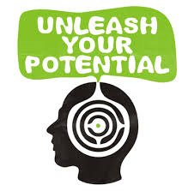

Quote of the day:
“When I stand before God at the end of my life, I would hope that I would not have a single bit of talent left and I could say, "I used everything that you gave me." — Erma Bombeck
Reflection:
Life is a precious gift. In the course of our busy day-to-day living it is easy to lose sight of just how unique each day and every moment of life is. You can fill every minute of the day with as much wonder, exploration, learning and joy as you want if you’ll make the choice to utilize your talents to the maximum degree. Everyone has hidden potential lying within. It is up to each one of us to use and develop our potential for good.
When you come to the end of your road, do you want to be able to say, ‘I used everything?’ Take some time to determine if you are working towards using your gifts and talents as much as you should be. If you’re not, ask yourself what is holding you back, then do something about it, start this week by taking one positive step, even if it seems a small step, towards your goal.
**

- Share Your Gifts With The World

Quote of the day:
“It is amazing what happens to us when we start thinking how we can serve others, and when we do, we also begin to think and feel more positively and better about ourselves.” — Author Unknown
Reflection:
Everyone on this planet is here for a reason. We all have a purpose in life. Unfortunately, many of us forget who we truly are, and end up thinking that this life is all there is. Remember, you are important, and you are capable of achieving amazing things.
You have unique gifts. Keep in mind that what may not seem like a gift to you, can make a big difference to others. What you may minimize as not very important might be the envy of someone else. Such as a great smile, a welcoming personality, the ability for good conversation. Perhaps less accomplished compared to the ability to understand quantum physics, but they make every day life much more pleasurable.
If you don’t already know spend some time before the New Year to discover what your gifts are. If you don’t feel you can determine them on your own, then seek the help of others, who can help you recognize your talents. Then share them with the world.
**

